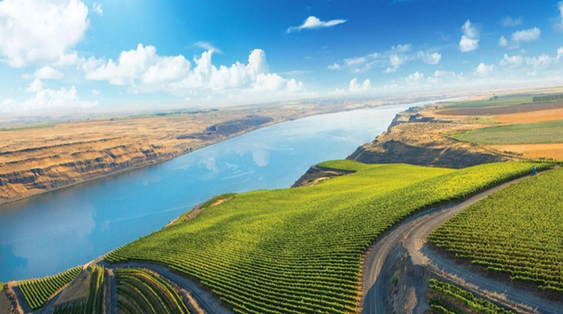
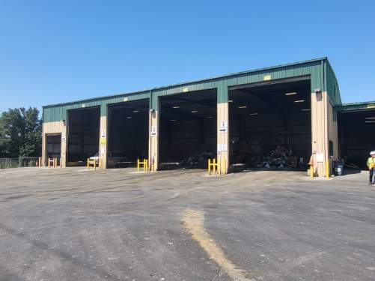

Benton County
Solid Waste and Hazardous Waste Management Plan

For Years 2024–2029

Benton County, Washington

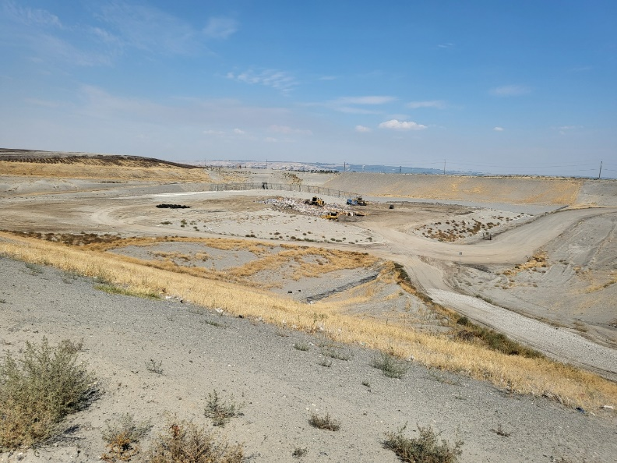 | November 2023

This page intentionally left blank.

Benton County
Solid Waste and Hazardous Waste Management Plan
For Years 2024–2029

November 2023

Prepared by:

HDR, Inc.
600 University Street
Suite 500
Seattle, WA 98101-4132

ACKNOWLEDGMENTS

The Benton County Department of Public Works acknowledges the valuable contribution of the following organizations for their assistance in the development of this Plan:

Benton County Solid Waste Advisory Committee Members

Washington State Department of Ecology Staff

Benton-Franklin Health District Staff

Benton County Public Works Staff

Benton County residents and businesses also contributed to this Plan through comments provided during public meetings and through various other channels. The Board of County Commissioners and Benton County Public Works gratefully acknowledge this input.
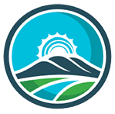

Table of Contents
Executive Summary xi
1.0 Background 1-1
1.1 Introduction 1-1
1.2 Purpose 1-1
1.3 Goals and Objectives 1-1
1.4 Participants in the Planning Process 1-3
1.5 Planning Area 1-3
1.6 Planning Authority 1-5
1.7 Plan Development Process 1-5
1.8 Status of Previous Plans 1-6
1.9 Relationship to Other Plans 1-6
1.9.1 The State Solid and Hazardous Waste Plan – Moving Washington Beyond Waste and Toxics 1-6
1.9.2 Benton County Growth Management Comprehensive Plan 1-6
1.9.3 City of Richland Solid Waste Management Plan 1-7
1.10 Required Plan Elements 1-7
1.11 Regulatory Overview 1-8
1.11.1 Solid Waste Handling Standards 1-8
1.11.2 Hazardous Waste Management Act 1-9
1.11.3 Relevant Oregon Solid Waste Regulations 1-9
1.12 Summary of Changes in Solid Waste Regulation and Policy Since 2013 1-10
1.12.1 Mercury-Containing Lights Product Stewardship Program 1-10
1.12.2 Revenue-Sharing Agreements 1-10
1.12.3 County Comprehensive Solid Waste Management Plan 1-11
1.12.4 Develop and Establish Objectives and Strategies for the Reuse and Recycling of Construction Aggregate and Recycled Concrete Materials 1-11
1.12.5 Quarantine – Agricultural Pests 1-11
1.12.6 Local Solid Waste Financial Assistance 1-12
1.12.7 Secure Drug Take-Back 1-12
1.12.8 Sustainable Recycling 1-12
1.12.9 Food Waste 1-12
1.12.10 Paint Stewardship 1-12
1.12.11 Product Design Labeling 1-13
1.12.12 Plastic Package Stewardship 1-13
1.12.13 Reducing Pollution from Plastic Bags 1-13
1.12.14 Organics Management Law 1-13
2.0 Waste Stream 2-1
2.1 Introduction 2-1
2.2 Waste Stream and Population Projections 2-1
2.2.1 Population and Waste Generation Rates 2-1
2.2.2 Recycling Data 2-3
2.2.3 Composition of Disposed Municipal Solid Waste 2-5
3.0 Solid Waste Collection 3-1
3.1 Introduction 3-1
3.2 Background 3-1
3.2.1 Legal Authority 3-1
3.2.2 Incorporated Areas 3-1
3.2.3 Unincorporated Areas 3-2
3.3 Existing Conditions 3-4
3.3.1 Waste Collection Programs 3-4
3.4 Status of Previous Recommendations 3-5
3.5 Alternatives and Evaluations 3-5
3.5.1 Alternatives 3-5
3.6 Recommended Actions 3-5
4.0 Waste Transfer and Disposal 4-1
4.1 Introduction 4-1
4.2 Background 4-1
4.2.1 State Legislation and Regulations 4-1
4.3 Existing Conditions 4-1
4.3.1 Transfer Stations and Drop-Box Sites 4-3
4.3.2 Landfills 4-4
4.4 Waste Import and Export 4-5
4.4.1 Waste Import 4-5
4.4.2 Waste Export 4-5
4.5 Status of Previous Recommendations 4-6
4.6 Alternatives and Evaluations 4-6
4.6.1 Transfer Station and Drop-Box Facilities 4-6
4.6.2 Landfill Facilities 4-7
4.7 Recommended Actions 4-7
5.0 Waste Reduction, Recycling, and Education and Outreach 5-1
5.1 Background 5-1
5.1.1 Waste Reduction and Recycling 5-1
5.1.2 CROP 5-2
5.1.3 Climate Action 5-3
5.2 Existing Program Elements 5-3
5.2.1 Recycling Services 5-4
5.2.2 Waste Reduction and Reuse 5-5
5.2.3 Public Education 5-5
5.2.4 Designation of Recyclable Materials 5-6
5.2.5 Urban and Rural Area Residential Recycling 5-8
5.2.6 Commercial Recycling 5-8
5.2.7 Public Event Recycling 5-8
5.2.8 Incentives for Recycling 5-9
5.2.9 Monitoring and Evaluation 5-9
5.2.10 Processing Facilities 5-9
5.2.11 Markets 5-9
5.2.12 Market Overview 5-9
5.2.13 Addressing Recyclables Key Contaminants 5-11
5.3 Status of Previous Recommendations 5-12
5.4 Alternatives and Evaluations 5-12
5.4.1 Refresh Educational Materials and Seek to Harmonize Messaging 5-12
5.4.2 Conduct New Waste Prevention Campaigns 5-14
5.4.3 Facilitate Business Material Exchanges 5-15
5.4.4 Promote Existing Reuse Programs 5-15
5.4.5 Recycling Contamination Reduction Campaigns 5-15
5.4.6 Expand Business Technical Assistance 5-15
5.4.7 Offer School Technical Assistance 5-16
5.4.8 Establish a Waste Diversion Goal 5-17
5.4.9 Recycling Rates by Material 5-17
5.4.10 Recycling Program Costs and Affordability 5-17
5.4.11 Sham Recycling 5-17
5.4.12 Glass Recycling 5-17
5.4.13 Provide Support for Recycling at Public Events 5-18
5.4.14 Require New Buildings to Provide Adequate Space and Facilities for Recycling Storage and Collection 5-18
5.4.15 Adopt Mandatory Recycling for Readily Recyclable Materials 5-18
5.4.16 Implement and Continue Pay-As-You-Throw Pricing for Garbage 5-18
5.5 Recommended Actions 5-18
6.0 Organics 6-1
6.1 Introduction 6-1
6.2 Background 6-1
6.2.1 Organics Regulations and Guidance 6-1
6.2.2 Washington State Department of Agriculture Regulations 6-2
6.3 Existing Conditions 6-3
6.3.1 Yard Debris Collection Programs 6-3
6.3.2 Home Composting 6-3
6.3.3 Compost Facilities 6-3
6.3.4 Compost Procurement Ordinances 6-3
6.3.5 Organic Material Generation 6-4
6.3.6 Christmas Tree Collection Program 6-4
6.4 Status Of Previous Recommendations 6-4
6.5 Alternatives and Evaluations 6-4
6.5.1 Organics Education 6-4
6.5.2 Evaluate Implementation of Curbside Recycling Services for Yard Waste and Food Waste 6-4
6.5.3 Food Waste 6-5
6.6 Recommended Actions 6-5
7.0 Miscellaneous Wastes 7-1
7.1 Introduction 7-1
7.2 Background 7-1
7.3 Agricultural Waste 7-2
7.3.1 Regulations and Guidelines 7-2
7.3.2 Current Practice 7-2
7.3.3 Planning Issues 7-2
7.4 Animal Carcasses 7-2
7.4.1 Regulations and Guidelines 7-2
7.4.2 Current Practice 7-3
7.4.3 Planning Issues 7-3
7.5 Appliances/White Goods 7-3
7.5.1 Regulations and Guidelines 7-3
7.5.2 Current Practice 7-3
7.5.3 Planning Issues 7-4
7.6 Asbestos 7-4
7.6.1 Regulations and Guidelines 7-4
7.6.2 Current Practice 7-4
7.6.3 Planning Issues 7-4
7.7 Biomedical/Infectious Waste 7-4
7.7.1 Regulations and Guidelines 7-4
7.7.2 Current Practice 7-5
7.7.3 Planning Issues 7-5
7.8 Carpet and Padding 7-5
7.8.1 Regulations and Guidelines 7-6
7.8.2 Current Practice 7-6
7.8.3 Planning Issues 7-6
7.9 Construction and Demolition Debris 7-6
7.9.1 Regulations and Guidelines 7-6
7.9.2 Current Practice 7-7
7.9.3 Planning Issues 7-7
7.10 Disaster Debris Management 7-7
7.10.1 Regulations and Guidelines 7-7
7.10.2 Current Practice 7-8
7.10.3 Planning Issues 7-9
7.11 Electronic Waste 7-10
7.11.1 Regulations and Guidelines 7-10
7.11.2 Current Practice 7-10
7.11.3 Planning Issues 7-10
7.12 Junk Vehicles 7-10
7.12.1 Regulations and Guidelines 7-10
7.12.2 Current Practice 7-10
7.12.3 Planning Issues 7-10
7.13 Litter and Illegal Dumping 7-11
7.13.1 Regulations and Guidelines 7-11
7.13.2 Current Practice 7-11
7.13.3 Litter 7-11
7.13.4 Illegal Dumping 7-11
7.13.5 Planning Issues 7-11
7.14 Mattresses 7-12
7.14.1 Regulations and Guidelines 7-12
7.14.2 Current Practice 7-12
7.14.3 Planning Issues 7-12
7.15 Petroleum-Contaminated Soils 7-12
7.15.1 Regulations and Guidelines 7-12
7.15.2 Current Practice 7-12
7.15.3 Planning Issues 7-12
7.16 Pharmaceuticals 7-12
7.16.1 Regulations and Guidelines 7-13
7.16.2 Current Practice 7-13
7.16.3 Planning Issues 7-13
7.17 Street Sweepings/Vactor Waste 7-13
7.17.1 Regulations and Guidelines 7-13
7.17.2 Current Practice 7-14
7.17.3 Planning Issues 7-14
7.18 Tires 7-14
7.18.1 Regulations and Guidelines 7-14
7.18.2 Current Practice 7-14
7.18.3 Planning Issues 7-14
7.19 Needs and Opportunities 7-14
7.20 Alternatives and Evaluations 7-14
7.20.1 General Alternatives 7-14
7.20.2 Construction and Demolition Debris Alternatives 7-15
7.20.3 Disaster Debris Management Alternatives 7-16
7.21 Recommended Actions 7-16
8.0 Moderate-Risk Waste 8-1
8.1 Introduction 8-1
8.2 Background 8-1
8.2.1 Definitions 8-1
8.2.2 Regulations and Guidance 8-3
8.2.3 Benton County MRW Facility 8-5
8.3 Moderate-Risk Waste Generation 8-6
8.3.1 Hazardous Waste Inventory 8-6
8.3.2 Inventory of Moderate-Risk Waste Generators 8-7
8.4 Existing Conditions 8-7
8.4.1 Current Moderate-Risk Waste and Oil Programs 8-7
8.5 Status of Previous Recommendations 8-9
8.6 Alternatives and Evaluations 8-9
8.6.1 Public Education 8-9
8.6.2 Business Technical Assistance 8-9
8.6.3 Household Collection 8-10
8.6.4 Business Collection 8-10
8.6.5 Compliance and Enforcement 8-10
8.6.6 Moderate-Risk Waste Plan Preparation 8-10
8.7 Recommended Actions 8-10
9.0 Energy Recovery 9-1
9.1 Introduction 9-1
9.2 Background 9-1
9.3 Existing Conditions 9-1
9.4 Status of Previous Recommendations 9-2
9.5 Alternatives and Evaluations 9-2
9.5.1 Energy Recovery Needs 9-2
9.6 Recommended Actions 9-3
10.0 Administration, Financing, and Enforcement 10-1
10.1 Introduction 10-1
10.2 Background 10-1
10.3 Existing Conditions 10-1
10.3.1 Benton County Public Works Department - Solid Waste Division 10-1
10.3.2 Benton County Solid Waste Advisory Committee 10-3
10.3.3 Incorporated Cities 10-3
10.3.4 Benton Franklin Health District 10-4
10.3.5 Washington State Department of Ecology 10-5
10.3.6 Washington Utilities and Transportation Commission 10-5
10.3.7 United States Environmental Protection Agency 10-6
10.4 Status of Previous Recommendations 10-6
10.5 Alternatives and Evaluations 10-6
10.5.1 Long-Term Funding Needs 10-6
10.5.2 Collection and Disposal Districts 10-8
10.5.3 Staffing 10-9
10.5.4 Permit Review 10-9
10.6 Recommended Actions 10-9
11.0 Implementation Plan 11-1
11.1 Recommended Strategies, Implementation Schedule, and Budget 11-1
11.2 State Environmental Policy Act 11-6
11.3 Twenty-Year Implementation Program 11-6
11.4 Draft Plan Review 11-7
11.5 Procedures for Amending the Plan 11-7

List of Tables
Table 1-1. Benton County Solid Waste Advisory Committee 1-3
Table 2-1. Benton County Population Estimates 2-1
Table 2-2. Current Waste Generation Rate (2018) 2-2
Table 2-3. Projected Waste Quantities 2-3
Table 2-4. Recycled and Diverted Materials (2018) 2-4
Table 2-5. Benton County Waste Stream Composition (2018) 2-5
Table 3-1. Solid Waste Collection Data (December 2022) 3-4
Table 4-1. Transfer Station Tipping Fees (2022) 4-3
Table 5-1. Recycling Operations in Benton County (2022) 5-4
Table 5-2. List of Designated Recyclable Materials 5-7
Table 5-3. Markets for Recyclable Materials (as of December 2022) 5-11
Table 7-1. Miscellaneous Wastes 7-1
Table 7-2. Potential Disasters and Resultant Debris 7-8
Table 8-1. Hazardous Household Substances List 8-1
Table 8-2. MRW Collection Event Quantities Shipped (in pounds) 8-8
Table 10-1. Benton County Solid Waste Financial Information 10-3
Table 10-2. Benton County Solid Waste Financial Information 10-7
Table 11-1. Summary of Recommendations, Implementation Schedule, and Budget 11-1

List of Figures
Figure 1-1. Benton County Solid Waste Planning Area 1-4
Figure 2-1. 2015–2016 Central Washington Region Waste Composition Study 2-5
Figure 3-1. WUTC Solid Waste Certificated Collection Areas 3-3
Figure 4-1. Benton County Solid Waste Facilities 4-2
Figure 4-2. WM Kennewick Transfer Station 4-3
Figure 4-3. City of Richland Horn Rapids Landfill 4-4
Figure 5-1. EPA Waste Hierarchy 5-1
Figure 8-1. Benton County MRW Facility 8-6
Figure 9-1. City of Spokane Waste-to-Energy Plant 9-1
Figure 10-1. Benton County Public Works Department - Solid Waste Organizational Structure 10-2

List of Appendices
Appendix A: Executed Solid Waste Interlocal Agreements
Appendix B: Resolutions of Adoption for this Plan
Appendix C: Information on the SWAC
Appendix D: Status of 2013 Plan Recommendations
Appendix E: SEPA Checklist
Appendix F: WUTC Cost Assessment
Appendix G: Determination of Non-significance
Appendix H: Comments and Responses on the Draft Plan

Acronyms and Abbreviations
BDI Basin Disposal, Inc.
BSE Bovine Spongiform Encephalopathy
C&D construction and demolition
CFCs chlorofluorocarbons
Commerce Washington Department of Commerce
County Benton County
CPG Coordinated Prevention Grant
CROP Contamination Reduction and Outreach Plan
DDMP disaster debris management plan
Ecology Washington State Department of Ecology
EIS Environmental Impact Statement
EMP Emergency Management Plan
EPA United States Environmental Protection Agency
EPR extended producer responsibility
ESHB Engrossed Substitute House Bill
FEMA Federal Emergency Management Agency
H5N1 Highly Pathogenic Asian Avian Influenza A
HB House Bill
HDPE high-density polyethylene
HDR HDR Engineering, Inc.
Health District Benton-Franklin Health District
HHW household hazardous waste
LSWFA Local Solid Waste Financial Assistance
MRW moderate risk waste
MSW municipal solid waste
MTCA Model Toxics Control Act
MW megawatts
OFM Washington Office of Financial Management
ORS Oregon Revised Statute
PCS petroleum-contaminated soils
PET polyethylene terephthalate
Plan Benton County Solid Waste and Moderate Risk Waste Management Plan
RCRA Resource Conservation and Recovery Act
RCW Revised Code of Washington
SEPA State Environmental Policy Act
SHB Substitute House Bill
SQG Small-Quantity Generator
SWAC Solid Waste Advisory Committee
TPY tons per year
UGA Urban Growth Area
WAC Washington Administrative Code
WM Waste Management of Washington, Inc.
WSDA Washington State Department of Agriculture
WUTC Washington Utilities and Transportation Commission

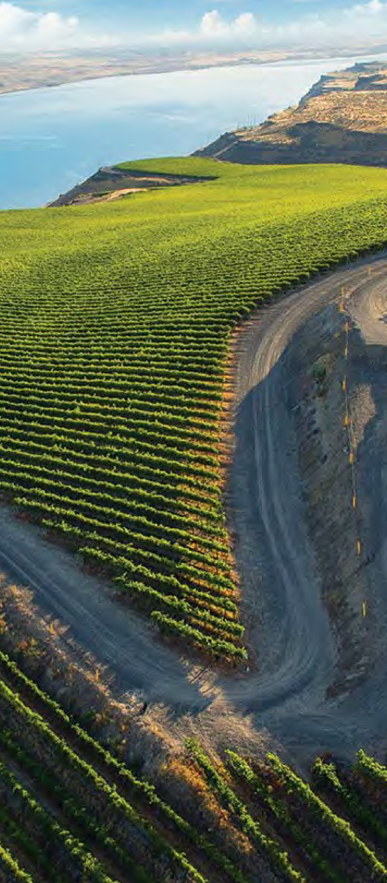
Executive Summary
This Solid Waste Management Plan (Plan) recommends strategies to manage solid waste generated in Benton County over the next 6 to 20 years as required by the Revised Code of Washington (RCW) 70A.205. This Plan will guide the actions of Benton County and the participating cities of Benton City, Kennewick, Prosser, Richland and West Richland and Waste Management and Basin Disposal, Inc. that provide curbside collection and processing and municipal solid waste and recyclable materials. It is the collaborative effort of participating cities’ and industry representatives, thought leaders and subject matter experts in the solid waste field, and incorporates a balanced approach to solid waste management in Benton County.
The overriding mission statement for the Plan is:
“Benton County and the participating jurisdictions provide citizens with efficient, reliable, and affordable solid waste collection, handling, recycling and disposal services in order to improve the quality of life while protecting and preserving human health, environmental quality and natural resources.”
To further this mission, the Plan proposes a comprehensive set of recommended strategies for implementation over the six-year planning period. Highlights include:
Staffing – The Plan recommends adequate staffing be maintained to implement programs and educational outreach initiatives through a cooperative effort with the County, cities and towns, waste haulers and other stakeholders. Staffing priorities are critical to the operations of the new Household Hazardous Waste Facility operations and implementation and compliance with regulatory requirements related to organics management reduction of contaminants in the recycling waste stream.
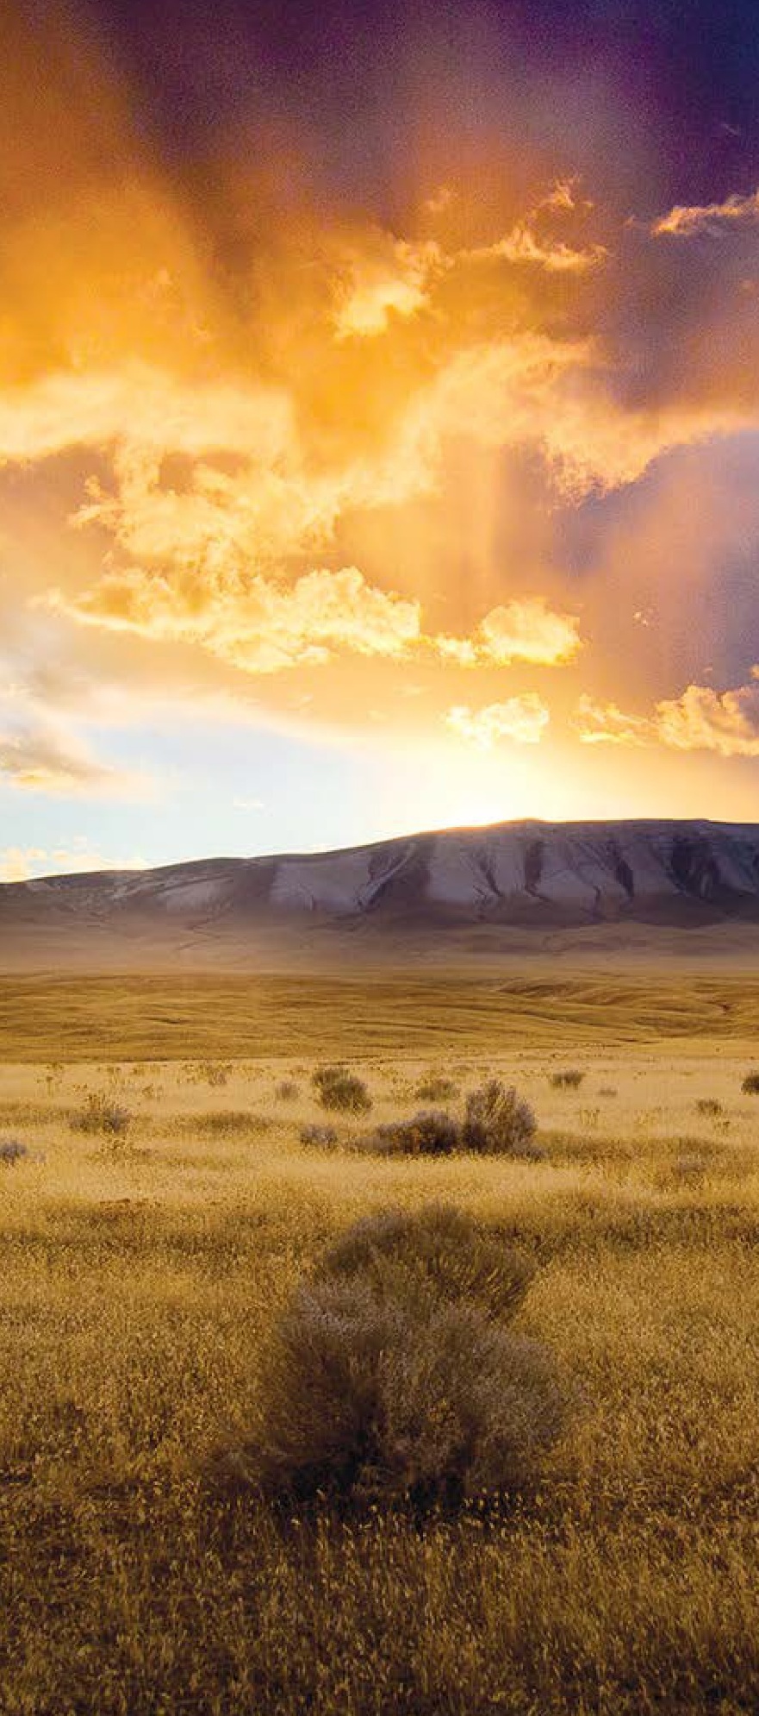
Waste Reduction and Recycling – Waste prevention, reduction and recycling are continuing priorities for this Plan. Promoting a variety of education and outreach initiatives, while dealing with changing recycling markets, will continue to be a priority through harmonization of programs and working cooperatively with jurisdictional and private partners.
System Enhancements – Modernization of curbside recycling programs to carted services that increase worker safety while diverting materials from disposal is a vital component to this Plan. Increasing marketable recyclable materials collected at the curb will provide a long-term benefit to the community through extended landfill life.
Long-range planning is essential to achieving a cost-effective and environmentally sound integrated solid waste system. To this end, this Plan facilitates a cooperative effort between partners and provides a framework for infrastructure planning, short-term and long-term management of solid waste and recyclables, policy making and funding for the system. The summary of recommendations and implementation costs can be found in Chapter 11 – Implementation Plan.
This Plan is intended to be a “living document” to be revisited on a regular basis to evaluate progress, reassess initiatives and implementation plans, and consider potential updates to the Plan in response to emerging data and information and future conditions.

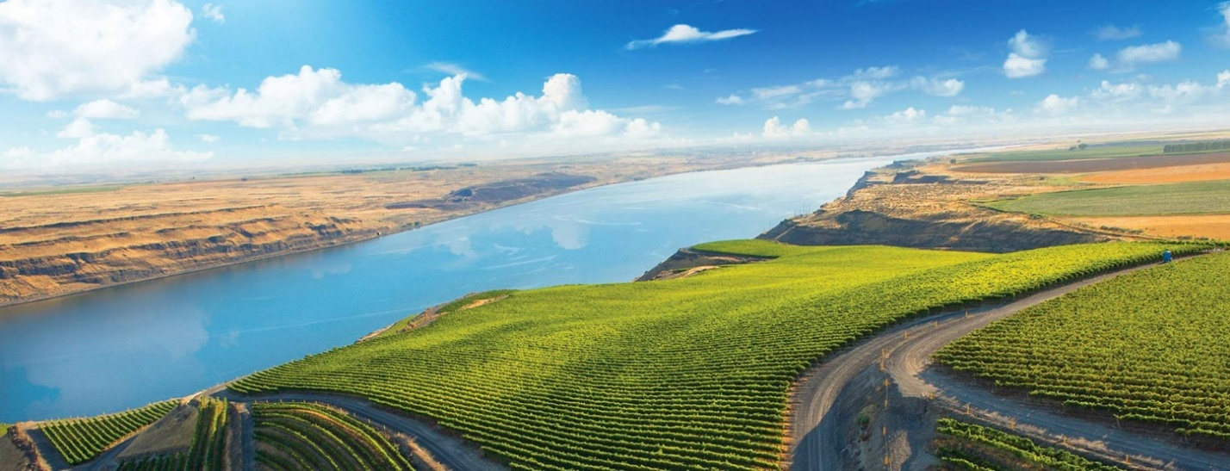
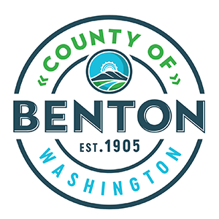

Chapter 1.0 Background

This page intentionally left blank.

Background
This section provides general information regarding the Benton County Solid Waste and Moderate Risk Waste Management Plan (Plan), its development, and its relationship to other state and local documents.

Introduction
This Plan recommends strategies to manage solid waste and moderate risk waste (MRW) generated in Benton County, Washington (County). Solid waste handling includes management, storage, collection, diversion, transportation, treatment, use, processing, and final disposal. This Plan includes recommendations for municipal solid waste (MSW), MRW, waste reductions, recycling and education, diversion, construction and demolition (C&D) debris, and special wastes.

Purpose
Washington State law assigns primary responsibility for managing MSW and MRW to local governments. Revised Code of Washington (RCW) 70A.205 requires local governments to maintain current solid waste management plans. RCW 70A.300 requires local governments to develop plans for managing hazardous waste, which in this Plan is covered in Chapter 8.0 – Moderate-Risk Waste.
The purpose of this Plan is to develop recommended waste management strategies for the period 2023 through 2029. The Plan also looks forward to confirmation that sufficient processing and disposal options are anticipated to be available to the County for at least the next 20 years, or through year 2043.
Local plans must be complete and in good standing to receive grant monies from the Washington State Department of Ecology (Ecology) Local Solid Waste Financial Assistance (LSWFA), which is a funding source for non-disposal-related programs and activities.

Goals and Objectives
The mission statement for this Plan is as follows:
Benton County and the participating jurisdictions provide citizens with efficient, reliable, and affordable solid waste collection, handling, recycling and disposal services in order to improve the quality of life while protecting and preserving human health, environmental quality, and natural resources.
For each element of the Plan, goals were developed. An assessment of existing conditions relative to each element was made, and then an identification of needs and opportunities followed. An evaluation of the alternatives was then performed, and recommendations for specific programs, policies, or actions were selected and adopted.
In summary, the goals for the Plan are as follows outlined below.
Infrastructure and System
- Manage wastes in a cost-effective manner that promotes, in order of priority, waste reduction, reuse, and recycling.
- Enhance and improve overall efficiency of waste and recyclables collection and transfer.
- Encourage and expand coordination and communication regarding waste collection, recycling, and disposal among all jurisdictions, agencies, and private firms in Benton County.
- Ensure that collection infrastructure is flexible and adaptable to changing recycling and waste diversion practices.
- Ensure that wastes are properly managed and facilities are operated in full compliance with appropriate rules and regulations.
- Establish guidelines and strategies for management of specific waste streams.
Economic Sustainability
- Manage waste as a resource to increase local job opportunities and support economic development.
- Consider environmental impacts to climate, air, water, and land that are associated with waste generation, transportation, handling, recycling, and disposal.
- In the County, edible food is eaten, and inedible food is composted or processed into other value-added products.
Education
- Reinvigorate the public education and outreach programs throughout the County.
- Encourage people and businesses to make responsible choices about what they produce and consume, and what they generate as waste.
- Encourage public/private partnerships for waste reduction and recycling programs.
Outside Influences
- Support changes to federal and state regulations and policies that support economically sustainable recycling opportunities and waste diversion.
- Manage waste in a manner that promotes Washington State’s waste management priorities presented in Ecology’s Moving Washington Beyond Waste and Toxics document.
- Comply with federal, state, and local solid waste and MRW regulations.
- Promote and support life-cycle product stewardship and industry advancements in packaging standards that lead to less waste generation.

Participants in the Planning Process
This document was developed with the guidance of the Benton County Solid Waste Advisory Committee (SWAC), whose participation is gratefully acknowledged. Committee members and their affiliations are shown in Table 1-1.

Table 1-1. Benton County Solid Waste Advisory Committee
Member | Affiliation
Will McKay  Matt Mahoney (Alternate) | Benton County
Jessica Wadsworth  David Sandretto (Alternate) | City of Benton City
Chuck Torelli  Jim Millbauer (Alternate) | City of Kennewick
Don Aubrey | City of Prosser
Theresa Richardson | City of Richland
Richard Bloom | City of West Richland
Darrick Dietrich  Rebecca Francik (Alternate) | Basin Disposal
Jeff Barcenas  Tami Yager (Alternate) | Waste Management
Khris Olsen | Public Citizen

Planning Area
The planning area (see Figure 1-1) includes the incorporated and unincorporated areas of the County. This includes the cities and towns of Benton City, Kennewick, Prosser, Richland, and West Richland, with only the Hanford site area excluded.

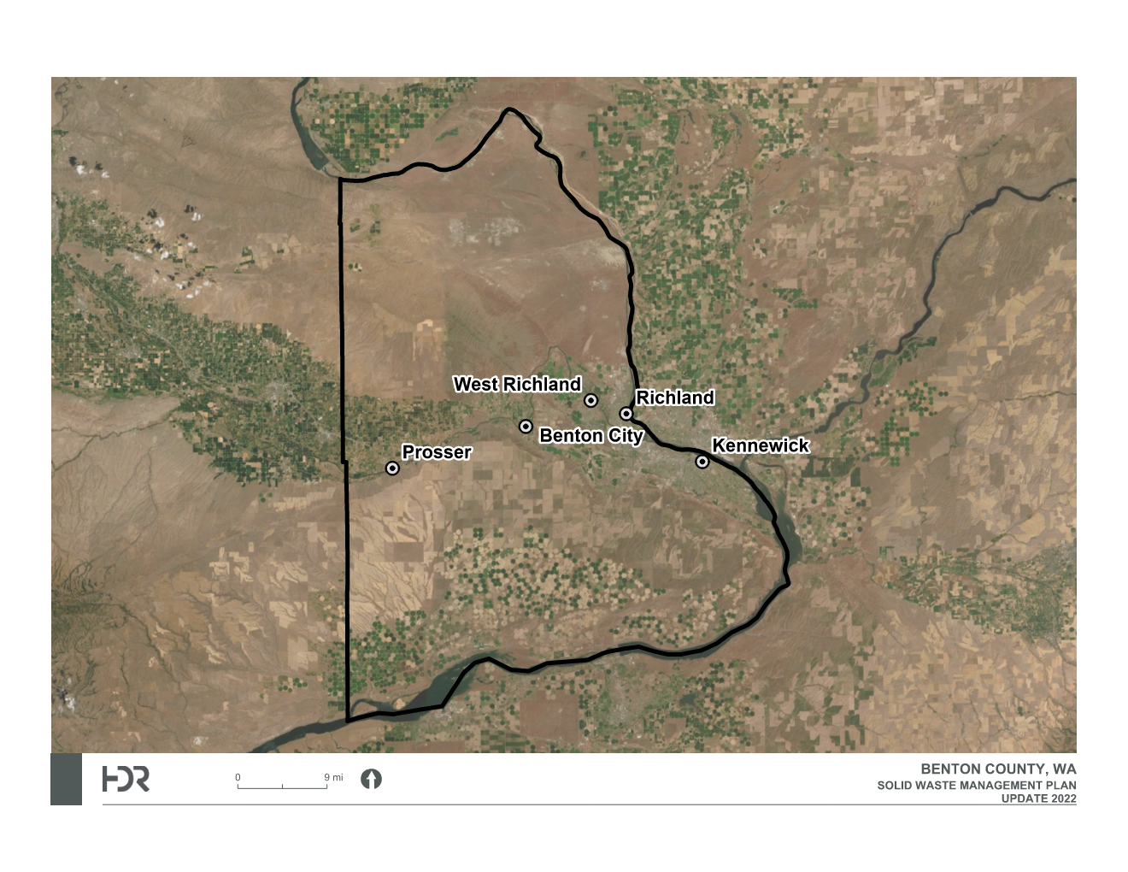
Figure 1-1. Benton County Solid Waste Planning Area

Planning Authority
This Plan is intended to satisfy the participating jurisdictions’ responsibilities for maintaining a current solid waste management plan in accordance with RCW 70A.205 and to provide a local hazardous waste management plan in accordance with RCW 70A.300.
Cities and counties share the responsibility for developing and maintaining a local solid waste management plan. RCW 70A.205 provides cities with three alternatives for satisfying their planning responsibilities:
- Prepare and deliver to the County auditor a city solid waste management plan for integration into the County solid waste plan;
- Enter into an agreement with the County to prepare a joint city-County plan; or
- Authorize the County to prepare a plan for the city for inclusion in the County plan.
The incorporated communities of Benton City, Kennewick, Prosser, Richland, and West Richland executed interlocal agreements with the County regarding solid waste management. The agreements authorize the County to prepare a countywide solid waste management plan that includes each of these cities and towns. Participating cities and towns have both the opportunity and responsibility to participate in plan development, review, and comment on the draft plan and to adopt the final plan.
Executed Solid Waste Interlocal Agreements can be found in Appendix A. Resolutions of Adoption for this Plan can be found in Appendix B.

Plan Development Process
The County began the Plan update process in 2018. Due to the COVID-19 pandemic, the update process was impacted with a final draft Plan being submitted in 2020. The County chose to move forward with a new Plan update process due to regulatory, staffing, and operational changes that have occurred since the previous process was undertaken.
This Plan was developed over a period of approximately 9 months. The process began in August 2022 with the contract execution for HDR Engineering, Inc. (HDR), as the team that would assist with starting the update process. During the 9 months, technical research, analysis, and recommendations were prepared by HDR and the County staff and discussed with the Benton-Franklin Health District (Health District), the SWAC, stakeholders, interested members of the public, and interest groups. This participatory, interactive process was undertaken in order to prepare and build support for the Plan.
The public participation process was largely focused on the SWAC. The Board of County Commissioners appointed SWAC members. Members are selected to represent a balance of interests including citizens, public interest groups, businesses, the waste management industry, local elected public officials, and the agricultural industry. The SWAC provides guidance to the Benton County Public Works Department in the development of programs and policies concerning solid waste handling and disposal. The SWAC reviews and comments on rules, policies, resolutions, and ordinances before they are proposed for adoption. SWAC meetings are open to the public, and meeting notices are published beforehand. For additional information on the SWAC, please refer to Appendix C.
The anticipation is that the Plan will be adopted by each participating city or town and by the Board of County Commissioners in meetings open to the public.

Status of Previous Plans
This Plan supersedes previous solid waste management plans including the 2013 Benton County Solid Waste and Moderate Risk Waste Management Plan (2013 Plan). The status of the 2013 Plan recommendations can be found in Appendix D.

Relationship to Other Plans
This section provides information on how this Plan is related to other state and local documents.

The State Solid and Hazardous Waste Plan – Moving Washington Beyond Waste and Toxics
Ecology released a waste and toxics reduction plan in June 2015. Moving Washington Beyond Waste and Toxics focuses on reducing waste and toxics by adopting a sustainable materials management approach, which is also used by the United States Environmental Protection Agency (EPA). This approach looks at the full life cycle of materials from design and manufacturing, through use, to disposal or recycling. The EPA believes a sustainable materials management approach can help identify more sustainable ways to produce products that are less impactful to the environment.
Moving Washington Beyond Waste and Toxics’ vision is as follows: “We can transition to a society where waste is viewed as inefficient, and where most wastes and toxic substances have been eliminated. This will contribute to economic, social and environmental vitality.” The following four priorities are included in Moving Washington Beyond Waste and Toxics:
- Increase our focus on manufacturing and use phases, not just on end-of-life issues;
- Reduce toxic threats in products and industrial processes;
- Increase efficiency of recycling (including organic processing) systems and maximize effectiveness of existing solid and hazardous waste infrastructure; and
- Mitigate climate change through waste reduction, reuse, and recycling.

Benton County Growth Management Comprehensive Plan
The County has been experiencing unprecedented population and economic growth from the Department of Energy and the Hanford site, the construction and operation of nuclear power plants, and food-processing for the agricultural community. RCW 36.70A.040 provides counties with planning requirements as required under the Growth Management Act. The County, in 2017, adopted the Benton County Comprehensive Land Use Plan under this authority and the Planning Commission Act (RCW 35.63), which provides for the procedures to be followed in guiding and regulating the physical development of the County. The Comprehensive Land Use Plan guides the growth of unincorporated Benton County (areas outside of the cities). It details policies and goals for zoning and development regulations, and addresses requirements of Washington State’s Growth Management Act. It includes specific guidelines for the unincorporated areas of the County as well as for the Urban Growth Areas (UGAs) of the cities of Richland, Kennewick, Prosser, West Richland, and Benton City.

City of Richland Solid Waste Management Plan
In August 2011, the City of Richland chose to adopt their own solid waste management plan to develop their collection system and improve their landfill. The City of Richland Solid Waste Management Plan is incorporated by reference into this Plan and is not intended to replace the City’s commitment to this Plan and Interlocal Agreement. The City of Richland Solid Waste Management Plan can be found at: https://www.ci.richland.wa.us/departments/public-works/management-plans
The City’s plan serves as a guide to Richland’s solid waste management approach over the planning period of 20 years, with recommendations that include the following:
- Enhance existing waste and recycling programs for commercial customers.
- Conduct curbside collection of food waste by commercial sector.
- Expand Horn Rapids Landfill.
- Expand diversion of C&D materials at Horn Rapids Landfill as markets allow.
- Support diversion of wood waste at transfer station and landfill.
- Encourage and support research and development of alternative energy industries and development of new recycling technologies.
- Promote programs and provide incentives that encourage and support waste reduction, reuse, and recycling.

Required Plan Elements
This Plan is intended to meet or exceed applicable requirements set by Washington State. RCW 70A.205 establishes requirements for local solid waste management plans. Local plans are required to include the following elements:
- An inventory and description of solid waste handling facilities, including any deficiencies in meeting current needs;
- The projected 20-year needs for solid waste handling facilities;
- A program for the development of solid waste handling facilities that meets applicable laws and regulations, takes into account the comprehensive land use plans of participating jurisdictions, and contains a 6-year construction and capital acquisition program and a plan for financing both capital costs and operational expenditures;
- A program for surveillance and control (to avoid or mitigate the negative impacts of improper waste handling);
- An inventory and description of solid waste collection operations and needs within each jurisdiction, including state collection certificate holders and municipal operations;
- A comprehensive waste reduction and recycling element;
- An assessment of the Plan’s impact on the costs of solid waste collection; and
- A review of potential areas that meet state criteria for land disposal facilities.
RCW 70A.300 establishes the required elements for local hazardous waste management plans identified below:
- A plan or program to manage MRW including an assessment of the quantities, types, generators, and fate of MRW in the jurisdiction;
- A plan or program to provide for ongoing public involvement and education, including the potential hazards to human health and the environment resulting from improper use and disposal of the waste;
- An inventory of existing generators of hazardous waste and facilities managing hazardous waste within the jurisdiction;
- A description of the public involvement process used in developing the plan; and
- A description of the eligible zone designations in accordance with RCW 70A.300.225.

Regulatory Overview
The statutes and regulations that govern solid waste handling are summarized briefly below.

Solid Waste Handling Standards
A rule governing solid waste facilities and handling practices, Washington Administrative Code (WAC) 173-350, also known as Solid Waste Handling Standards, went into effect in 2003. This rule replaced WAC 173-304. WAC 173-350 sets out standards of operation and permitting requirements for solid waste handling facilities for recycling, intermediate handling (i.e., transfer), composting, MRW, and tires (unless exempted by definition or due to beneficial use). The rule regulates landfill disposal of a new category of wastes called “inert” wastes.
WAC 173-350 also places importance on local solid waste management plans (such as this document) by requiring solid waste handling facilities (whether exempt or requiring a permit) to conform to local solid waste plans. WAC 173-350 also states that a facility’s exemption for handling only recyclable materials is contingent on meeting the definition of a recyclable material as designated in a local solid waste management plan.
Landfill disposal of solid waste is regulated under a separate rule, WAC 173-351, Criteria for Municipal Solid Waste Landfills. This rule was last revised in October 2015.

Hazardous Waste Management Act
In 1982, Ecology adopted rules that combined the state and federal regulation of hazardous wastes. These rules, as amended several times in the ensuing years, are contained in WAC 173-303 and are the main body of regulations for hazardous wastes in this state. In 1983, the State Legislature adopted a hierarchy of hazardous waste management methods in RCW 70A.300. In descending order of priority for management, the hierarchy is waste reduction; waste recycling; physical, chemical, and biological treatment; incineration; solidification/stabilization treatment; and landfill.
Amendments to RCW 70A.300 in 1985 and 1986 defined MRW and required that local governments (counties) develop plans for the proper management of MRW. As stated in RCW 70A.300, the legislature’s intent was “to promote cooperation between state and local governments by assigning responsibilities for planning for hazardous waste to the state and planning for MRW to local government.” In 1987, the legislature appropriated funds for grants to counties to assist in their planning efforts and clarified the schedule.
The legislature enacted the Used Oil Recycling Act, RCW 70A.205, in 1991. This statute requires local governments to manage used oil in conjunction with their MRW programs and to submit annual reports to Ecology. Local governments were required to adopt used oil recycling amendments to their MRW management plans by July 1, 1993.
New Solid Waste Handling Standards (WAC 173-350) were developed by Ecology and became effective February 10, 2003. These standards address MRW facilities (including construction, record keeping, and reports).
The Dangerous Waste Regulations (WAC 173-303) have been amended several times to address new issues and to incorporate new provisions of state and federal regulations.

Relevant Oregon Solid Waste Regulations
Oregon statute (Oregon Revised Statute [ORS] 459.305) requires out-of-state local governments, which export more than 75,000 tons annually into Oregon for landfill disposal, to provide the opportunity to recycle and implement recycling education programs. Specifically, the local government must either achieve a recovery rate equivalent to that achieved in a comparable Oregon county or implement an equivalent recycling program. The disposal site operator is responsible for demonstrating to the Oregon Department of Environmental Quality that the city from which the waste originates has implemented an equivalent recycling program.
An equivalent recycling program requires that each person be notified of the opportunity to recycle and be encouraged to source-separate recyclables through education programs. Additionally, for cities with a population of:
- Less than 4,000, a convenient drop-off recycling location must be provided for source separated recyclables.
- More than 4,000, monthly curbside collection of source-separated recyclables must be provided.

Summary of Changes in Solid Waste Regulation and Policy Since 2013
Several new rules have been adopted since the previous 2013 Plan was developed. Important new rules and regulations for consideration in Plan development are shown below (not in order of priority).

Mercury-Containing Lights Product Stewardship Program
WAC 173-910 requires establishment of a product stewardship program for mercury-containing lights throughout Washington State. Producers of mercury-containing lights sold for residential use must finance and participate in the product stewardship program by doing the following:
- Fund its producer share cost of the standard plan and program operated by the department-contracted stewardship organization or operate, either individually or jointly, an independent plan and program approved by Ecology.
- Pay administrative and operational costs associated with the standard program or the independent program in which they participate, except for the collection costs associated with curbside and mail-back collection programs. For curbside and mail-back programs, a stewardship organization must finance the costs of transporting and processing mercury-containing lights from the point of accumulation. For collection locations, including household hazardous waste (HHW) facilities, charities, retailers, government recycling sites, or other suitable locations, a stewardship organization must finance the costs of collection, transportation, and processing of mercury-containing lights collected at the collection locations.
- Submit market share data to Ecology to determine market share in the event more than one approved product stewardship plan is operating.
- Meet its financial obligations to the plan, which includes Ecology’s annual fee.
- Comply with producers' requirements.
- Participate in a fully implemented plan.
- Take actions required to correct violations.
The LightRecycle program is set to sunset in 2025 unless action is taken to extend the law, and after July 1, 2026, the program may be terminated or extended.

Revenue-Sharing Agreements
An update to RCW 81.77.185 allows waste collection companies to retain up to 50 percent of the revenue paid to the companies for the material if the companies submit a plan to the Washington Utilities and Transportation Commission (WUTC) that is certified by the appropriate local government authority as being consistent with the local government solid waste plan and that demonstrates how the revenues will be used to increase recycling. The remaining revenue shall be passed to residential customers.

County Comprehensive Solid Waste Management Plan
RCW 70A.205 was updated to indicate that when updating a solid waste management plan after June 10, 2010, each local comprehensive plan must, at a minimum, consider methods that will be used to address the following:
- C&D waste for recycling or reuse;
- Organic material including yard debris, food waste, and food-contaminated paper products for composting or anaerobic digestion;
- Metals, glass, and plastics for recycling; and
- Waste reduction strategies.

Develop and Establish Objectives and Strategies for the Reuse and Recycling of Construction Aggregate and Recycled Concrete Materials
Effective January 1, 2016, RCW 70A.205.700 requires that local governmental entities with a population of 100,000 or more residents must, as part of their contracting process, request and accept bids that include the use of construction aggregate and recycled concrete materials for each transportation, roadway, street, highway, or other transportation infrastructure project. Prior to awarding a contract for a transportation, roadway, street, highway, or other transportation infrastructure project, the local governmental entity must compare the lowest responsible bid proposing to use construction aggregate and recycled concrete materials with the lowest responsible bid not proposing to use construction aggregate and recycled concrete materials, and award the contract to the bidder proposing to use the highest percentage of construction aggregate and recycled concrete materials if that bid is the same as, or less than, the bid from a bidder not proposing to use construction aggregate and recycled concrete materials or proposing to use a lower percentage of construction aggregate and recycled concrete materials.

Quarantine – Agricultural Pests
Effective January 1, 2017, the Washington State Department of Agriculture (WSDA) amended WAC 16-470 by adding MSW, yard debris, organic feedstocks, organic materials, and agricultural wastes to the list of commodities regulated under the apple maggot quarantine. Special permits are required for the following:
- Transportation and disposition of MSW from an area under quarantine for disposal at a solid waste landfill or disposal facility in the apple maggot and plum curculio pest-free area.
- Transportation and disposition of yard debris, organic feedstocks, organic materials, and agricultural wastes from the area under quarantine for disposal at a solid waste landfill or treatment at a composting facility in the apple maggot and plum curculio pest-free area.
Refer to Chapter 6.0 – Organics for additional information regarding how these rules affect solid waste in the County.

Local Solid Waste Financial Assistance
In September 2017, WAC 173-312 was updated to replace the Coordinated Prevention Grant (CPG) program. The purpose of WAC 173-312 is to provide financial assistance for local programs related to hazardous waste planning and implementation, local solid waste planning and implementation, and enforcement of rules and regulations governing solid waste handling. Planning, implementation, and enforcement are designed to prevent, or minimize, environmental contamination resulting from improper management or disposal of waste. WAC 173-312 established a structure for the administration of local solid waste financial assistance.

Secure Drug Take-Back
Washington’s Safe Medication Return program, also known as the Drug Take-Back program, was established in 2018 under RCW 69.48. This program will create a unified, statewide, medication return program that will give Washington residents free, convenient, and environmentally responsible options for disposing of unwanted medication. Drug manufacturers will fund the program at no cost to taxpayers. It will be operated by an approved program operator(s). The Health Department will oversee the establishment of the program, monitor ongoing operations, manage enforcement when compliance issues arise, and evaluate program effectiveness.

Sustainable Recycling
House Bill (HB) 1543, Sustainable Recycling, was signed by Governor Inslee on April 29, 2019. This act took effect July 1, 2019. This act creates a Recycling Development Center within Ecology. Ecology will work with the Washington Department of Commerce (Commerce) on recycling market research and development. Ecology and Commerce will appoint an advisory board and enter into an interagency agreement. Ecology will create a State recycling Contamination Reduction and Outreach Plan (CROP) by July 1, 2020. Local jurisdictions will need to create their own CROPs or adopt the state CROP by July 1, 2021. Counties with populations of fewer than 25,000 are exempt from this requirement. Local governments may use LSWFA Grants and Waste Reduction and Recycling Education Grants to support CROPs.

Food Waste
HB 1114, now codified as RCW 70A.205.715, established a goal for the state to reduce, by 50 percent, the amount of food waste generated annually by 2030. Ecology is required to establish baseline data and annually track progress toward the statewide food reduction goals and to develop and implement a food waste reduction plan. The Use Food Well Washington Plan was completed in December 2021 and provides local governments with recommendations for best management practices to incorporate into local plans. Additional information on this topic is located in Chapter 6.0 – Organics.

Paint Stewardship
Substitute HB (SHB) 1652 requires producers of architectural paint sold in Washington to participate in an approved paint stewardship plan. This bill prohibits a producer or retailer of paint from selling or offering for sale architectural paint unless the producer or brand of paint is participating in a stewardship plan. A paint stewardship organization will implement this bill, with Ecology providing oversight.

Product Design Labeling
Engrossed SHB (ESHB) 1569 authorizes the state’s attorney general and local governments to pursue false or misleading environmental claims and “greenwashing” for plastic products claiming to be “compostable” or “biodegradable” when in fact they are not. The bill also requires clear and easy-to-understand labeling on compostable products sold for use in Washington.

Plastic Package Stewardship
In 2019, Senate Bill 5397 was authorized, which would create data reports that could lead to legislation (in 2021) to improve the recycling system in Washington by creating a stewardship program paid for by the plastic packaging manufacturers.

Reducing Pollution from Plastic Bags
In 2020, ESHB 5323 was authorized, which prohibits a retail establishment from the following:
- Providing to a customer or a person at an event a single-use plastic carryout bag or a paper carryout bag or reusable carryout bag made of film plastic that does not meet recycled content requirements.
- Using or providing certain polyethylene or other non-compostable plastic bags.
In addition, the bill prohibits a city, town, county, or municipal corporation from implementing a local carryout bag ordinance.
The bill also:
- Authorizes a retail establishment to provide a reusable carryout bag or a recycled content paper carryout bag of any size to a customer at the point of sale.
- Requires a retail establishment to collect a pass-through charge of not less than 8 cents for every recycled content paper carryout bag or reusable carryout bag made of film plastic it provides.

Organics Management Law
In 2022, Washington’s Legislature passed HB 1799 requiring diversion of organic materials away from landfill disposal and towards food rescue programs and organics management facilities. Each city or county with a population greater than 25,000 must develop a compost procurement ordinance, and new or updated comprehensive plans and comprehensive solid waste management plans must include identification of possible locations for organic materials management facilities.
This new organics management law requires state and local governments, businesses, and other organizations to reduce the amount of organic materials disposed of in landfills and increase the demand for processed organic materials such as compost. The legislation also calls for an increase in edible food recovery and amends many laws affecting organics management.
By January 1, 2023, cities and counties must adopt compost procurement ordinances. This section applies to a city or county with a population greater than 25,000 as measured by Washington’s Office of Financial Management, and to each city or county in which organic material collection services are provided under RCW 70A.205.
Beginning December 31, 2024, jurisdictions must report to Ecology the total tons of organic matter they diverted from the landfill, including the amount of compost purchased from specific sources.
After July 1, 2024, new and updated local comprehensive solid waste management plans must address the new requirement to provide organic materials collection and management to residential and nonresidential customers. This includes identifying priority areas to locate new organic management facilities.
Additional information can be found in Chapter 6.0 – Organics.

This page intentionally left blank.

Chapter 2.0 waste stream

This page intentionally left blank.

Waste Stream
This chapter provides information on population, waste generation, and future waste quantities.

Introduction
The data in this chapter is used in various ways in this Plan, such as assessing the need for or determining the impact of a proposed new program.

Waste Stream and Population Projections
This section presents information regarding past, present, and future projections as they relate to waste generated in the County.

Population and Waste Generation Rates

Population
Current population levels and future population growth are important factors to consider for solid waste management plans. People create solid waste and, in general, the more people there are (now and in the future), the more waste is created.
Table 2-1 provides past, current, and future estimates of the County population. The table uses population figures produced by the Washington State Office of Financial Management (OFM), which are based on U.S. Census 2010 results and adjustments made through 2021. For future population projections, the OFM produces three different sets of forecasts for population growth: a low, a medium, and a high series. The medium series figures are used in this Plan.

Table 2-1. Benton County Population Estimates
Area | 2010¹ | 2021¹ | 2025² | 2030² | 2040² | 2045²
Benton County, Total | 175,177 | 209,400 | 215,740 | 228,162 | 250,524 | 259,113
Unincorporated Areas | 30,752 | 36,760 | 37,873 | 40,054 | 43,980 | 45,488
Incorporated Areas | 144,425 | 172,640 | 177,867 | 188,108 | 206,544 | 213,625
Cities
Benton City | 2,928 | 3,500 | 3,606 | 3,814 | 4,187 | 4,332
Kennewick | 70,790 | 84,620 | 87,182 | 92,202 | 101,238 | 104,709
Prosser | 5,129 | 6,130 | 6,316 | 6,679 | 7,334 | 7,585
Richland | 51,298 | 61,320 | 63,176 | 66,814 | 73,363 | 75,877
West Richland | 14,280 | 17,070 | 17,587 | 18,599 | 20,422 | 21,122
¹Data for these years are from the Office of Financial Management's "April 1, 2021 Population of Cities, Towns, and Counties, 2010-2021," http://www.ofm.wa.gov/pop/april1/default.asp. (OFM 2021).
²Total population data for the years 2025 through 2045 is from the OFM's "Projections of the Total Resident Population for the Growth Management Act (GMA), Medium Series: 2010 to 2045 by five year intervals," https://www.ofm.wa.gov/washington-data-research/population-demographics/population-forecasts-and-projections/growth-management-act-county-projections. Population figures by area and city for the years 2025 through 2040 assume the same breakdown as for 2021.
According to the OFM April 2021 Population Changes and Rank Report, the County is the tenth most populated county in Washington State and incurred an 18.1 percent growth in population from April 2010 to April 2021.

Waste Generation Rates
Washington State defines solid waste as:
All putrescible and non-putrescible solid and semisolid wastes including, but not limited to, garbage, rubbish, ashes, industrial wastes, swill, sewage sludge, demolition and construction wastes, abandoned vehicles or parts thereof, contaminated soils and contaminated dredged material, and recyclable materials (WAC 173-350-100).
This Plan focuses primarily on MSW, consisting of those wastes generated by residential and commercial sources that are meant to be handled by the County’s solid waste disposal system. Wastes generated by industrial and agricultural sources are generally included to the extent that these are similar to what is disposed of through the County’s system, and they do not require special handling. Special wastes handled separately by these sources are addressed only briefly in this Plan.
Table 2-2 shows the 2018 solid waste disposed of in the County or taken to other facilities. The table also presents the amount of materials recycled or diverted through various drop-off and collection programs in the County as well as the amounts of C&D debris and other special wastes disposed of in the County or taken to other facilities in 2018. These materials are accounted for in developing a waste generation rate because tonnages may shift from one facility to another in the future due to new programs, changes in rates, or other factors.

Table 2-2. Current Waste Generation Rate (2018)
Facility and Waste Stream | Annual Amount
MSW Disposed Tonnage at Columbia Ridge Landfill | 96,794
MSW Disposed Tonnage at Horn Rapids Landfill | 59,855
MSW Disposed Tonnage at Finley Buttes | 49,572
Materials tonnage to Other Landfills/Facilities | 4,640
Total MSW Tonnage Disposed | 210,861
Recycling Tonnages | 115,455
Additional Diverted Materials Tonnages | 7,405
Total Materials Tonnage Recycled/Diverted | 122,860
Grand Total Tonnage, All Solid Waste | 333,721
Population (2018 Estimate)¹ | 197,410
Waste Generation Rate, per person per year | 3,381 pounds
Waste Generation Rate, per person per day | 9.26 pounds
Notes: MSW and Recycling tonnages are 2018 figures from Ecology records.
¹ 2018 Population estimate from OFM GMA Projections – Medium Series.
In Table 2-3, waste quantities have been projected using the most current (2018) available per capita generation rate multiplied by population forecasts for the County. The current generation rate was calculated by combining the tons disposed of in 2018 with the tons recycled, diverted, or sent to special landfills in 2018 and then dividing by the population in 2018. By applying the current per capita rate to future years, the projected figures for 2025 through 2045 assume no change in waste generation or disposal practices or in percentage of material recycled and reduced. This approach also assumes no change in the amount of waste migrating to out-of-county facilities and other factors (such as the ratio of annual tourists and migrant workers to the general county population).

Table 2-3. Projected Waste Quantities
Year | Total Population¹ | Waste Generated TPY² | Waste Generation Rate | Amount Recycled TPY³ | Amount Diverted TPY³ | MSW Disposed TPY³
Actual Amounts
2018 | 197,410 | 333,721 | 9.26 | 115,455  (35%) | 7,405  (2%) | 210,861  (63%)
Projected Amounts
2025 | 215,740 | 364,708 | 9.26 | 127,648 | 7,294 | 229,766
2030 | 228,162 | 385,707 | 9.26 | 134,998 | 7,714 | 242,995
2040 | 250,524 | 423,510 | 9.26 | 148,229 | 8,470 | 266,811
2045 | 259,113 | 438,030 | 9.26 | 153,311 | 8,761 | 275,958
¹ Figures, except the year, population and generation rate, are shown as tons per year (TPY). The waste generation rate is shown as pounds per person per day. Population figures are from Table 1-1.
² Projected waste generation figures for 2020 through 2045 are based on the estimated waste generation rate for 2018 (9.26 pounds per person per day) and population forecasts.
³ The projected amounts of recycling, other diversion, disposed MSW, and other wastes assume the same percentage of the total waste generated as in Table 2-2.

Additional information on quantities of MSW handled through County facilities can be found in Chapter 3.0 – Solid Waste Collection and Chapter 4.0 – Waste Transfer and Disposal.

Recycling Data
The most recent recycling survey conducted by Ecology suggests that 37 percent of the County’s MSW was recycled, diverted or composted (see Table 2-4). This figure is generally called a recycling rate, although it sometimes includes composting and some reuse as well. For comparison purposes, Ecology reports that the state recycling rate for the same time period is 49 percent.
Ecology also defines a diversion rate, which includes several additional materials shown in Table 2-4 that are not included in the stricter recycling rate. These diverted materials include specific materials such as agricultural organics and tires, which are still being put to a beneficial use but do not count as recycling as defined by Washington State. Diverted materials also include special wastes sent to other facilities. Including these other wastes equates to an overall diversion rate of 37 percent of the total tons generated.
Table 2-4. Recycled and Diverted Materials (2018)
Materials | Annual Tons | % of Total Tons of MSW Disposed | % of Total Tons Generated
Recycled Materials
Asphalt & Concrete | 42,085 | 20% | 13%
Land-clearing Debris | 13 | <1% | <1%
Aluminum Cans | 215 | <1% | <1%
Appliances/White Goods | 2,001 | <1% | <1%
Other Ferrous Metals | 14,977 | 7% | 5%
Other Nonferrous Metal | 8,576 | 4% | 3%
Steel Cans | 77 | <1% | <1%
Antifreeze | 82 | <1% | <1%
Auto Lead Acid Batteries | 1,169 | <1% | <1%
Electronics | 155 | <1% | <1%
Household Batteries | 2 | <1% | <1%
Light Bulbs | 23 | <1% | <1%
Oil Filters | 64 | <1% | <1%
Other Batteries | 44 | <1% | <1%
Used Motor Oil | 1,622 | <1% | <1%
Food Processing Waste | 2,306 | <1% | <1%
Meats, Fats & Oils | 791 | <1% | <1%
Other Organics | 6,804 | 3% | 2%
Yard Debris | 18,334 | 9% | 6%
Miscellaneous | 11 | <1% | <1%
Textiles | 32 | <1% | <1%
Tires | 398 | <1% | <1%
Cardboard | 13,035 | 6% | 4%
High Grade Paper | 501 | <1% | <1%
Mixed Paper | 863 | <1% | <1%
Newspaper | 897 | <1% | <1%
HDPE Plastics | 108 | <1% | <1%
LDPE Plastics | 72 | <1% | <1%
PET Plastics | 145 | <1% | <1%
Other Recyclable Plastics | 53 | <1% | <1%
Tons Recycled/Composted | 115,455 | - | -
Recovered/Diverted Materials
Tires (Energy Recovery, Baled, and Reuse) | 52 | - | -
Other Organics Land Applied (Reuse) | 7,353 | - | -
Tons Diverted | 7,405 | - | -
Tons Diverted or Recycled/Composted | 122,860 | - | -
Tons Disposed | 210,861 | - | -
Total Tons Generated | 333,721 | - | -
Overall Diversion Rate | 37% | - | -
Notes: Data for recycled and diverted materials, and for the amount of “other wastes,” is from the 2018 annual survey conducted by Ecology. HDPE = high-density polyethylene; LDPE = low-density polyethylene; PET = polyethylene terephthalate

Composition of Disposed Municipal Solid Waste
In 2015–2016, Washington conducted a waste composition study for the entire state. In 2021, they conducted another waste composition study; however, due to the impact of COVID-19 on the data gathered, the 2015–2016 report is utilized for the purpose of this Plan. Figure 2-1 presents an overview of the 2015–2016 Central Washington Region State Waste Composition Study by material type disposed of and percentage of the waste stream.

Figure 2-1. 2015–2016 Central Washington Region Waste Composition Study
Waste composition can be expected to change in the future due to changes in consumption patterns, packaging, disposal habits, tourism, and other factors. These changes are difficult to predict in the long term. Furthermore, implementation of this Plan may affect waste composition in the County by changing purchasing and disposal habits. Utilizing the compositional analysis derived from 2015–2016 Central Washington Region Waste Composition Study, Table 2-5 illustrates the composition of the total measured County 2018 waste stream.

Table 2-5. Benton County Waste Stream Composition (2018)
Materials | Waste Stream
Materials | Percent by Weight | Tons of Material
Paper | 14.9% | 31,418
Cardboard | 3.9% | 8,224
Newspaper | 0.6% | 1,265
Mixed Paper | 2.9% | 6,115
Compostable Paper | 3.4% | 7,169
Non-Recoverable Paper | 1.4% | 2,952
Magazines | 0.3% | 633
Other Groundwood Paper | 0.4% | 843
High-Grade Paper | 2.0% | 4,217
Plastic | 14.1% | 29,731
Polyethylene Terephthalate (PET) | 2.5% | 5,272
High-Density Polyethylene (HDPE) Bottles/Jars/Tubs | 1.5% | 3,163
Other Plastic | 2.4% | 5,061
Recyclable Film | 4.0% | 8,434
Plastic Bags | 1.5% | 3,163
Bulky Rigid Plastic Products | 1.1% | 2,319
Expanded Polystyrene | 0.7% | 1,476
PP Plastic | 0.4% | 843
Glass | 2.5% | 5,272
Clear Containers | 1.2% | 2,531
Brown Containers | 0.6% | 1,265
Green Containers | 0.4% | 843
Other Glass | 0.3% | 633
Metals | 5.0% | 10,543
Aluminum Cans | 0.5% | 1,054
Aluminum Foil/Containers | 0.1% | 211
Other Metal | 0.2% | 422
Tin Cans | 0.8% | 1,687
Other Ferrous Metal | 2.0% | 4,217
Other Non-Ferrous Metal | 0.1% | 211
Non-Recyclable Metal | 1.3% | 2,741
Organics | 32.7% | 68,952
Food Waste | 19.7% | 41,540
Yard Debris | 10.9% | 22,984
Animal Manure | 1.7% | 3,585
Other Organics | 0.4% | 843
Other Materials | 13.2% | 27,834
Electronics | 0.8% | 1,687
Textiles | 3.0% | 6,326
Furniture | 2.0% | 4,217
Tires & Rubber | 1.0% | 2,108
Disposable Diapers | 3.2% | 6,748
Residues (Ash, Dust, Fines, Sludge) | 3.2% | 6,748
Hazardous Waste | 0.5% | 1,054
Paint/Primer/Sealer/Solvent | 0.1% | 211
Other Hazardous/Special Wastes | 0.4% | 843
Construction Materials | 17.1% | 36,057
Painted Wood | 2.1% | 4,428
Dimensional Lumber | 2.8% | 5,904
Other Wood | 5.2% | 10,965
Insulation/Concrete/Drywall/Carpet | 3.9% | 8,223
Ceramics/Brick/Soil/Rocks/Sand | 0.8% | 1,687
Other Construction Materials | 2.3% | 4,850
Total 2018 Tons Disposed (in tons) |  | 210,861

Chapter 3.0 Solid Waste Collection

This page intentionally left blank.

Solid Waste Collection

Introduction
This chapter discusses existing MSW collection services in the County and the participating cities and towns, identifies relevant planning issues, and develops and evaluates alternative collection strategies.

Background
This section provides information regarding legal authority as well as information on incorporated and unincorporated areas within the County.

Legal Authority
Ecology, WUTC, the County, cities, and towns share the legal authority for solid waste collection within Benton County.
RCW 70A.205 assigns primary responsibility for solid waste handling (management) to local government. Private industry’s role in waste management is reflected in the legislative language: “It is the intent of the legislature that local governments are encouraged to use the expertise of private industry and to contract with the same to the fullest extent possible to carry out solid waste recovery and recycling programs” (RCW 70A.205).
For information regarding establishment of collection and disposal districts as allowed by RCW 36.58A, refer to Chapter 10.0 – Administration, Financing, and Enforcement.
Refer to Chapter 7.0 – Miscellaneous Wastes, Section 7.9 Construction and Demolition Debris for information regarding the “Sham Recycling Bill” and the Recyclable Materials Transporter and Facility Requirements (WAC 173-345).

Incorporated Areas
Cities and towns have three alternatives for collecting solid waste within their boundaries:
- Municipal collection: Municipal employees collect waste.
- Contract collection: The municipality conducts a competitive procurement process and selects a private company to provide collection services.
- Permitted solid waste carriers: If a city does not wish to be involved in managing garbage collection within its boundaries, a WUTC certified hauler for the area can provide those services. The city may pass an ordinance requiring that certain services be provided. A city may also require a permitted hauler to secure a license from the city. Benton City, Kennewick, Prosser, and West Richland contract for collection within their municipality limits. The City of Richland provides municipal collection, both residential and commercial, within its city limits. Section 3.3.1 provides additional information regarding solid waste collection.

Unincorporated Areas
Waste collection companies are included as a regulated transportation industry. As such, the WUTC grants exclusive rights to specific haulers, referred to as “Solid Waste Carriers,” in unincorporated areas. RCW 81.77.030 allows the WUTC to supervise and regulate waste collection companies by:
- Fixing and altering its rates, charges, classifications, rules, and regulations;
- Regulating the accounts, service, and safety of operations;
- Requiring the filing of annual and other reports and data;
- Supervising and regulating such persons or companies in all other matters affecting the relationship between them and the public they serve;
- Requiring compliance with local solid waste management plans and related implementation ordinances; and
- Requiring that certificate holders under RCW 81.77 use rate structures and billing systems consistent with the solid waste management priorities set forth under RCW 70A.205 and the minimum levels of solid waste collection and recycling services pursuant to local comprehensive solid waste management plans.
WAC 480-70 implements RCW 81.77 by establishing standards for public safety; fair practices; just and reasonable charges; nondiscriminatory application of rates; adequate and dependable service; consumer protection; and compliance with statutes, rules, and commission orders.
At the time of this writing, four companies hold solid waste authority, granted by the WUTC, to operate in Benton County:
- Ed’s Disposal, Inc. (G-110) – P.O. Box 3850, Pasco, WA 99308
- Basin Disposal, Inc. (BDI) (G-118) - P.O. Box 3850, Pasco, WA 99308
- Waste Connections of Oregon, Inc., dba Sanitary Disposal (G-00173) – 12115 NE 99th Street, Suite 1830, Vancouver, WA 98682
- Waste Management of Washington, Inc. (WM), dba Waste Management of Kennewick (G-237) – 720 4th Avenue, Suite 400, Kirkland, WA 98033
Figure 3-1 shows WUTC solid waste collection areas.

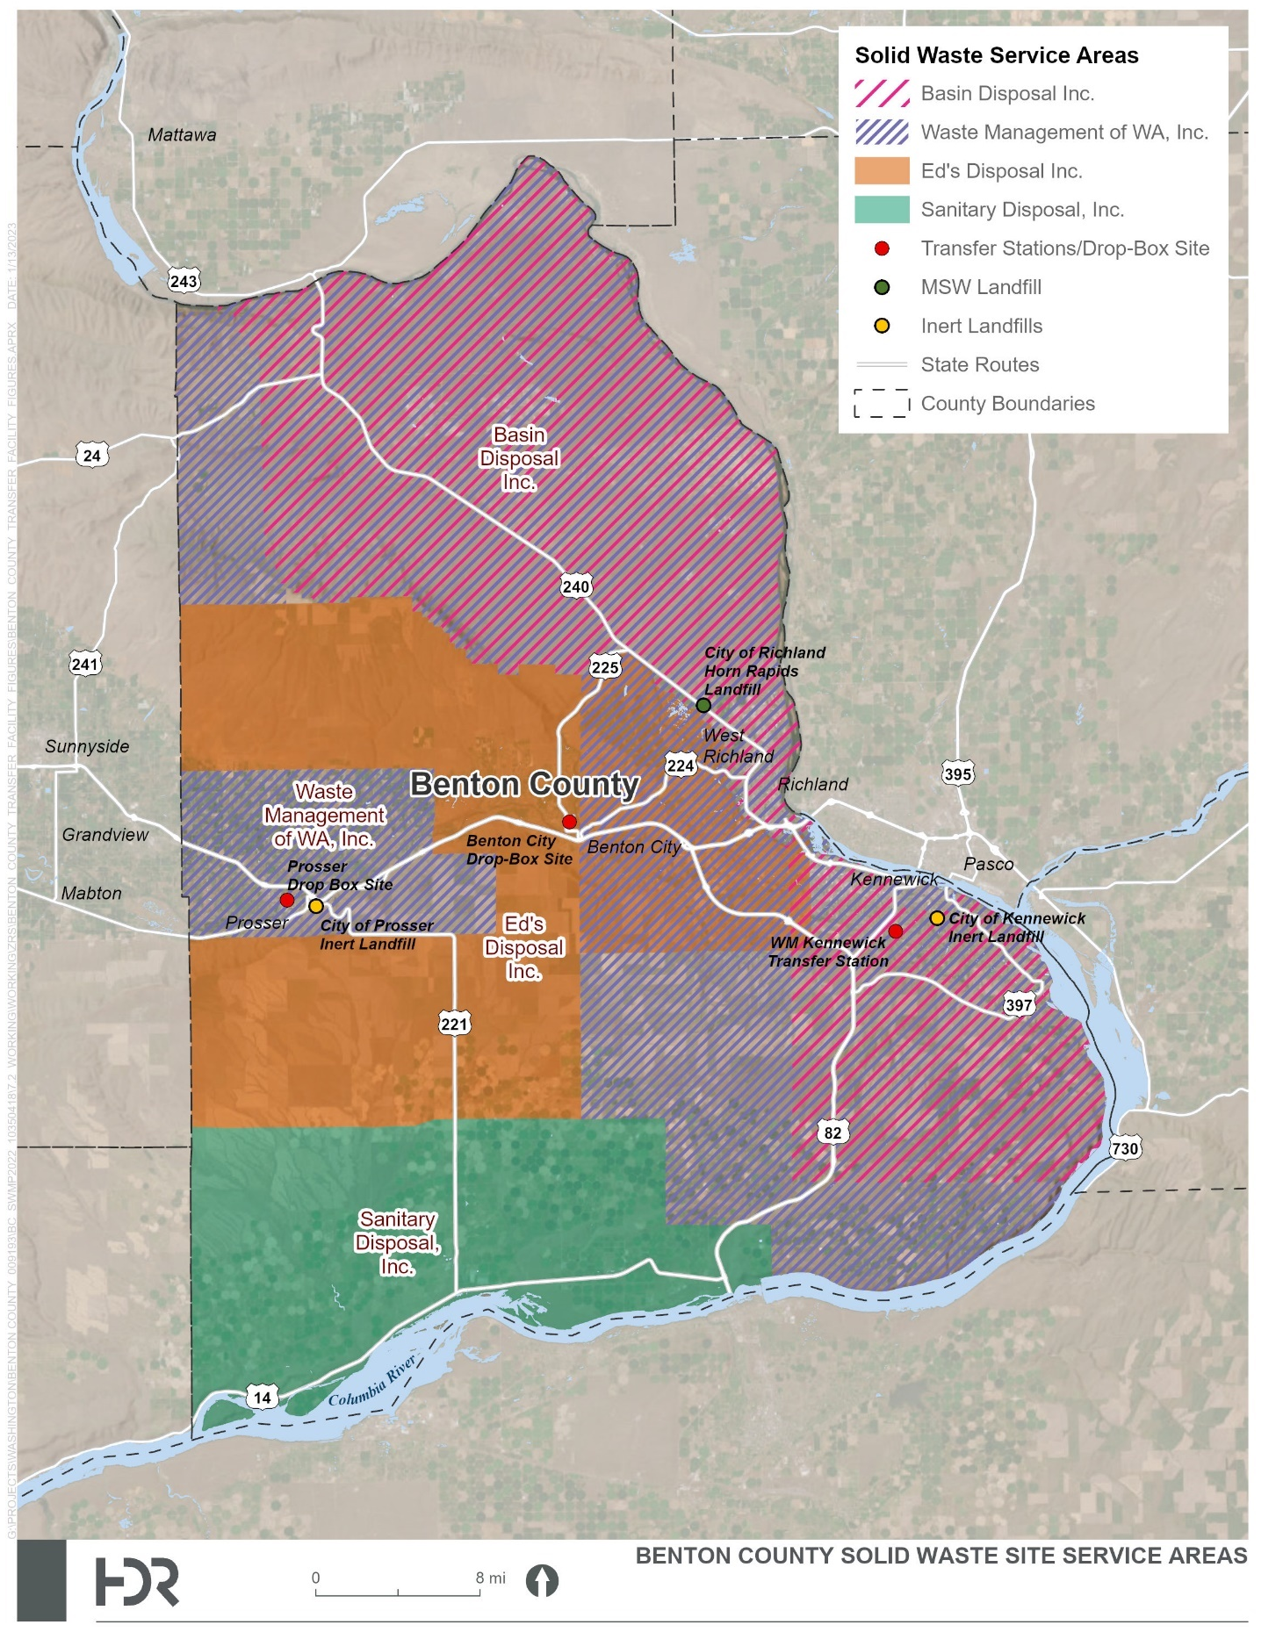
Figure 3-1. WUTC Solid Waste Certificated Collection Areas

Existing Conditions
Residential curbside waste collection is not mandatory in the unincorporated areas of Benton County, but it is mandatory within city and town limits. MSW collected curbside by Ed’s Disposal, Inc., and BDI is transported to the BDI transfer station, then long-hauled to the Finley Buttes Landfill. Morrow County, Oregon, for disposal.
MSW collected by Sanitary Disposal, Inc. is transported to their Hermiston, Oregon, transfer station, then long-hauled to the Finley Buttes Landfill for disposal.
Curbside MSW collected by WM is transported to the WM transfer station in Kennewick, compacted and hauled to the Columbia Ridge Landfill, Arlington, Oregon for disposal.
The City of Richland’s Solid Waste Division provides residential, commercial, and roll-off box collection services, which are directly disposed at the City-owned and operated Horn Rapids Landfill.
Additional information regarding waste transfer and disposal can be found in Chapter 4.0 – Waste Transfer and Disposal. More detailed information about the haulers’ service areas can be found at the WUTC’s website:
https://www.utc.wa.gov/regulated-industries/transportation/regulated-transportation-industries/solid-waste-carriers/solid-waste-service-maps-county

Waste Collection Programs
Table 3-1 lists the style of residential garbage collection, the approximate number of customers served, and the rates per household per month in Benton County.
Table 3-1. Solid Waste Collection Data (December 2022)
Municipality | Population 2021¹ | Residential Garbage Cart Size (gallons) | Collection Entity | Mandatory Service | Rate per Household per Month²
Benton City | 3,500 | 64 and 96 | Ed’s Disposal | Yes | $19.01 and $24.08
Kennewick | 84,620 | 35 and 96 | WM | Yes | $15.66 and $19.04
Prosser | 6,130 | 64 and 96 | BDI | Yes | $19.10 and $24.22
Richland | 61,320 | 96 | City of Richland | Yes | $17.50
West Richland | 17,070 | 64 and 96 | Ed’s Disposal | Yes | $19.01 and $24.08
Unincorporated | 36,760 | 64 and 96 | Ed’s Disposal | No | $19.01 and $24.08
Unincorporated | 36,760 | 64 and 96 | BDI | No | $19.10 and $24.22
Unincorporated | 36,760 | 35, 64, and 96 | WM | No | $11.30, $14.90, and $18.60
¹ Population information from Chapter 2.0 – Waste Stream, Table 2-1 Benton County Population Estimates.
² Rate per household data provided by WM, BDI, Ed’s Disposal, and City of Richland Solid Waste Department as of December 2022.

Bulky Waste Collection Service
Bulky waste collection is available on call and county-wide through each waste collection program for a fee.

Commercial Collection Service
Commercial garbage collection is mandatory in the City of Richland as outlined in Richland Municipal Code 15.01.040. Commercial garbage collection in non-mandatory in all other jurisdictions and the unincorporated areas of Benton County. Style and frequency of service as well as rates charged vary by commercial customer.

Status of Previous Recommendations
The status of the recommendations made by the 2013 Plan can be found in Appendix D.

Alternatives and Evaluations
Existing service gaps and other issues connected to the solid waste collection component of solid waste management are discussed below.

Alternatives

Solid Waste Collection
Curbside MSW collection programs appear to be operating satisfactorily in both the incorporated and unincorporated areas of the County.

Curbside Recycling
Currently, the Cities of Kennewick and Richland provide residential recyclable collection. The collection and recycling relationship is addressed in greater detail in Chapter 5.0 – Waste Reduction, Recycling, and Education and Outreach, which includes collection system alternatives to be considered to encourage responsible recycling.

Collection Contract Compliance with the Plan
To ensure that the cities’ collection contracts in the County comply with the Plan, cities could implement a contract review process. The County would provide a checklist of items to be reviewed by each city’s contract administrators to verify the collection contracts comply with the Plan. The review process could occur at the time of renewals and/or procurement.

Recommended Actions
The following recommendations are made for solid waste collection programs:
SWC1) Encourage the use of carted curbside collection services, when possible, and ensure that collection services are available to all residents.
SWC2) Review collection contracts to confirm compliance with the Plan.
SWC3) Coordinate residential and commercial curbside collection programs with recycling program recommendations as implemented.

This page intentionally left blank.

Chapter 4.0 Waste Transfer and Disposal

This page intentionally left blank.

Waste Transfer and Disposal

Introduction
This chapter discusses existing transfer facilities and disposal programs, identifies relevant planning issues, and develops alternative strategies for transfer and disposal of solid waste.

Background
This section provides an overview of Benton County’s waste disposal system, which is regulated by RCW 70A.205 Solid Waste Management, WAC 173-350 Solid Waste Handling Standards, and WAC 173-351 Criteria for Municipal Solid Waste Landfills.

State Legislation and Regulations
Ecology regulates design and operation of transfer stations and drop boxes under WAC 173-350, Solid Waste Handling Standards. Counties may site and operate transfer facilities or may contract this service to a provider. Transfer stations are required to obtain a solid waste permit from the jurisdictional health district. There is currently one privately owned and operated transfer station and two drop-box sites located in the County. Information on these transfer stations can be found in Section 4.3.1, Transfer Stations and Drop-Box Sites.
In addition, WAC 173-350, Solid Waste Handling Standards, regulates design and operation of inert landfills. These landfill facilities are required to obtain a solid waste permit from the jurisdictional health district. There are currently two publicly owned and operated inert waste landfills operating in the County. Additional information on these inert waste landfills is in Section 4.3.2, Landfills.
In Washington State, landfill design and operations are regulated under WAC 173-351; the County currently has one operating MSW landfill, the Horn Rapids Landfill, which is owned and operated by the City of Richland. Information on the Horn Rapids Landfill is in Section 4.3.2, Landfills.

Existing Conditions
Figure 4-1 shows the locations of the transfer stations and landfills in the County.

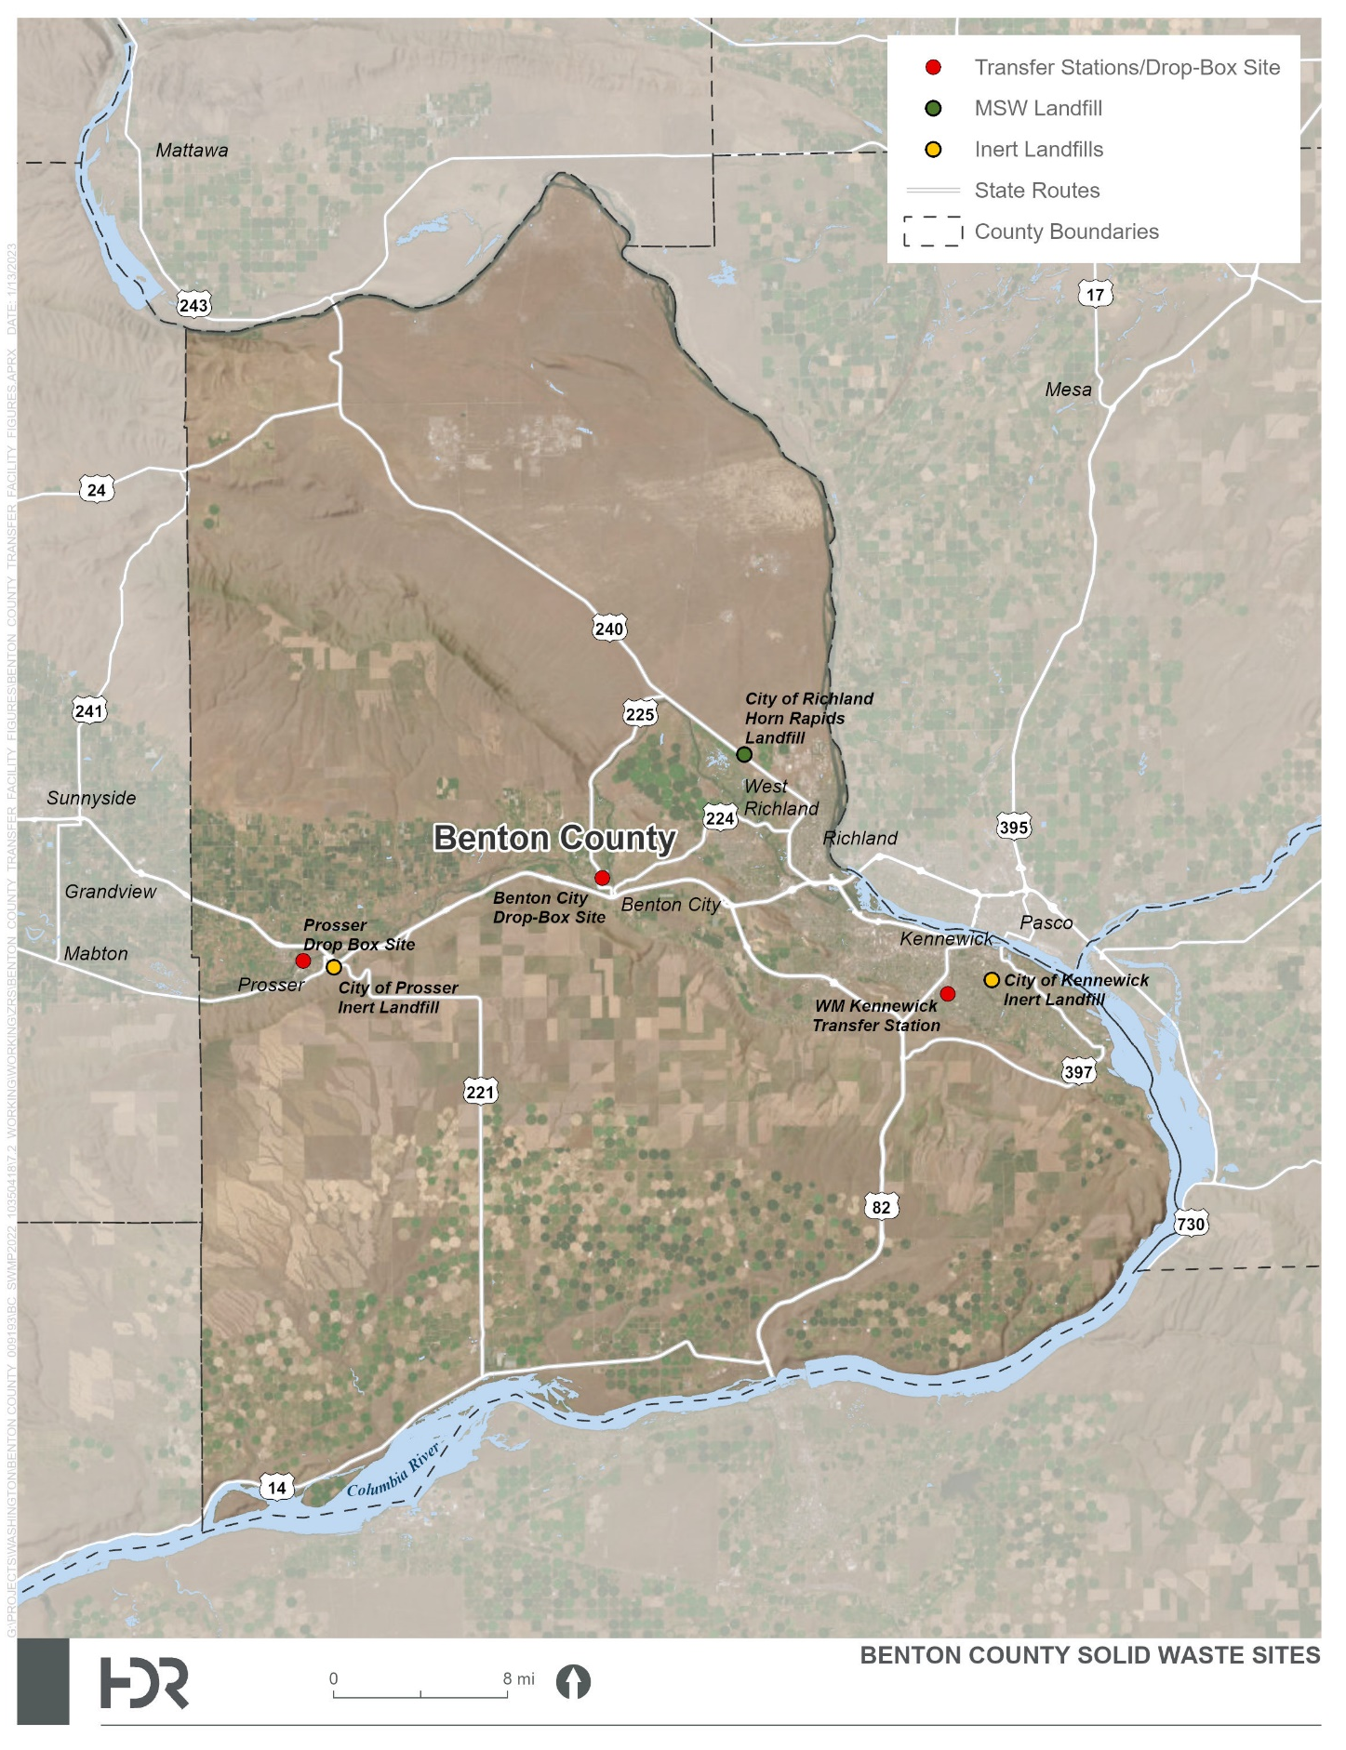
Figure 4-1. Benton County Solid Waste Facilities

Transfer Stations and Drop-Box Sites
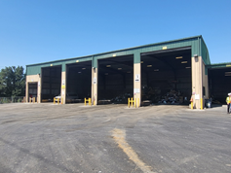
There is currently one operating transfer stations and two drop-box sites located in Benton County:
- WM Kennewick Transfer Station located at 2627 S Ely Street, Kennewick, Washington (see Figure 4-2)
- BDI Drop-Box Site located at 1605 Sherman Avenue, Prosser, Washington
Figure 4-2. WM Kennewick Transfer Station
- BDI, Drop-Box Site located at 7th Street and Dinah Lane, Benton City, Washington
Waste collected in Benton County is also transported to two transfer stations located outside Benton County:
- BDI Transfer Station located at 1721 Dietrich Road in Pasco, Washington
- Sanitary Disposal, Inc., Transfer Station located at 81144 North Highway 396, Hermiston, Oregon
County residents may also self-haul their waste directly to a transfer station or drop-box site. Table 4-1 provides tipping fees charged for each transfer station facility.

Table 4-1. Transfer Station Tipping Fees (2022)
Material Charge Type | Fee
WM Kennewick Transfer Station
Minimum Charge | $48.92 (up to 500 lbs.; $6.40 per 100 lbs. after that)
Passenger Tires (off rim)  Passenger Tires (on rim) | $23.98 (first tire), $7.32 (each additional)  $31.31 (first tire), $14.65 (each additional)
Compressor Units | $104.58 each (e.g., refrigerator, air conditioner, freezer)
Motor Oil  Cooking Oil | No Charge  No Charge
Sharps Disposal  Scrap Metal | No Charge  No Charge
Household Recyclables | No Charge
BDI Prosser Drop-Box Site
Minimum Charge | $10.00 ($18.00 disposal fee per yard)
Refrigerator/Freezer | $63.97 each
Passenger Tires (off rim)  Passenger Tires (on rim) | $5.34  $9.92
Truck Tires (off rim)  Truck Tires (on rim) | $6.87  $11.45
BDI Benton City Drop-Box Site
Minimum Charge | $10.00 ($18.00 disposal fee per yard)
Passenger Tires (off rim) | $6.50
Truck Tires (off rim) | $7.50
BDI Pasco Transfer Station
Minimum Charge | $17.00 ($80.00 disposal fee per yard)
Appliances | $12.02 each
Freon Appliances | $65 each
Passenger Tires (off rim)  Passenger Tires (on rim) | $4.00  $7.00
Truck Tires (off rim)  Truck Tires (on rim) | $5.00  $8.00
Semi Tires (off rim)  Semi Tires (on rim) | $12.00  $15.00
Animals (0–500 pounds)  Animals (500–750 pounds)  Animals (750–1,200 pounds)  Animals (>1,200 pounds) | $20.00  $60.00  $100.00  $140.00
Sanitary Disposal, Inc. Hermiston Transfer Station
Minimum Charge | $5.60 ($61.60 per ton)
Refrigerator/Freezer | $10.00 plus weight fee of $61.60 per ton
Passenger Tires (off rim)  Passenger Tires (on rim) | $1.50 plus weight fee of $61.60 per ton  $5.00 plus weight fee of $61.60 per ton
Truck Tires (off rim)  Truck Tires (on rim) | $7.00 plus weight fee of $61.60 per ton  $12.00 plus weight fee of $61.60 per ton

Landfills

Horn Rapids Landfill
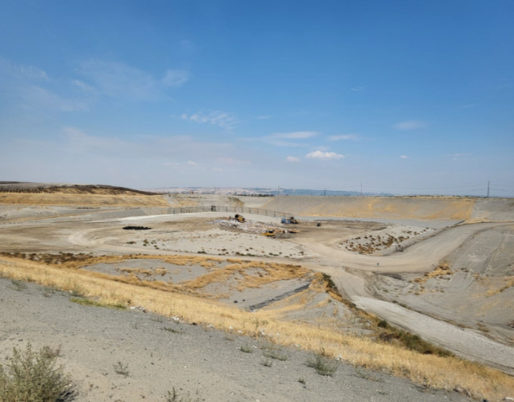
The City of Richland Horn Rapids Landfill is located at 3102 Twin Bridges Road, Richland, Washington (see Figure 4-3). The landfill was permitted and began receiving waste in 1974 within a 46-acre disposal area. The original permitted disposal area was filled and completed in 2020. Closure and post-closure work on this landfill is ongoing. The City permitted and opened a new disposal area in 2019. The new disposal area meets all current state and federal design standards and is approximately 150 acres in size. Also on the 3102 Twin Bridges, site the City has permitted and operates a 15-acre composting facility and a 14-acre customer transfer station. In 2023, the City and its private industry partners will open a renewal natural gas plant at the landfill.
Figure 4-3. City of Richland Horn Rapids Landfill

City of Prosser Inert Landfill
The City of Prosser 7.4-acre inert landfill has been in operation since 1990 and is located off Dump Road, Prosser, Washington. This landfill is not open to the general public and is used only by the City of Prosser Public Works Department. The site accepts street sweepings, dirt and rocks generated from City projects, and broken concrete/asphalt. Operation is permitted and regulated by the Health District.

City of Kennewick Inert Landfill
The City of Kennewick inert landfill is utilized for the diversion of street sweepings, dirt and rock deemed clean enough to be landfilled, and waste collected from the storm water system. This landfill is not open to the general public. The testing, handling, and disposal requirements for this facility are found in their permit and operations plan. Operation is permitted and regulated by the Health District.

Waste Import and Export

Waste Import
“Waste import” refers to transfer of waste into Benton County from other areas. Some waste entering the County comes from neighboring Franklin County residents bringing materials to the Horn Rapids Landfill in Richland. This is assumed to be a very small amount of waste and is not tracked independently of regular residential waste brought to the landfill. Periodically, Yakima County residents may use the Prosser Transfer Station Facility, particularly during Prosser Cleanup Days. Due to the WSDA quarantine for Japanese Beetle in the southeastern portion of Yakima County and the southwestern portion of Benton County, yard debris from these areas is not accepted.

Waste Export
“Waste export” refers to the transfer of waste from Benton County to a landfill or transfer station located outside the area. Waste Management of Kennewick; Ed’s Disposal, Inc.; BDI of Pasco; and Sanitary Disposal, Inc., of Hermiston provide for the collection of solid waste and the export of waste out of the County for disposal. Information on this service is provided below.

Waste Management
Currently, WM is under contract with the City of Kennewick, and under a WUTC franchise certificate for portions of unincorporated Benton County, for the collection and disposal of solid waste. Waste collected by WM is transported to its transfer station in Kennewick, compacted into containers, and transported to the WM Columbia Ridge Landfill in Arlington, Oregon.

Ed’s Disposal, Inc.
Ed’s Disposal, Inc., of Pasco collects waste from unincorporated areas of Benton County and the cities of West Richland and Benton City. The waste is brought to the BDI Transfer Station in Pasco and hauled to the Waste Connections’ Finley Buttes Landfill in Morrow County, Oregon, for final disposal.

Basin Disposal, Inc.
BDI of Pasco collects waste in unincorporated areas of Benton County and the City of Prosser. Waste collected by BDI is brought to the BDI transfer station in Pasco and is long-hauled to the Waste Connections’ Finley Buttes Landfill facility for final disposal.

Sanitary Disposal, Inc.
Sanitary Disposal, Inc., collects waste from unincorporated areas in the southern portion of Benton County. Waste collected in this section of the County is transported to Sanitary Disposal’s transfer station in Umatilla County, Oregon, near City of Hermiston and is then long-hauled to the Waste Connections’ Finley Buttes Regional Landfill in Morrow County, Oregon.
Additional information on waste collection can be found in Chapter 3.0 – Solid Waste Collection.
Currently, all landfills utilized for waste disposal have sufficient capacity to dispose of waste collected in Benton County during this planning period.
As discussed previously, in order for a Washington municipality of 4,000 or more people to import waste into Oregon, or for a city to export more than 75,000 tons of waste per year into Oregon, the municipality must have a certified recycling program according to Oregon law. See Chapter 5.0 – Waste Reduction, Recycling, and Education and Outreach for more information about recycling in Benton County and compliance with Oregon law.

Status of Previous Recommendations
The status of the recommendations made by the 2013 Plan can be found in Appendix D.

Alternatives and Evaluations
No existing service gaps and other issues connected to the waste transfer and disposal component of solid waste management in Benton County were identified. Additional detail is provided for the transfer and disposal facilities below.

Transfer Station and Drop-Box Facilities
The projected Benton County population in 2040 is 250,524 people. Using a calculated waste generation rate of 9.26 pounds per person per day, estimated waste generation in Benton County in 2040 will be approximately 1,052 tons per day. The existing transfer station and drop-box facilities utilized for Benton County waste transfer have sufficient capacity to accommodate the tonnages received. Implementation of additional waste reduction and recycling strategies could assist in maintaining transfer capacity to handle waste over this planning period. Additional information on waste reduction and recycling strategies can be found in Chapter 5.0 – Waste Reduction, Recycling, and Education and Outreach.

Landfill Facilities
The MSW and inert landfill facilities currently utilized for disposal of Benton County waste have sufficient capacity to handle the current and projected waste streams. Due to the costs of siting, permitting, constructing, and operating a new MSW landfill in Benton County, waste should continue to be disposed of as recommended during this planning period.

Recommended Actions
The following recommendations are being made for waste transfer and disposal:
WTD1) The County should monitor population growth and tonnage projections to ensure that capacity for waste transfer and disposal continues to be adequate for the waste handling and disposal needs of County residents.

This page intentionally left blank.

Chapter 5.0 waste reduction, recycling, and education and outreach

This page intentionally left blank.

Waste Reduction, Recycling, and Education and Outreach
This chapter discusses existing waste reduction, reuse, and recycling programs, and the Contamination Reduction and Outreach Plan (CROP) and identifies relevant planning issues to meet local and state goals and develops and evaluates alternative strategies.

Background
This section provides information on the regulations and authorities that govern waste reduction, recycling, organics, and climate change programs and issues.

Waste Reduction and Recycling
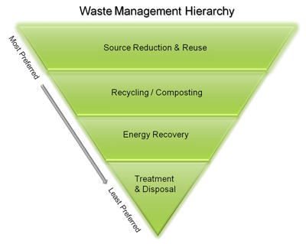
Chapter 5.0 provides an update of Benton County’s methods to divert waste away from landfill disposal and to comply with Washington State requirements and the EPA Waste Hierarchy in Figure 5-1 regarding waste reduction and recycling opportunities and programs. The state’s requirements are based on the “Waste Not Washington Act” (ESHB 1671), which declared that waste reduction and recycling must become a fundamental strategy for solid waste management in Washington State. This law is reflected in various sections of the Revised Code of Washington and Washington Administrative Code. RCW 70A.205 includes the following goals (among others) and requires that solid waste management plans demonstrate how these goals will be met:
Figure 5-1. EPA Waste Hierarchy
- Washington State is to achieve a statewide recycling rate of 50 percent. Ecology conducts waste composition studies and recycling surveys on an annual basis to track achievement of waste reduction and recycling goals. Ecology currently emphasizes waste generation as its primary measurement as this is a more accurate way to assess if Washington residents and businesses are truly reducing waste.
- Source separation of waste (at a minimum, separation into recyclable and non-recyclable fractions) must be a fundamental strategy of solid waste management.
- Steps should be taken to make recycling at least as affordable and convenient to the ratepayer as disposal of mixed solid waste.
Other applicable state requirements are as follows:
- Establish programs for the collection of source-separated materials from residences in urban and rural areas. In rural areas, these programs shall include, but not be limited to, drop-off boxes, buy-back centers, or a combination of both, at each solid waste transfer, processing, or disposal site, or at locations convenient to the residents. The drop-off boxes and buy-back centers may be owned or operated by the public, a nonprofit, or a private company or person.
- Establish programs to educate and promote concepts of waste reduction and recycling.
- Develop clear criteria for designating areas as urban or rural for the purpose of providing solid waste and recycling services (RCW 70A.205.050).
- Monitor the collection of source-separated waste from non-residential sources when there is sufficient density to economically sustain a commercial collection program. Planning guidelines can include criteria such as anticipated recovery rates and levels of public participation, availability of environmentally sound disposal capacity, access to markets for recyclable materials, unreasonable cost impacts on the ratepayer, utilization of environmentally sound waste reduction and recycling technologies, and other factors as appropriate (RCW 70A.205.045).
RCW 70A.205.050 also requires that counties develop clear criteria for designating areas as urban or rural for the purpose of providing solid waste and recycling services. RCW 70A.205.045 requires recyclables to be collected from homes and apartments in urban areas (with some exceptions), whereas drop-off centers and other methods can be used in rural areas.
RCW 70A.205 requires a monitoring program for collection of source-separated waste from non-residential sources when there is sufficient density to economically sustain a commercial collection program. Benton County achieves this by working cooperatively with Ecology and using the data Ecology collects through the annual Washington State Recycling Survey.
In addition, public education and outreach is an important element for solid waste management systems. County residents and businesses need to be informed as to the proper and available methods for waste reduction, disposal, and recycling. The programs described in this chapter encourage residents and businesses to take the extra steps to recycle or reduce waste or to avoid generating waste in the first place.

CROP
HB 1543, Sustainable Recycling, was signed on April 29, 2019, and took effect July 1, 2019. The act required Ecology to create a state recycling CROP by July 1, 2020, with local jurisdictions required to either create their own CROP or adopt the state CROP by July 1, 2021. The County has chosen to create their own CROP as part of this Plan.
RCW 70A.205.045 stipulates the requirements to be included in a CROP as follows:
- A list of actions for reduction of contamination in recycling programs for single-family and multi-family residences, commercial locations, and drop boxes.
- A list of key contaminants identified by the jurisdiction or Ecology.
- A discussion of problem contaminants and the contaminants’ impacts on the collection system.
- An analysis of the costs and other impacts associated with contaminants to the recycling system.
- An implementation schedule and details of how outreach is to be conducted, which may include sharing community-wide messaging through newsletters, articles, mailers, social media, websites, or community events; informing recycling drop-box customers about contamination; direct outreach through route collection drivers; and improving signage.

Climate Action
The County updated the Hazard Mitigation Plan in 2019 with the goal to make County residents, communities, state agencies, local governments, and businesses less vulnerable to the effects of hazards through the effective administration of hazard mitigation grant programs, hazard risk assessments, wise and efficient infrastructure hardening, and a coordinated approach to mitigation policy through federal, state, regional, and local planning efforts. The combined prioritization will be the protection of people, structures, infrastructure, and unique ecosystems that contribute to our way of life and the sustainability of the local and regional economy. Additional information on this plan can be found at:
https://www.co.benton.wa.us/files/documents/FinalCPAppendixNBentonCountyNaturalHazardMitigationPlan2019129055838061620PM.pdf
The City of Kennewick also has a sustainability program with a mission to proactively make sustainability decisions as good stewards of the public and consider the long-term effects of business practices and how those decisions affect our citizens and the environment. Additional information on this program can be found at:
Sustainability | Kennewick, WA (go2kennewick.com)
The Benton-Franklin Health District has created two new full-time positions to address the health effects caused by climate change. Staff will focus initially on protecting the community from wildfire smoke, extreme heat conditions, and toxic algae in the Columbia River. In addition, two new staff members are devoted to emergency preparedness to assist with extreme weather conditions exacerbated by climate change.

Existing Program Elements
The following sections provide background information regarding waste reduction, recycling, and education and outreach and discuss the County’s existing programs.

Recycling Services
The County, cities and towns, and waste collection companies provide numerous drop-off recycling sites throughout the County. Current sites are detailed in Table 5-1.

Table 5-1. Recycling Operations in Benton County (2022)
Recycler Facility and Location | Type | Hours of Operation | Paper (including grocery bags) | Plastic | Metal |  |  | Other Recycling Facilities
City of Richland
1378 Lee Boulevard | Drop box | 24 hours | X | X | X
1300 Block of Jadwin Avenue | Drop box | 24 hours | X | X | X
2411 George Washington Way | Drop box | 24 hours | X | X | X
Battelle Complex | Drop box | 24 hours | X | X | X
2400 Stevens Drive | Drop box | 24 hours | X | X | X
3120 Twin Bridges Road | Drop box | 24 hours | X | X | X
103 Keene Road | Drop box | 24 hours | X | X | X
2801 Duportail Street | Drop box | 24 hours | X | X | X
DTG Recycling Center: 1936 Saint Street | Drop box | Call for Information |  |  |  |  |  | X
Local Boys Metal Recycling: 510 Wellsian Way | Drop box | Call for Information |  |  | X
City of Kennewick
McDonalds: 395 Kennewick | Drop box | 24 hours | X | X | X
WM: 2027 S. Ely Road | Drop box | 24 hours | X | X | X
DTG Recycling Center: 119 E Albany Avenue | Drop box | Call for Information |  |  |  |  |  | X
Pacific Recycling: 1615 E Chemical Drive | Drop box | Call for Information |  |  |  |  |  | X
City of West Richland
3957 W Van Giesen Street | Drop box | 24 hours | X | X | X
City of Prosser
10th Street and Sherman Avenue | Drop off | 9:00 am–5:00 pm Wednesday Friday and Saturday 24 hours | X | X | X
8th Street and Bennett Avenue | Drop off | 24 hours | X | X | X
Mayflower Metals: 139406 W Johnson Road | Drop box | 8:30 am–4:30 pm M–F |  |  | X
Benton City
Home Drive (SR-225) | Drop box | Call for Information | X | X | X
100 Dyna Lane | Drop box | Call for Information | X | X |  | X

Waste Reduction and Reuse
Waste reduction is the highest priority for solid waste management according to RCW 70A.205 and is preferred over recycling and composting because the social, environmental, and economic costs are typically lower for avoiding the creation of waste.
Waste collection fees can be used to encourage waste reduction (and recycling) through existing “pay as you throw” rates in which single-family households are charged according to the amount of garbage they discard. Businesses and multifamily properties are generally charged according to the amount of garbage disposed. The opportunity for customers to financially reduce disposal costs is first and foremost to not acquire the item with its associated packaging in the first place.
Other opportunities for reuse and waste reduction that are available in the County include a non-profit Habitat for Humanity reuse store for building materials and organizations such as the Salvation Army and Goodwill that accept gently used clothes, furniture, and home goods. The County also has numerous local thrift and donation stores for reuse of clothing and household goods.

Public Education
Public education and outreach programs supporting waste reduction, recycling, and organics management activities have been ongoing in the County. Local governments and waste collection companies have developed programs on a variety of topics. Education efforts are described below.

Benton County
The County provides information on its website and its County Event Posting page about the location of drop-off and buy-back sites for recyclables, as well as ways to reduce and reuse materials, the proper disposal of household hazardous waste, the Washington E-Cycle Program, used motor oil collection sites, and disposal of medical waste. The County purchases and maintains recycling containers that are available to public events for free upon request. The County also provides outreach on all its programs at a booth at the County Fair and information to high schools on paper recycling, as well as support to the Benton-Franklin Cooperative Extension office’s composting seminars.

City of Richland
The City’s Communications and Marketing Division provides information to the public about various environmental issues affecting the City or community through their website. Information is regularly sent to the public in newsletters, utility bill inserts, press releases to radio and television, e-newsletters, and other printed publications (including the local newspaper). The Green Living Office also has a number of environmental resources available to the public, including books, curriculum, handouts, and videos. Programs and presentations relating to the environment also are made available to service organizations, businesses, non-profit organizations, and students/schools.
The City’s website and social media outlets include information on how to recycle in Richland and the materials that are accepted through various programs. The City of Richland has a 24-hour government access channel (CityView, Channel 13), which regularly plays environmentally related videos during the “Eye on our Earth” segment and runs public service announcements. The City has an Electronic Reader Board with waste reduction and recycling information uploaded for motorists to see.

City of Kennewick
Each new Kennewick resident and business is mailed a brochure outlining the City’s existing recycling programs in coordination with Waste Management. The City provides curbside and drop-box recycling information on its website and partners with local Master Gardeners to offer backyard composting workshops. The City’s website provides information on allowable items for curbside services, additional recycling locations and links for hazardous waste recycling options.
The City has multiple social media outlets that share information from partner organizations to include Household Hazardous Waste Collection Events and Free Tire Recycling day for mosquito control.
In addition, WM provides information for the City of Kennewick collections through their website:
https://www.wmnorthwest.com/kennewick/
The City of Kennewick contracts with WM for solid waste and recycling collection services, education, and outreach. WM distributes an annual service guide to each residential customer and new customers, has a locally designated website and a WM Kennewick Facebook page focused on sustainability. The WM team annually participates in the Salmon Summit teaching about recycling and sustainability to thousands of school students in addition to supporting National Night Out, Earth Day and similar events. WM also worked with Blippi on a Garbage Trucks for Children video. The WM website also contains information about WM Recycling Centers, Transfer Stations and Landfills. In addition, WM also provides tools and resources for kids, households and businesses that are available.

Designation of Recyclable Materials
Table 5-2 shows the list of “designated recyclable materials” required by WAC 173-350, which should be used for guidance as to the materials to be recycled. This list is based on existing conditions (collection programs and markets), so future markets and technologies may warrant changes in this list. Because market conditions for recyclables can change rapidly, the list of designated materials is accompanied by a description of the process for its revision, if needed, before the next major Plan update.
This list is not intended to create a requirement that recycling programs in the County collect every designated material. Instead, the intent is that if materials become feasible for recycling, the County will review the feasibility of collection in respect to markets, ease of collection, size of waste stream, special events, or removal of collection limitations and consider programs for collection so that residents and businesses have an opportunity to recycle the designated materials listed through at least one program.
Table 5-2. List of Designated Recyclable Materials
Priority Level | Material
Routine Collection: Materials feasible to be collected by curbside collection and drop-off programs throughout Benton County. | - Aluminum Can  - Cardboard (Corrugated)  - HDPE Plastics (Milk Jugs)  - High-Grade Paper  - Mixed Paper (Loose)  - Newspaper  - PET Plastics (Soda and Juice Bottles)  - Tin Cans
Limited Collection: Materials that can be recycled but have collection or marketing limitations in Benton County. | - Electronics covered by E-Cycle Washington  - Mercury-Containing Lights covered by LightRecycle Washington  - Textiles  - Organics  - Wood Waste  - Cell Phones  - Ink Cartridges  - Motor Oil  - Antifreeze  - Tires  - Vehicle Batteries  - Ferrous Metals  - Non-Ferrous Metals  - Latex Paint
Potentially Recyclable: Hard-to-recycle materials that could be recycled if markets are available or customer charges are assessed. | - Mattresses  - Plastics, #3 through #7  - Plastic Containers (Non-Bottle)  - Plastic Film  - Poly-Coated Paper  - Food Waste  - Glass

The following conditions are grounds for additions to or deletions from the priority-level list of designated materials:
- The market price for an existing material becomes so low that it is no longer feasible to collect, process, or transport it to markets.
- Local markets or brokers expand their list of acceptable items based on new uses for materials or technologies that increase demand.
- New local or regional processing or demand for a particular material develops.
- No market can be found for an existing recyclable material, causing the material to be stockpiled with no apparent solution in the near future.
- The potential for increased amounts of diversion.
- Legislative mandate.
- Other conditions not anticipated at this time.
Proposed changes to the list of designated materials should be submitted to the County Public Works Director for review and may be forwarded to the SWAC for concurrence. Unless there are objections from the SWAC, the County Public Works Director or their designee can make minor changes to the list. These will be adopted depending on the schedule of SWAC meetings without formally amending the Plan. Should the Public Works Director conclude that the proposed change is a “major change” (what constitutes a “major change” is expected to be self-evident at the time, although criteria such as opposition by the SWAC or difficulty in achieving consensus for adoption could be used as indicators), then an amendment to the Plan (a process that could take 120 days or longer to complete) would be necessary. In either case, Ecology should be notified of changes made to the List of Designated Recyclable Materials or of the initiation of an amendment process.

Urban and Rural Area Residential Recycling
RCW 70A.205 requires counties to develop clear criteria for designating areas as urban or rural for the purpose of providing solid waste and recycling services. RCW 70A.205 requires recyclables to be collected from homes and apartments in urban areas (with some exceptions), whereas drop-off centers and other methods can be used in rural areas. According to the Washington State OFM, a “rural county” is defined as “…a county with a population density less than 100 persons per square mile.”
Currently, curbside residential recycling service is provided in the City of Kennewick and the City of Richland. The cities of Benton City, Prosser, and West Richland and the unincorporated areas of the County are serviced by residential recycling drop-boxes. Recycling drop-box locations can be found in Table 5-1.

Commercial Recycling
Commercial-sector recycling is available in the County and is provided by collection companies operating within each city and town and the unincorporated areas.

Public Event Recycling
RCW 70A.200.100 requires public event recycling in communities where there is an established curbside service and where recycling service is available to businesses. A recycling program must be provided at every official gathering and at every sports facility by vendors who sell beverages in single-use aluminum, glass, or plastic bottles or cans. A recycling program includes provision of receptacles or reverse vending machines, and provisions to transport and recycle the collected materials. Facility managers or event coordinators may choose to work with vendors to coordinate the recycling program. The recycling receptacles or reverse vending machines must be clearly marked and must be provided for the aluminum, glass, or plastic bottles or cans that contain the beverages sold by the vendor.
Public event recycling is provided by the solid waste collection companies operating within the County.

Incentives for Recycling
As previously discussed in Section 5.2.1, recycling bins are located at multiple locations throughout the County as an incentive and opportunity to recycle. Additional recycling opportunities can enable residents and businesses to reduce their garbage service volumes and lower their garbage collection fees in cities with “pay-as-you-throw” price models.

Monitoring and Evaluation
The County relies on Ecology for information on recycled quantities and an estimate of the countywide recycling rate. Annual figures for recycled tonnages are reported on a voluntary basis by both public- and private-sector entities.

Processing Facilities
The private sector handles the processing of the materials collected for recycling in the following ways:
- There are private facilities that process specific waste streams, such as DTG Recycling (DTG), Pacific Recycling, Local Boys Metal Recycling, and Mayflower Metals.
- Recyclables collected at the curb and drop-box sites by WM are currently transported to an out-of-County facility for processing and marketing (WM SMaRT Recycling Center in Spokane).
- Recyclables collected by Basin Disposal and Ed’s Disposal are taken to their Pasco facility located at 1721 Dietrich Road for processing and marketing.
- Recyclable materials collected in the City of Richland are processed by DTG under terms of a contract with the City.

Markets
Washington State regulations (RCW 70A.205.045) require “a description of markets for recyclables,” which is provided below. This description is intended to be only a brief report of current conditions, and it should be noted that market conditions for recyclables can change drastically and rapidly.

Market Overview
In July 2017, China's government announced that it would ban 24 recyclables, including "unsorted mixed paper" and "mixed plastics," starting in 2018. This ban originates from China's "National Sword" campaign to crack down on smuggling and contaminated scrap imports.
China applied a strict new contamination standard for other recyclables. Starting in March 2018, scrap materials imported into China may not exceed 0.5 percent contamination. This is below typical processing standards of 3-5 percent at Washington recycling facilities, and it risks excluding domestic recyclables from sale in China.
With a few exceptions, China has frozen the approval of scrap paper import permits. As a result, most scrap paper companies cannot import any scrap paper into China, causing a total suspension of imports since September 2017. This has created market uncertainty, even for materials not covered by the restrictions.
In 2018, China's government implemented new restrictions on what recyclables may be imported into the country, significantly impacting Washington’s recycling programs. China was a major buyer of Washington’s recyclables.
China no longer allows the importation of low-grade plastics and unsorted paper. The regulations aim to increase the quality of recyclables entering China by requiring a low amount of contamination in the recyclables it imports.
The import ban is creating a major disruption in Washington and throughout the region. Material recovery facilities in Washington, which receive mixed recyclables and sort them for resale to commodities brokers, have been slowing down their processing of recyclable materials in an attempt to reduce contamination. This slowdown has reduced the amount of material that can be processed. The amount of material collected in Washington currently exceeds the processing capacity at these slower processing rates. In the short term, some materials may not be able to be processed, and recyclable materials may need to be disposed of as MSW.
An important factor for marketing of recyclable materials collected in the County is the cost of transporting them to end-markets, some of which are outside of Washington State. The low market value of many recyclable materials limits the number of materials that can be cost-effectively moved to markets. Primary markets for specific materials and comments on factors that affect them are shown in Table 5-3.
As the markets continue to change, new facilities are being proposed locally to handle commodities. In 2019, Norpac, which is located in Longview, Washington, pledged to bring in an additional 400,000 tons per year of recycled paper as it shifts one-third of its production capacity into packaging production. This expansion was completed in 2022, at a cost of $50 million in new equipment, creating 100 new jobs. This project is predicted to have the ability to consume available mixed paper grades in Washington, Oregon, and Idaho.
WM has also continued its long-standing commitment to Washington communities and business through advancing recycling technology in the state. The SMaRT Center in Spokane will receive $15 million in upgrades in 2023/2023. This facility currently accepts all collected recyclable materials in Kennewick. In addition, WM is remodeling their transfer station, in Kennewick, to accommodate recycling route trucks for transload and direct haul to the SMaRT Center.
Markets for recyclables are volatile and affect commodities that are able to be collected and processed for recycling. Primary markets for specific materials and comments on factors that affect them as of December 2022 are presented in Table 5-3. Ecology also provides recycling market data that is updated every 2 months and available at the following link:
https://app.box.com/s/kzy7vdio1vv4tab5zzewl8t5xghwzdm3

Table 5-3. Markets for Recyclable Materials (as of December 2022)
Material | Primary Market(s) | Comments
Paper
Cardboard | Regional paper markets, paper mills, and export | The markets for cardboard (used in packaging) have recently been improving and may be stabilizing.
Mixed Paper and Newspaper | Regional paper markets, paper mills, and export | The markets are fluctuating due to supply and demand from overseas markets and processors and are primarily low at this time.
Plastics
Bottles #1 through #7 | Regional markets in Western Washington and Oregon, and export | The markets for PET and HDPE bottles are currently weak to non-existent (#1 and #2), and even weaker for bottles #3 through #7.
Other Plastics | Primarily export | Markets are volatile and sometimes unreliable.
Metals
Aluminum | Regional markets in Western Washington and Oregon; can manufacturing in St. Louis | Aluminum prices were weak in 2022.
Tin Cans, Appliances, and Ferrous and Non-ferrous Scrap | Regional markets in Western Washington and Oregon | Steel has fluctuated heavily, and the market is currently weak.
Glass
Clear Glass | Regional markets in Western Washington and Oregon | Prices are poor for clear glass.
Brown and Green Glass | Regional markets in Western Washington and Oregon | Prices for brown and green glass are low or negative (i.e., the glass is recycled for a charge).

Addressing Recyclables Key Contaminants
The following is the initial list of key contaminants to be addressed in the current recyclables as required by RCW 70A.205.045 CROP:
- Plastic bags, film, and clamshells
- Non-program plastics
- Food and liquids
- Hose, wire, and rope (tanglers)
- Textiles and toys
Additional contaminants also to be addressed include:
- Hazardous materials
- Hypodermic needles
Contamination in recyclables is best addressed through a variety of means and actions, to include:
- Visual inspections of self-haul loads of recyclables delivered to the drop-box locations and advising customers of proper segregation techniques.
- Visual inspections of curbside recyclables collected, with customers advised of proper segregation techniques.
- Updated signage at the drop-box locations to advise system users on contamination in commodities and acceptable recyclable materials.
- Cooperation between the County, cities, and waste collection companies to implement a coordinated County-wide messaging campaign.
Costs for contaminants in the recycling system are currently covered through curbside fees for collection assessed to users, commodity pricing for recyclables, and tipping fees charged at the disposal facilities. Implementation costs for the CROP are discussed in Chapter 11.0 – Implementation Plan.

Status of Previous Recommendations
The status of the recommendations made in the 2013 Plan can be found in Appendix D.

Alternatives and Evaluations
Existing service gaps and other issues connected to waste reduction, recycling, contamination reduction, and climate change are evaluated below.

Refresh Educational Materials and Seek to Harmonize Messaging
Education and outreach initiatives have greater impact if messaging is consistent throughout the County. To achieve this, County staff can coordinate between departments and with cities and waste collection companies to unify their messaging on waste prevention, recycling, contamination reduction, private recycling options, and extended producer responsibility options. Harmonization can involve:
- Standardizing a list of accepted materials.
- Setting similar priorities for education objectives in terms of material and content.
- Maintaining consistency in labeling, use of picture-based icons, color coding, and—when applicable—translations for bin decals and signage.
- Communicating across agencies (e.g., with the Health District) to jointly work on overlapping objectives (e.g., moderate risk waste).
Unified messaging includes using one set of materials (e.g., decals, flyers, brochures, pamphlets, mailings), which can be co-branded or individually branded by the agency or collection company distributing them.
County staff can also review and selectively refresh its large library of existing materials or create new materials to reflect priority recycling and composting topics; objectives around waste reduction; recycling contamination reduction; and key littering, illegal dumping, and moderate risk waste issues. Building on materials and resources—such as for open-source photos for recyclables—from other jurisdictions and organizations can be cost-effective. For example, Ecology offers a Recycle Right toolkit, and The Recycling Partnership offers free images for signage.
Unified messaging materials can be tailored to specific generator types with relevant resources according to the specific challenges presented to the group (such as food waste prevention, reducing contamination in recyclables, edible food recovery, and composting for grocery and food-service businesses).
When feasible, all materials should also have translated versions. Adapting already-translated external resources, with permission, or partnering with nearby cities and counties could be a cost-effective way of obtaining translated informational material.

Distribute Informational Mailings to Households and Businesses
Annual mailings (electronic) could be sent to all households and businesses, potentially in partnership with the certificated hauler. These mailings should have easy-to-follow general information about what, how, where, and when to recycle and compost. For easy access, the mailings should include a collection calendar (when recycling or composting is not collected every time garbage is collected); highly visual lists of materials accepted for recycling and composting; and links to online resources with additional waste prevention, recycling, and composting information.
Periodically as needed, County staff could also distribute special mailings on specific topics or tailored to specific audiences. Examples include, but are not limited to, the following:
- Preventing food waste and donating edible food.
- Increasing recovery of materials with low capture rates, such as food waste (residents and businesses), mixed paper (residents and businesses), cardboard (businesses and self-haul), clean wood (self-haul), and metals (self-haul).
- Minimizing contamination by keeping specific problematic materials out of recycling and compost containers and drop boxes.
- Minimizing C&D debris through building material reuse, salvaging, and deconstructing and recycling unavoidable C&D debris.
- Properly disposing of and using safer alternatives to hazardous household and moderate-risk waste products.
- Minimizing littering and illegal dumping through information about the “Secure Your Load” state regulation and disposal opportunities.
- Education on emerging technologies for materials.

Update and Expand on Digital Education Through Websites, Social Media, and Newsletters
County staff’s efforts to reach younger or more digitally inclined groups can include updating existing digital materials and expanding on digital education campaigns through social media, the County website, and email newsletter subscriptions. At a minimum, the County should refresh its website to remove outdated information, add updated information, make it more visual, and make it easier for different types of users (e.g., single-family residents, multifamily tenants, multifamily property managers, businesses, and self-haulers) to find all the information related to them.
The website should include information on what, where, and how to recycle and compost and on how to reduce waste generation. The County website can add depth and details to brief informational mailings on recycling, contamination reduction, composting, hazardous waste, food waste prevention, C&D, and littering and illegal dumping. For instance, a digital campaign for C&D may emphasize the value of reusing building material and reducing C&D waste. The County website can then include a list of building material reuse options with relevant links, tips from green building organizations on reducing waste during construction, and directories of recycling providers. The website can provide user-friendly databases that inform C&D self-haulers on how to separate and prepare specific materials.
Social media campaigns are a low-cost supplement to other education and outreach efforts and can build on free resources provided by organizations such as the social media toolkit from The Recycling Partnership. This toolkit provides a schedule for various content, including text and images to align with seasons and holidays, throughout the year. Social media campaigns also offer flexibility in topics that can be covered, including promoting upcoming events and addressing seasonal or emerging issues (such as backyard composting in spring or collection schedule changes during weather events).
An important consideration when using social media, newsletters, or blogs is that individual posts and articles about a small subset of products can lead to an overload of unorganized information. If adopted, these digital methods should direct users to resources on the County website, so they should be organized and easy to find by residents and businesses later.

Conduct New Waste Prevention Campaigns
County staff could conduct additional waste prevention campaigns on materials such as clothing and reusable cups and food containers.
Clothing waste prevention campaigns can address purchasing (buying less, second-hand, and/or higher quality clothing) as well as caring for and repairing clothing to extend its lifespan. A campaign could also include organizing repair events for clothing as well as other household products. To develop this campaign, County staff could build on resources from King County, Snohomish County and Spokane County in Washington, and the Oregon Department of Environmental Quality.
Many coffee shops allow customers to bring their own cups, and Washington’s Department of Health is in the process of adopting new provisions allowing customers to bring their own refillable containers to certain businesses for bulk items. A campaign by County staff could include promotions on social media and at participating businesses as well as outreach during business technical assistance on allowing customers to bring their own containers.

Facilitate Business Material Exchanges
The County and signatory cities could promote or financially support forums or other methods to facilitate regional business material exchanges (such as the IMEX program in King County available at www.hazwastehelp.org/imex). Such programs help businesses find and connect to markets for surplus materials and items that might otherwise become waste.

Promote Existing Reuse Programs
The County and signatory cities could promote and support expansion of existing reuse and material exchange opportunities in the County, such as the Habitat for Humanity Store and local reuse and donation stores. Residential options include providing information on reuse organizations or supporting reuse events focused on specific products (such as bike swaps). Promotion could involve maintaining and publishing a resource guide in local newspapers, a stand-alone guide with a map, or a web page listing organizations that promote waste reduction activities such as thrift shops, repair services, and tool rental businesses.

Recycling Contamination Reduction Campaigns
By collaborating with a certificated hauler, the County could develop and implement cart-tagging campaign(s) for single-family collection services. This system can provide the most direct education and feedback for single-family residents on reducing contamination in recyclables collected.
In addition, the County, cities and haulers can develop and implement a recycling drop-box site contamination reduction campaign for direct contact with residents and businesses utilizing the drop-box sites. The campaign could include County and city staff members visiting drop-box sites and providing educational materials, updating site signage and providing assistance to customers on proper methods of recycling segregations and commodity acceptance.

Expand Business Technical Assistance
County staff can refresh and expand its business outreach and technical assistance program with:
- Refreshed and reorganized webpages with updated information and resources.
- Hotline and email assistance to answer businesses’ questions about waste prevention, recycling, contamination reduction methods, and composting.
- On-site technical assistance including waste audits, collection infrastructure assessments, customized recommendations for waste prevention and increasing recycling and composting, support implementation recommendations, and employee trainings.
- Business toolkits and business tip sheets for preventing waste, increasing recycling and composting, and minimizing contamination.
- Provision of collection signage and free or low-cost indoor collection containers.
To promote business technical assistance, County staff could focus efforts on:
- Businesses that already participate in environmental programs that may be more open to reducing waste.
- Businesses in a few small areas of the County to make door-to-door canvassing more efficient and create a hub of waste reduction, particularly when combined with a recognition program.
- Proper ingress and egress requirements for solid waste and recycling collection containers as outlined in the building codes.
This technical assistance program could coordinate with the Health District on hazardous waste reduction efforts to identify opportunities for businesses to reduce their use of toxics.
County staff could also join the statewide EnviroStars Green Business Program, which offers member agencies an existing platform on which to build the County business technical assistance program. EnviroStars offers a web portal, business recognition program, and joint marketing program. Collaboration with the local Chamber of Commerce could also be implemented.

Offer School Technical Assistance
Schools present important opportunities to reduce and prevent waste—especially food waste—and increase recycling. Technical assistance to schools could include:
- On-site technical assistance including waste audits, collection infrastructure assessments, and customized recommendations for waste preventing and increasing recycling and composting.
- Assistance and/or grants to support implementation of waste reduction strategies such as switching to milk dispensers with reusable cups, switching to reusable dishes and trays, setting up a sharing table or bin for students to trade unopened food/drinks and uneaten whole fruit with peels, setting up a school swap day at the end of the school year when students are cleaning out lockers, installing water-bottle filling stations, donating edible food, and more.
- Assistance implementing recommendations regarding green purchasing, waste collection practices, and waste collection infrastructure.
- Working with a school’s existing student green team to implement a food waste audit and prevention campaign, an on-site composting demonstration project, or a waste audit and recycling/composting education campaign.
County staff can draw on programs developed by Clark County, Clackamas County (Oregon), King County, and the Washington Green Schools program. The Washington Green Schools also offers recognition for a school’s performance in multiple environmental categories.

Establish a Waste Diversion Goal
The County and signatory cities, as part of this planning process, have set a specific performance target, during this Plan period, for waste reduction, recycling, and composting programs at 40 percent. Setting diversion goals provides a benchmark for measuring future performance.

Recycling Rates by Material
Overall, Benton County’s waste diversion rate is estimated to be 37 percent. In 2018, a total of 122,860 tons was reported recycled, composted, or otherwise diverted. Refer to Chapter 2.0 – Waste Stream for data sources and detailed information. Recovery rates in the County appear to be highest for asphalt and concrete, yard debris, ferrous metals, and cardboard.

Recycling Program Costs and Affordability
An overriding goal of Benton County’s solid waste program is to keep costs and rates affordable for both residents and businesses. Recycling and other services discussed in this Plan may add to program costs and increase rates. The key issues related to costs, rates, and affordability that should be considered as part of developing this Plan.

Sham Recycling
Some facilities may claim they are recycling a material without actually doing so. Others haul mixed garbage they claim constitutes recyclable materials to avoid flow control policies in areas with high transfer station or landfill tip fees. These practices can both be considered “sham recycling.” Though Washington State’s 2005 “Sham Recycling Bill” and the Recyclable Materials Transporter and Facility Requirements (WAC 173-345) limit this practice by requiring recycling haulers to register with Washington State and prohibiting delivery of recyclable materials to transfer stations and landfills, sham recycling may still occur. To date, no sham recycling has been documented in the County.

Glass Recycling
The growth of wineries and microbreweries in the County has increased public interest in recycling glass. Additionally, new residents coming from places where glass is recycled have requested the ability to recycle glass. A number of jurisdictions and companies are working together to address the difficulties associated with glass recycling in Eastern Washington. Current conditions make economical glass recycling a challenge due to no local markets in the area and the significant cost for transportation to markets in Seattle and Portland. The County could consider the addition of glass to its recycling programs if collection and recycling become financially feasible.

Provide Support for Recycling at Public Events
Washington State law requires public events to provide recycling containers (RCW 70A.205). To support this requirement, the County could operate a program that provides recycling bins loaned out to event organizers and other support for these events. This program is a low-cost public service with high visibility that provides a positive benefit for those involved.

Require New Buildings to Provide Adequate Space and Facilities for Recycling Storage and Collection
The County and signatory cities could develop clear guidelines to help developers and permit review staff comply with WAC 51-50-009, which mandates that local jurisdictions require new buildings to provide adequate space for recycling. The County and signatory cities could also update building codes to require adequate space for recycling infrastructure with minimum specified capacity per residential unit or per square foot of building space and could include an assessment of recycling capacity in the permit review process.

Adopt Mandatory Recycling for Readily Recyclable Materials
Signatory cities that contract for or directly provide garbage collection service could adopt a disposal ban requiring residential and commercial customers to recycle readily recyclable materials. Recyclable materials may include yard waste, food waste, mixed paper, newspaper, cardboard, plastic bottles, aluminum cans, tin cans, electronics covered by E-Cycle Washington, and clean wood.
Before adopting mandatory disposal bans and recycling policies, signatory cities would need to ensure that residents and businesses have the option to subscribe to a recycling service and have adequate access to drop-off recycling sites.

Implement and Continue Pay-As-You-Throw Pricing for Garbage
Signatory cities could require haulers to establish rate schedules that charge proportionately more to dispose of larger quantities of garbage. Signatory cities that contract for collection services could increase the fee differential for different bin sizes (for both residential and commercial collection). Residents and businesses will need to have the option to subscribe to a recycling service or have adequate access to drop-off recycling sites. Cities would need to negotiate a contract amendment or implement changes during contract renewals or bid processes.

Recommended Actions
The following recommendations are made for waste reduction and recycling programs:
WRR1) Refresh educational materials and seek to harmonize messaging.
WRR2) Distribute informational materials to households and businesses.
WRR3) Update and expand on digital education through websites, social media, and newsletters.
WRR4) Provide multifamily technical assistance.
WRR5) Expand business technical assistance.
WRR6) Offer school technical assistance.
WRR7) Adopt the updated list of designated materials and maintain it through periodic review and updates.
WRR8) Establish a waste reduction and recycling goal of 40 percent for this planning period.
WRR9) Focus recycling and diversion efforts on waste streams that represent significant tonnage disposed and coordinate messaging and efforts to reduce contaminants on materials recycled.
WRR10) Support private sector programs, forums, or other methods, such as existing reuse and reusable materials exchange programs, to facilitate material exchanges.
WRR11) Increase promotion of existing reuse programs through newsletters, community reuse events, guidebooks, and community-based social marketing.
WRR12) Incorporate and expand the education and promotion program.
WRR13) Work cooperatively with County, city and hauler staff to create and implement recycling contamination reduction campaigns for curbside and drop-box recycling programs.
WRR14) Work cooperatively with cities and towns to develop guidelines and revise building codes to establish standards that promote commercial waste reduction and recycling.
WRR15) Encourage signatory cities to modernize curbside recycling programs with convenient, efficient carted service to increase diversion and safety and reduce litter.
WWR16) Review and implement actions pertaining to the CROP as needed during this Plan cycle.

This page intentionally left blank.

Chapter 6.0 organics

This page intentionally left blank.

Organics

Introduction
This chapter discusses existing organics management collection and handling methods in the County and the participating cities and towns, identifies relevant planning issues, and develops and evaluates organics management strategies.

Background
This section provides information regarding regulations and guidance related to organics management.

Organics Regulations and Guidance
Beginning in 1989, the Waste Not Washington Act (ESHB 1671) declared that waste reduction and recycling must become a fundamental strategy of solid waste management. To that end, RCW 70A.205 included a statement that encouraged yard debris be eliminated from landfills by 2012 in those areas where alternatives exist.
RCW 70A.205 also required that collection programs for yard debris be addressed in areas where there are adequate markets or capacity for composted yard debris within or near the service area.
In 2019, the Legislature passed HB 1114, now codified as RCW 70A.205.715 to address food waste and wasted food in Washington. The law established a statewide food waste reduction goal, relative to 2015 levels, and required a subset of the goal to focus on reducing the amount of edible food that is wasted. Ecology is required to establish baseline data and annually track progress toward the statewide food waste reduction goals and to develop and implement a food waste reduction plan, now titled the Use Food Well Washington Plan, which focuses on three key strategies:
- Prevention: Prevent and reduce the amount of food that is wasted.
- Rescue: Rescue edible food that would otherwise be wasted and ensure that the food reaches those who need it.
- Recovery: Support productive uses of inedible food materials, including using them for animal feed, for energy production through anaerobic digestion, and for off-site or on-site management systems including composting, vermicomposting, and other biological systems.
The Use Food Well Washington Plan was completed in December 2021 and provides local governments with recommendations for best management practices to incorporate in local Plans.
In addition, HB 1799 was enacted that requires diversion of organic materials away from landfill disposal and directs them towards food rescue programs and organics management facilities. Highlights of HB 1799 include:
- Establishment of a 75 percent goal of reducing landfilling of organic materials by 2030 (relative to 2015 numbers).
- Requires Ecology to collaborate with a third-party consultant to evaluate adequacy of local government solid waste management funding.
- Focuses on implementing required collection and management of organic waste from all residents and some businesses.
- Requires updated Comprehensive Solid Waste Management Plans that are developed, updated, or amended after July 1, 2024, to include an identification of priority areas for siting organic materials management facilities without overburdening communities.
- Requires cities and counties with a population greater than 25,000 and/or where curbside organics collection is offered in the jurisdiction to develop a compost procurement ordinance and report compost procurement accomplished by January 1, 2023.
- Identify how much organic materials is generated in the County and if capacity exists to manage that material.

Washington State Department of Agriculture Regulations
In 2016, the WSDA amended WAC 16-470 Quarantine – Agricultural Pests as follows:
- Adding MSW, yard debris, organic feedstocks, organic materials, and agricultural wastes to the list of commodities regulated under the apple maggot quarantine;
- Establishing a special permit to allow transportation and disposition of MSW from the areas under quarantine for disposal at a solid waste landfill or disposal facility in the apple maggot and plum curculio pest-free area; and
- Establishing a special permit to allow transportation and disposition of yard debris, organic feedstocks, organic materials, and agricultural wastes from the area under quarantine for disposal at a solid waste landfill or treatment at a composting facility in the apple maggot and plum curculio pest-free area.
Benton County is designated as a non-quarantined area by the WSDA, which allows the transportation of organics to permitted facilities outside of the County. In addition, due to the WSDA non-quarantine status, organics or municipal solid waste from an apple maggot quarantine area cannot be accepted unless a special permit has been issued by WSDA.
In September 2022, the WSDA placed a quarantine for Japanese beetle in the southeastern corner of Yakima County and the southwestern corner of Benton County in accordance with WAC 16-470-700 to 720. Under this quarantine, yard debris is considered a regulated article (WAC 16-470-710) and is prohibited from moving outside of the quarantined area unless it meets one of the following treatment methods (WAC 16- 470-717(2)):
- Steam heated to a temperature of 140 degrees Fahrenheit for 1 hour to kill all life stages of Japanese beetle;
- When consisting solely of woody materials containing no soil, yard debris may be chipped to a screen size of 1 inch or smaller in two dimensions during the Japanese beetle adult flight season (May 15 through October 15). Woody material containing no soil can be moved outside of the Japanese beetle adult flight season without chipping; or
- Another treatment determined to be effective at eradicating Japanese beetle and approved in writing by the director.

Existing Conditions
The sections below describe existing collection and processing activities for organic materials.

Yard Debris Collection Programs
The City of Richland offers weekly collection of yard waste every week, on regular collection days, weather permitting to residential customers. The program accepts loose grass, leaves, plant trimmings, garden debris, non-treated wood, and branches less than 4 inches in diameter.
WM, in Kennewick, offers collection of unlimited bags of leaves the first week of November, December, and January with materials collected currently being directed for disposal.
In 2027, jurisdictions with a population of over 50,000 residents will be required to implement curbside collection of organics, which will require the City of Kennewick to consider options for organics collection curbside programs.

Home Composting
Benton County encourages home composting of yard waste and food waste through their website. Information on home composting can be found at the Solid Waste Division comprehensive website:
https://www.co.benton.wa.us/pview.aspx?id=9697&catid=0

Compost Facilities
The City of Richland, in Benton County, owns and operates a compost facility for yard debris collected through their curbside collection programs and biosolids from their wastewater treatment plant. Natural Selection Farms in Sunnyside, Washington, and Dirt Hugger in Dallesport, Washington, are the next-closest compost facilities located in Eastern Washington.
Information on the City of Richland Compost Facility can be found at:
https://www.ci.richland.wa.us/departments/public-works/solid-waste-utility/horn-rapids-landfill/compost#:~:text=Residential%20customers%20are%20able%20to,McDonald%20(509)%20627%2D1153

Compost Procurement Ordinances
The cities of Kennewick and Richland and Benton County have adopted compost procurement ordinances.

Organic Material Generation
Information on County organic waste stream composition and tonnage can be found in Chapter 2.0 – Waste Stream.

Christmas Tree Collection Program
Christmas tree collection programs are offered by the City of Richland and Ed’s Disposal through curbside collection, by WM of Kennewick at the transfer station, and BDI through their Pasco Transfer Station. The City of Richland is currently the only program that composts the Christmas trees collected.

Status Of Previous Recommendations
The status of the recommendations made by the 2013 Plan can be found in Appendix D.

Alternatives and Evaluations
Existing service gaps and other issues connected to the organics component of solid waste management are discussed below.

Organics Education
The County has a home composting education program available on its website. As additional programs grow, such as a pilot food waste collection and composting program or yard debris collection program, educational materials outlining the benefits of the programs could be developed and distributed.

Evaluate Implementation of Curbside Recycling Services for Yard Waste and Food Waste
Curbside recycling programs and the availability of a composting facility for processing materials are essential elements to increase waste diversion efforts. Current composting facility infrastructure at the City of Richland would not currently be adequately sized to accept the volume of yard and food waste that could potentially be collected through implementation of additional curbside collection programs.
Implementation of yard waste and food waste recycling programs would require evaluation and a substantial investment for a new composting facility, additional capacity at the City of Richland composting facility, collection trucks, recycling carts, and staffing. There is the potential that the current City of Richland compost facility could be expanded to manage the additional materials but this expansion and operations would need to be negotiated directly with the City of Richland. If the City of Richland compost facility expansion cannot be negotiated, a new compost facility could be located in the County in zoning areas that allow for this type of facility through a conditional-use permit process.
The County and city partners could undertake a study to determine the infrastructure necessary to implement additional yard waste and food waste collection and recycling programs. The County could also consider the potential for public-private partnerships to assist with volumes throughput and the offset of costs for facility construction, maintenance, operations, and product marketing.

Food Waste
The County and participating municipalities could evaluate the potential for establishing food waste and edible food recovery collection programs. The County could encourage a pilot program in cooperation with the cities and the Tri-Cities Food Bank, and if successful, consider expanding the program to serve more customers. The County should also consider implementation of strategies for education and outreach from the Use Food Well Washington Plan as they pertain to organics and food waste handling in the County system.

Recommended Actions
The following recommendations are made for organics:
O1) Continue to develop and distribute educational materials related to organics management as programs are established and implemented.
O2) Advocate that adequate funding is provided by the State to develop and implement programs for organics and food waste collection and processing as required by RCW 70A.205.715 and HB 1799.
O3) Consider initiating a study to determine program and infrastructure needs necessary for implementation of additional yard waste and food waste collection and processing programs.
O4) Evaluate a pilot food waste and edible food waste collection program for potential implementation based on participation and customer satisfaction and consider expanding the program as appropriate.
O5) Consider developing a County-wide Christmas tree recycling pilot program to assess public interest and participation.
O6) Evaluate recommendations from the Use Food Well Washington Plan and implement as appropriate.

This page intentionally left blank.

Chapter 7.0 miscellaneous wastes

This page intentionally left blank.

Miscellaneous Wastes

Introduction
This chapter discusses existing programs, identifies relevant planning issues, and develops and evaluates alternative strategies for the management of miscellaneous wastes.

Background
Miscellaneous wastes have some similarities to “normal” MSW and can be managed in a similar fashion with some additional precautions or special handling procedures. Each type of special waste is governed by slightly different regulations, based on its physical and chemical characteristics and the degree of environmental, health, or safety risk it poses. This chapter is subdivided into the sections shown in Table 7-1 to describe regulations, current programs, and planning issues for each type of special waste.

Table 7-1. Miscellaneous Wastes
Section | Miscellaneous Waste Type
7.3 | Agricultural Waste
7.4 | Animal Carcasses
7.5 | Appliances/White Goods
7.6 | Asbestos
7.7 | Biomedical/Infectious Waste
7.8 | Carpet and Padding
7.9 | Construction and Demolition Debris
7.10 | Disaster Debris Management
7.11 | Electronic Waste
7.12 | Junk Vehicles
7.13 | Litter and Illegal Dumping
7.14 | Mattresses
7.15 | Petroleum-Contaminated Soils
7.16 | Pharmaceuticals
7.17 | Street Sweepings/Vactor Waste
7.18 | Tires

Agricultural Waste
This section addresses management and disposal of agricultural waste within the County.

Regulations and Guidelines
WAC 173-350-100 defines agricultural wastes as “wastes on farms resulting from the raising or growing of plants and animals including, but not limited to, crop residue, livestock manure, animal bedding, and carcasses of dead animals.” WAC 173-350-230 addresses land application, the beneficial use of agricultural waste applied to land for its agronomic value or soil-amending capability.

Current Practice
As defined above, little of the agricultural waste generated is disposed of within the County’s Solid Waste Division’s programs. Hence, agricultural wastes are not under the purview of this Plan. Agricultural wastes, whether crop residues or animal manures, can be returned to the land where they were generated. An exception to this is the disposal of animal carcasses, which is addressed below in Section 7.4.
Unusable produce from a food processor, such as a load of rotten potatoes, is handled as MSW and may be disposed of at a transfer station or landfill.
Note that empty pesticide and herbicide containers may be disposed of as refuse following triple rinsing.

Planning Issues
Current agricultural waste management and disposal practices are generally adequate and should be maintained.

Animal Carcasses
This section addresses disposal of animal carcasses within the County.

Regulations and Guidelines
Animal carcass disposal requirements generally differ according to cause of death, as follows:
- Animals that die of natural causes (but not an infectious disease) can be buried on site (typically on a farm) in accordance with state and local regulations, taken to a rendering facility, or taken to the Horn Rapids Landfill for disposal.
- Animals killed by collision with motor vehicles (“road kill”) are also taken to the landfill for disposal.
- The carcasses of animals that die from an infectious disease must be treated to destroy the disease-causing agent to prevent it from infecting other animals or humans. This involves coordination with the Health District.

Current Practice
The County’s policy and procedures for disposal of animals can be summarized as follows:
- Animal carcasses are accepted at the Horn Rapids Landfill.
- Customers are charged $75 for animals under 100 pounds and $150 for animals over 100 pounds.
- Customers wishing to dispose of infectious and/or diseased animals are directed to the Health District for further instructions.

Planning Issues
Because they can potentially infect humans, two of the most important animal diseases are Bovine Spongiform Encephalopathy (BSE) and avian flu.
BSE-infected cattle must be buried in a lined landfill. In addition, BSE-infected cattle cannot be disposed of in a landfill where the leachate goes to a sewage treatment plant, because chlorination also does not deactivate prions. Incineration is also an accepted method of BSE-cow disposal.
Highly Pathogenic Asian Avian Influenza A (H5N1) or “avian flu” is caused by bird influenza viruses. Since 1997, H5N1 has infected and killed humans who had close contact with infected poultry. There is concern the H5N1 virus could mutate and eventually acquire the ability to spread easily from one person to another, without birds as the carrier. On-site composting has proven to be an effective mass disposal method for dead poultry, as the avian influenza virus is deactivated after 10 days of composting at 60° Celsius (140° Fahrenheit). Single birds may also be accepted as MSW if they are double bagged. In larger quantities, the birds are required to be disposed of at a lined landfill or incinerated.

Appliances/White Goods
This section addresses management of waste appliances generated within the County.

Regulations and Guidelines
Major appliances, also known as white goods, are considered a special waste because their sizes make it difficult to handle them in the “normal” garbage collection system, and because some types of appliances contain chlorofluorocarbons (CFCs, or “Freon”) that must be removed prior to disposal. On the federal level, the Clean Air Act prohibits the release of CFCs, and state law (RCW 70.94, the Washington Clean Air Act) also requires that CFCs be handled in a manner that prevents release into the atmosphere. Furthermore, CFCs and hydrochlorofluorocarbons are designated as dangerous wastes under WAC 173-303, although they are exempt from these rules if recycled properly.

Current Practice
Appliances are composed mainly of steel, copper, plastic, and rubber, but are typically recycled as ferrous scrap metal. As a service to customers, some appliance dealers recycle old appliances when a new one is delivered. Appliances are accepted for a fee at the following:
- Mayflower Metals – 139406 West Johnson Road, Prosser
- Local Boys Metal Recycling – 51 Wellsian Way, Richland
All facilities confirm that the Freon refrigerants from refrigerators, freezer, air conditioners, and similar devices are removed. Various companies also haul and recycle appliances based on price and availability.

Planning Issues
Current appliance management and disposal practices are generally adequate and should be maintained.

Asbestos
This section addresses asbestos disposal within the County.

Regulations and Guidelines
Asbestos is a naturally occurring crystalline material that breaks down into small particles that float in air, and once inhaled, these particles can become lodged in a person’s lungs and cause cancer. Several federal laws address asbestos removal and disposal, including the Toxic Substances Control Act, the Occupational Safety and Health Act, the Clean Air Act, and the Clean Water Act. There are also several state laws that address asbestos through worker training and protection requirements as well as disposal rules under the Dangerous Waste Regulations (WAC 173-303). The Benton Clean Air Agency regulates the removal and disposal of asbestos. Their website provides additional information on asbestos removal and disposal at: http://bentoncleanair.org/.

Current Practice
Customers with asbestos-containing materials are referred to the Benton Clean Air Agency for regulatory requirements and disposal options.

Planning Issues
Current asbestos waste management and disposal practices are generally adequate and should be maintained.

Biomedical/Infectious Waste
This section addresses disposal of biomedical waste generated within the County.

Regulations and Guidelines
Washington State’s definition of biomedical waste (RCW 70A.228.010) includes the following waste types:
Animal waste: animal carcasses, body parts, and bedding of animals that are known to be infected with, or have been inoculated with, pathogenic microorganisms infectious to humans.
Biosafety level 4 disease waste: contaminated with blood, excretions, exudates, or secretions from humans or animals that are isolated to protect others from highly communicable infectious diseases that are identified as pathogenic organisms assigned to biosafety level 4 by the Centers for Disease Control and Prevention.
Cultures and stocks: wastes infectious to humans, including specimen cultures, cultures and stocks of etiologic agents, wastes from production of biologicals and serums, discarded live and attenuated vaccines, and laboratory waste that has come into contact with cultures and stocks of etiologic agents or blood specimens. Such waste includes, but is not limited to, culture dishes, blood specimen tubes, and devices used to transfer and inoculate cultures.
Human blood and blood products: discarded waste human blood and blood components, and materials containing free-flowing blood and blood products.
Pathological waste: human-source biopsy materials, tissues, and anatomical parts that emanate from surgery, obstetrical procedures, and autopsy. Does not include teeth, human corpses, remains, and anatomical parts that are intended for interment or cremation.
Sharps waste: all hypodermic needles, syringes, and intravenous tubing with needles attached; scalpel blades; and lancets that have been removed from the original sterile package.
The WUTC regulates transporters of biomedical wastes. Its regulations also allow regular solid waste haulers of refuse to haul wastes that they observe to contain infectious wastes as defined by the WUTC.

Current Practice
There are a number of state-licensed firms that collect and properly dispose of biomedical/infectious wastes in the County. Due to privacy considerations, these firms do not provide information about where these wastes are generated.
Sharps, when properly prepared, are currently accepted for disposal by the local waste collection companies operating in the County.

Planning Issues
The list of potential generators of biomedical waste includes medical and dental practices, hospitals and clinics, veterinary clinics, and farms and ranches, as well as individual residences. Some of these may not always dispose of biomedical wastes properly. There is no definitive estimate of the quantity of syringes and other biomedical wastes that are improperly disposed of locally, but haulers in other areas often report seeing syringes sticking out of garbage bags. This problem is expected to increase due to an aging population and additional medications delivered via syringe that have become available for home use (for human immunodeficiency virus, arthritis, osteoporosis, and psoriasis).

Carpet and Padding
This section addresses carpet and padding disposal within the County.

Regulations and Guidelines
In 2019, the legislature passed HB 1543 concerning sustainable recycling and directing Ecology to create a recycling development center to research, incentivize, and develop new markets and expand existing markets for recycled commodities and recycling facilities. One of the materials that can be investigated for potential recycling opportunities is carpet and padding.

Current Practice
Customers with carpet and padding are referred to the landfill and transfer stations for disposal. There are currently no carpet recycling facilities operating in the County.

Planning Issues
Current carpet and padding waste management and disposal practices are generally adequate and should be maintained. The County could consider supporting extended producer responsibility (EPR) legislation for recycling of carpet and padding to eliminate this bulky waste stream from disposal in the landfills and to preserve valuable landfill space. The County will continue to monitor opportunities and technologies for carpet and padding recycling and consider implementation as appropriate.

Construction and Demolition Debris
This section addresses management and disposal of C&D debris within the County.

Regulations and Guidelines
Construction, demolition, and land-clearing wastes are solid wastes resulting from the construction, renovation, and demolition of buildings, roads, and other man-made structures. Construction wastes generally include wood scraps, drywall scraps, and excess concrete, as well as cardboard boxes and other packaging used to hold materials or products prior to installation. Demolition wastes typically contain concrete, brick, wood, drywall, and other materials. Land-clearing debris (tree stumps, brush, and soil) is often included with C&D wastes, but little of this material is actually sent to disposal facilities. Another component of C&D wastes is reusable building materials, which are salvaged materials from construction or demolition that would otherwise be landfilled.
C&D wastes are generated by construction companies, homeowners, and others. Large amounts of C&D wastes generated by construction companies and contractors are more likely to be collected separately from normal garbage and brought to special disposal sites. Homeowners are more likely to bring small, mixed loads containing both C&D wastes and garbage to County disposal facilities.
WAC 173-350-400 allows many types of C&D wastes to be disposed of in limited-purpose landfills. In addition, state law prohibits the open or unregulated burning of “treated wood, metal and construction debris.”
Ecology released an updated waste and toxics reduction plan in June 2015. Moving Washington Beyond Waste and Toxics focuses on reducing C&D waste through design and recycling and provides the following goals pertaining to C&D waste:
- Waste generation will be reduced throughout the system by both businesses and residents (GOAL SWM 4).
- Advance building salvage and building material reuse to reduce construction and demolition waste by promoting design for deconstruction principles, sharing model contract language that requires salvage, and other related efforts.
The state legislature passed the “Sham Recycling Bill” in 2005, requiring transporters of recyclable materials to register with Washington and certain recycling facilities to notify the state before commencing operation. A new state rule, the Recyclable Materials Transporter and Facility Requirements (WAC 173-345), was developed in response to this legislation. Although originally directed at C&D recycling issues, the new rule covers all types of recyclable materials (all materials designated as recyclable in this Plan). The new rule prohibits delivery of recyclable materials to transfer stations and landfills. The rule does not apply to several entities, including self-haulers, cities and city contractors, and charities.

Current Practice
There are no operational C&D processing facilities in the County at this time. C&D debris is currently accepted at the WM Kennewick Transfer Station, Horn Rapids Landfill, Prosser Inert Landfill, and Kennewick Inert Landfill. Additional information on these landfills located within the County can be found in Chapter 4.0 – Waste Transfer and Disposal.

Planning Issues
C&D debris waste volume at the Horn Rapids Landfill is experiencing growth due to population increases within the County. Management practices may need to be modified to include consideration of recycling opportunities for handling of specific recyclable waste streams in the future.

Disaster Debris Management
This section addresses management and disposal of wastes generated during disasters within the County.

Regulations and Guidelines
Natural and man-made disasters can result in a surge of unanticipated debris that can inhibit or obstruct emergency services and overwhelm normal Benton County Department of Public Works capabilities. It is critical to clear debris immediately after a disaster to allow emergency vehicles to respond to life-threatening situations. Once the debris is cleared from the right-of-way and vehicle access is achieved, the removal and disposal of debris are important for the community’s recovery from a disaster.
Being prepared with a plan to address the increased quantity and potential types of disaster debris can help to protect the health and safety of the community. Successful implementation of that plan can positively affect the speed and cost of recovery and the ability to obtain financial assistance for the recovery efforts.
Numerous resources that provide guidance for the development of disaster debris management plans (DDMPs) are available. The EPA in March 2008 developed Planning for Natural Disaster Debris (EPA 2008) as a tool for local communities to create such a plan. Another guidance tool is the Federal Emergency Management Agency’s (FEMA) Public Assistance Program and Policy Guide, Appendix D: Debris Management Plan Job Aid (FEMA 2016). Both of these documents are available online and provide guidance that could assist the County in developing a DDMP.

Current Practice
The County has an Emergency Services Department that has prepared an Emergency Management Plan (EMP).
From 2003 to September 2022, three federally declared disasters affected the County (not including fire management assistance), according to FEMA’s website:
- Severe winter storms, flooding, landslides, and mudslides – 2017
- Drought Declaration – 2019
- COVID-19 Pandemic – 2020
The County is historically at risk primarily for storm, drought, and fire disasters. However, wind-borne ash from the 1980 volcanic eruption of Mount St. Helens also affected the County. Table 7-2 summarizes the types of disasters most likely to occur in or near the County and the types of debris likely to be generated. Evaluation of potential disasters and resultant debris can help prepare for disaster response and recovery.

Table 7-2. Potential Disasters and Resultant Debris
Debris Type | Biodisaster/ Epidemic | High Winds | Floods | Wildfires | Winter Storms | Volcanoes
C&D Material: concrete, asphalt, metal, wallboard, brick, glass, wood |  | XX | X | X | X | X
Personal property: appliances, e-waste, MRW, furniture, other personal belongings |  | XX | X | X
Vehicles and vessels |  | X | X | X
Vegetative debris: trees, yard debris, woody debris |  | X | XX | X | XX | X
Animal carcasses, bedding, manure, contaminated items | XX
Displaced sediments: sand, soil, rock, sediment |  |  | XX | X |  | X
Mixed other debris |  | X | X | X |  | X
Note: X = smaller quantity; XX = significant quantity
Planning for debris management enables the County to consider and evaluate alternative debris management options before a natural disaster occurs. Adequate preparation helps make disaster debris management more cost-effective and meet community concerns, which typically include:
- Public health and safety.
- Prioritizing response activities to target resources in an appropriate manner.
- Preserving property and the environment.
- Minimal impact or disruption of normal solid waste services.
- Cost.
- Compliance with regulations governing specific waste streams such as asbestos and hazardous waste.
- Availability of facilities permitted to accept specific waste streams.
- Ability to recycle portions of the waste stream.
- Eligibility for cost-recovery funds through FEMA or other government programs.

Planning Issues
In an emergency, timely response, saving lives, and minimizing property damage are the primary goals. Following the initial response, disaster debris handling becomes important. A DDMP can be used to coordinate between emergency responders and County agencies that provide various services. Following the DDMP during and after an emergency is likely to allow for a speedier response and recovery and assist in reducing the financial impact. The DDMP supplements the EMP by elaborating on debris clearance and demolition activities. Following are issues the DDMP could address:
- Forecast of type and quantity of debris;
- Types of equipment required to manage debris;
- Description of critical local accessibility routes;
- Plan for public debris collection and removal and debris removal from private property;
- Plan for informing the public regarding debris handling;
- Health and safety requirements for emergency workers;
- List of environmental considerations and regulatory requirements;
- Temporary debris management sites and disposal locations, including any necessary permits or variances;
- Potential resources, such as contractors or County staff, and their responsibilities; and
- Plan for monitoring debris removal and disposal operations.

Electronic Waste
This section addresses disposal of electronic and electronic equipment waste, commonly referred to as “e-waste,” generated within the County.

Regulations and Guidelines
Electronic products contain heavy metals and other chemicals at hazardous levels that make them difficult to dispose of safely. The Electronic Product Recycling law (RCW 70A.500) requires manufacturers of computers, monitors, laptops, and portable computers to provide recycling services throughout the state at no cost to households, small businesses, small local governments, charities, and school districts. This law led to the E-Cycle Washington program developed by Ecology. Names and locations of collection sites can be obtained by calling 1-800-RECYCLE or going to www.ecyclewashington.org.

Current Practice
The E-Cycle Washington program allows for the collection and recycling of televisions, desktop computers, laptop computers, tablet computers, e-readers, portable video disc players, and computer monitors. However, peripherals such as keyboards, mice, and printers are not covered by the program. More than 330 collection sites (statewide) have been established since January 2009. In the first 5 years of its existence, E-Cycle Washington has collected more than 200 million pounds of discarded electronics. The County currently has 14 sites that accept electronic waste free of charge.

Planning Issues
Based on the E-Cycle Washington statistics, the statewide program is working well.

Junk Vehicles
This section addresses disposal of junk vehicles within the County.

Regulations and Guidelines
RCW 70.93.060 prohibits the abandonment of junk vehicles upon any property located in a county unincorporated area. Abandoned vehicles are also regulated under RCW 46.55, which establishes rules for removal and disposal of junk vehicles. If a junk vehicle is abandoned in violation of RCW 70.93.060, RCW 46.55.230 governs the vehicle’s removal, disposal, and sale, and the penalties that may be imposed against the registered owner of the vehicle.

Current Practice
The County does not accept any licensed vehicles for disposal at the landfills and transfer stations due to Washington State rules and regulations. Junk vehicles may be taken to an auto recycling center for disposal.

Planning Issues
Current junk vehicle waste management and disposal practices are generally adequate and should be maintained.

Litter and Illegal Dumping
This section addresses litter and illegal dumping within the County.

Regulations and Guidelines
The Waste Reduction, Recycling, and Model Litter Control Act, RCW 70.93, is the primary law that guides and directs litter programs in Washington State. Originally passed by the Washington State Legislature in 1971 as the Model Litter Control Act, the law was the first of its kind anywhere. Voters ratified the law in the 1972 general election as an alternative to beverage container deposits. Amendments in 1979 added a youth employment program and public awareness activities concerning recycling.
Concern over the litter problem increased in 1997, after which Ecology convened a Litter Task Force to examine the effectiveness of litter control in Washington State. The Litter Task Force made several recommendations for improving the existing system and moving toward a standard of zero litter. These recommendations formed the basis of the 1998 Litter Act (Second SHB 3058), amending RCW 70.93. The 1998 Litter Act included several changes. Most significantly, it put Ecology in a leadership role overseeing funds from the Waste Reduction, Recycling, and Litter Control Account.

Current Practice
Current practices for litter and illegal dumping vary in the County and are described below.

Litter
The County has a Litter Control Program in place. The program is funded with grant money from Ecology from a dedicated account, the Waste Reduction, Recycling, and Model Litter Control Account (RCW 70.93.180). Money is raised from a tax on industries whose products tend to contribute to the litter problem. In the budget that began July 1, 2013, funds were transferred from this dedicated account to State Parks to meet other state priorities. Beginning in 2008, half of the funds were redirected away from the litter grants; however, funding was fully restored in 2019.
The County program utilizes an adult corrections crew from the County Jail with litter picked up on County and municipal roadways, trails, parks, and properties.

Illegal Dumping
The Health District receives and investigates illegal dumping and nuisances throughout the County. Additional information regarding the Health District investigation and enforcement program can be found in Chapter 10.0 – Administration, Financing, and Enforcement.

Planning Issues
Currently, funding for the Countywide Litter Control Program comes from grant funding through Ecology. If funding is reduced, the County Litter Control Program will have to look to other funding sources or discontinue the program. In addition, funding for the Health Department enforcement program comes from grant funding from Ecology.

Mattresses
This section addresses mattress disposal within the County.

Regulations and Guidelines
Mattresses represent a small part of the waste stream, but can be problematic due to their bulk and size. There are currently no regulatory requirements directed at recycling or disposal of mattresses in the state.

Current Practice
Customers with mattresses are referred to the landfill and transfer stations for disposal.

Planning Issues
Current mattress waste management and disposal practices are generally adequate and should be maintained. Additional opportunities for recycling of mattresses should be considered if they become available, including EPR legislation to eliminate this bulky material from disposal in the landfills and to preserve valuable landfill space.

Petroleum-Contaminated Soils
This section addresses disposal of petroleum-contaminated soils (PCS) within the County.

Regulations and Guidelines
PCS can contain fuel oil, gasoline, diesel, or other volatile hydrocarbons in concentrations below dangerous waste levels, but greater than cleanup levels established by Ecology. Small amounts of PCS may be disposed of as solid waste in an approved landfill. Depending on the contamination levels, large amounts may need to be treated by a process that removes or destroys the contamination. Treatment processes include aeration, bioremediation, thermal stripping, and incineration.

Current Practice
The County refers PCS to the WM Kennewick Transfer Station and the Horn Rapids Landfill for disposal. The Health District monitors acceptance and disposal of PCS at the landfill. The transfer station in Kennewick also accepts PCS for export to the regional landfills for disposal.

Planning Issues
Current management and disposal practices are generally adequate to handle the volume of PCS generated within the County.

Pharmaceuticals
This section addresses disposal of pharmaceuticals within the County.

Regulations and Guidelines
Generally, two types of pharmaceuticals are of interest to County waste management: (1) controlled substances (prescription drugs and illegal drugs) and (2) over-the-counter, nonprescription substances (e.g., aspirin, vitamins, other health supplements, cold medicines). Controlled substances are covered by their own regulations, which do not address disposal other than to prevent their reuse. Over-the-counter substances are not specifically addressed by solid waste regulations.

Current Practice
RCW 69.48, The Drug Take-Back Program created a unified, statewide medications return program for the collection of covered drugs in 2020. Administered by the Washington State Department of Health and funded by pharmaceutical producers, Washington State’s Drug Take-Back Program became the first statewide EPR program for residential medications in the nation. A list of drop-off locations is available online at:
https://medtakebackwashington.org/).
The County encourages people to give pharmaceutical waste to community drug take-back programs to provide proper disposal rather than mixing it with trash. The Costco pharmacy and Kennewick Police Department offer drug-take back programs that can be utilized.

Planning Issues
Currently, the EPA lists pharmaceuticals and personal care products as “contaminants of emerging concern.” For household pharmaceuticals, the EPA’s interim recommendation is to not flush medications to the sewer or septic tank. Rather, the EPA recommends that residents double-bag medications and place them directly into exterior garbage cans to avoid children or pets accessing them.
Current pharmaceutical waste management and disposal practices are generally adequate.

Street Sweepings/Vactor Waste
This section addresses disposal of wastes generated from maintaining paved areas within the County.

Regulations and Guidelines
Street sweepings and vactor wastes may be contaminated with a variety of materials, depending on the locale, unauthorized or accidental discharges, and frequency of cleaning. Both street sweepings and vactor waste may contain small amounts of petroleum hydrocarbons from motor oil that leaks from vehicles traveling on public streets. Currently, vactor wastes can be classified as clean fill, solid waste, or dangerous wastes, depending upon the level of contamination.

Current Practice
Street sweepings and vactor waste collected at the West Richland, Richland, and Kennewick decant facilities are routinely tested for Model Toxics Control Act levels. Kennewick disposes of the material at their Inert Landfill, Richland utilizes the material as an alternate cover for the landfill, and West Richland uses it for fill material on various city projects. Prosser also disposes of street sweepings in their Inert Landfill.

Planning Issues
Current waste management and disposal practices for street sweepings and vactor waste are generally adequate.

Tires
This section addresses tire disposal within the County.

Regulations and Guidelines
WAC 173-350-100 defines waste tires as any tires that are no longer suitable for their original intended purpose because of wear, damage, or defect. WAC 173-350-350 imposes restrictions on outdoor piles of more than 800 tires.

Current Practice
Many tire shops and auto repair shops recycle the tires they replace (typically for a fee). Waste tires are also accepted at the Kennewick Transfer Station and Horns Rapid Landfill for a fee.

Planning Issues
Recycling and disposal practices for tires are generally adequate. The areas of primary concern are large tire stockpiles, loads of tires that are illegally dumped on public or private property, and small quantities of tires stored by residents and businesses for disposal at some indeterminate future date.

Needs and Opportunities
The status of the recommendations made by the 2013 Plan can be found in Appendix D.

Alternatives and Evaluations
Existing service gaps and other issues connected to the special waste component of solid waste management are discussed below.

General Alternatives
Collection programs may be required or desired in the future for materials that cannot be fully anticipated at this time. As these needs arise or are identified, options should be evaluated and feasible cost-effective solutions implemented, as necessary. Possible steps that could be taken include the following:
- Increased education: Additional education for generators who are the sources of the waste stream could be conducted to promote safe handling and disposal practices.
- Collection programs: Additional or new collection programs could be developed or existing ones expanded to include additional materials or sources.
- Product stewardship: New product stewardship programs could be considered or supported to address specific waste materials.

Construction and Demolition Debris Alternatives
There are currently few opportunities for C&D recycling, although specific types of C&D materials (e.g., clean wood, cardboard, metals, and reusable building materials) can be diverted to various recovery operations. In general, reuse and recycling options for C&D wastes could include:
- Salvage for on-site and off-site reuse: This option generally applies to demolition projects, although a small amount of reusable materials and products is also generated at construction sites. To be effective, salvaging requires pre-demolition removal of reusable materials and hence requires some additional time and steps in a project’s schedule. Off-site reuse could be accomplished through a variety of means, including reuse stores and private efforts.
- On-site crushing and grinding for reuse and recycling: This generally applies to concrete and asphalt, which could be crushed to serve as road base or replace other basic materials, although in some cases wood and other materials could also be handled on-site.
- Source separation for off-site processing: Source separation at C&D sites could allow recycling of wood, cardboard, and other materials.
- Mixed C&D processing off-site: This option would require a significant investment in one or more facilities that are properly equipped and operated to process and market C&D waste.
- Central site for recycling and reuse: An ideal option could be a facility, or a series of local facilities, that combine reuse and recycling as appropriate for the material. These facilities could sell salvaged products (e.g., doors, windows, and cabinets), as well as crush or grind other materials (e.g., concrete and wood) for use as aggregate or hog fuel.
- Collection depots at transfer and disposal facilities: Collection containers for reusable and/or recyclable C&D materials at solid waste facilities could allow these materials to be transferred to a central processing or salvage facility. Transportation costs can be a significant barrier, however, since the recovered materials typically have only a low monetary value.
The County could partner with the Benton Habitat for Humanity ReStore to salvage and divert recyclable materials received at transfer stations. Materials that could be recycled and resold through the Habitat for Humanity ReStore could be set aside for pickup, or customers could be redirected to the Habitat for Humanity ReStore.
Contractors and homeowners could benefit from more information about the potentially hazardous materials that can be uncovered during demolition activities. Information could include proper handling and disposal as well as the potential health impacts. Disposers of C&D waste can most easily identify potential hazards if they separate their demolished waste. Others can learn about the hazards they are exposing themselves to with County-provided brochures. Contractors and homeowners could be given a brochure when they apply for a permit.

Disaster Debris Management Alternatives
The Benton County Department of Public Works, Solid Waste Division, could coordinate with the Benton County Emergency Management Department to determine details regarding debris removal and disposal activities that could provide better guidance for disaster debris management activities and preparedness. A portion of the details should describe critical lines of communication related to debris removal and disposal. This would facilitate a quicker response and reduce the number of decisions that need to be made during a disaster while the extent of damage and possible options for addressing them were being assessed. Any revisions to the EMP would best be done on the normal schedule for updating this document.
The County can develop a separate DDMP. In this case, both the EMP and a DDMP together would be used for guidance in the event of a disaster. The DDMP could either be a separate plan or be added as an appendix to the EMP. The DDMP could provide the detail for critical lines of communication specific to debris management activities, identify disasters that would most likely impact the solid waste system and the type of debris that would be generated from each one, address the need for temporary staging areas including potential locations, contain forms and brochures that could be easily modified for use in such an event, and have identified reuse/recycle activities that would minimize disposal at landfills. The level of detail for this DDMP could range from simple plans consisting largely of checklists and an outline of procedures to more complex plans that would be reviewed and approved by FEMA.

Recommended Actions
The following options were selected by the SWAC for recommended implementation:
MW1) Continue to dispose of miscellaneous wastes through a cooperative effort with the Health District, waste haulers, transfer stations, landfills, the County, and Ecology.

MW2) Promote proper reuse, recycling, and disposal of C&D wastes.
MW3) Partner with private organizations such as the Benton Habitat for Humanity ReStore to promote recycling and reuse of C&D wastes and building materials.
MW4) Develop an internal plan for handling disaster debris, in coordination with the Benton County Emergency Management Department.

This page intentionally left blank.

Chapter 8.0 moderate-risk waste

This page intentionally left blank.

Moderate-Risk Waste

Introduction
This chapter discusses programs for MRW, identifies relevant planning issues, and develops and evaluates alternative strategies.

Background
This section provides a summary of MRW definitions, regulations and guidance, and Benton County MRW facilities.

Definitions
MRW refers to materials that have the characteristics of and pose the same risks as hazardous wastes: they are flammable, corrosive, toxic, and/or reactive. State and federal laws do not regulate these wastes as hazardous wastes due to their relatively small quantities. MRW is regulated by WAC 173-350-360 under the authority of RCW 70A.300 and RCW 70A.205. MRW is defined as solid waste that is limited to conditionally exempt Small-Quantity Generators (SQGs) waste and HHW.

Household Hazardous Waste
The Hazardous Household Substances List developed by Ecology is shown in Table 8-1. When generated in a residence, these products become HHW when discarded.

Small Quantity Generator Waste
Many businesses and institutions produce small quantities of hazardous wastes; the list is the same as for HHW (see Table 8-1). SQGs produce hazardous waste at rates of less than 220 pounds per month or per batch (or 2.2 pounds per month or per batch of extremely hazardous waste) and accumulate less than 2,200 pounds of hazardous waste on site (or 22 pounds of extremely hazardous waste). Extremely hazardous wastes include certain pesticides and other poisons that are more toxic and pose greater risks than other HHW. SQGs are conditionally exempt from state and federal regulation, meaning that they are exempt only as long as they properly manage and dispose of their wastes.

Table 8-1. Hazardous Household Substances List
Substance or Class of Substance | Flammable | Toxic | Corrosive | Reactive
Group 1: Repair and Remodeling
Adhesives, Glues, and Cements | x | x
Roof Coatings and Sealants |  | x
Caulking and Sealants |  | X
Epoxy Resins | X | X |  | X
Solvent-Based Paints | X | X
Solvents and Thinners | X | X | X | X
Paint Removers and Strippers |  | X | X
Group 2: Cleaning Agents
Oven Cleaners |  | X | X
Degreasers and Spot Removers | X | X | X
Toilet, Drain, and Septic Cleaners |  | X | X
Polishes, Waxes, and Strippers | X | X | X
Deck, Patio, and Chimney Cleaners | X | X | X
Solvent Cleaning Fluid | X | X | X | X
Household Bleach (>8% solution) |  |  | X
Group 3: Pesticides
Insecticides | X | X
Fungicides |  | X
Rodenticides |  | X
Molluscides |  | X
Wood Preservatives |  | X
Moss Retardants |  | X | X
Herbicides |  | X
Fertilizers |  | X | X | X
Group 4: Auto, Boat, and Equipment Maintenance
Batteries |  | X | X | X
Waxes and Cleaners | X | X | X
Paints, Solvents, and Cleaners | X | X | X | X
Additives | X | X | X | X
Gasoline | X | X | X | X
Flushes | X | X | X | X
Auto Repair Materials | X | X
Motor Oil |  | X
Diesel Oil | X | X
Antifreeze |  | X
Group 5: Hobby and Recreation
Paints, Thinners, and Solvents | X | X | X | X
Chemicals (including Photo and Pool) | X | X | X | X
Glues and Cements | X | X | X
Inks and Dyes | X | X
Glazes |  | X
Chemistry Sets | X | X | X | X
Pressurized Bottled Gas | X | X |  | X
White Gas | X | X |  | X
Charcoal Lighter Fluid | X | X
Batteries |  | X | X | X
Group 6: Persistent Bioaccumulative Toxins
Mercury-Containing Products |  | X | X
Lead-Containing Products |  | X
E-Waste |  | X
Polycyclic Aromatic Hydrocarbons |  | X
Polychlorinated Biphenyl |  | X
Group 7: Miscellaneous
Ammunition | X | X | X | X
Asbestos |  | X
Fireworks | X | X | X | X
Marine Aerial Flares | X | X
Pharmaceuticals |  | X
Non-Controlled Substances |  | X
Sharps |  | X
Personal Care Products | X | X | X
Source: Guidelines for Developing and Updating Local Hazardous Waste Plans - Appendix F, Ecology, 2010. https://fortress.wa.gov/ecy/publications/documents/1007006.pdf

Regulations and Guidance
MRW is primarily regulated by state and federal laws that govern proper handling and disposal of these wastes. A review of the recent regulatory changes affecting solid wastes and MRW is provided in Chapter 1.0 – Background, and the relevant details for MRW are repeated below.

Moving Washington Beyond Waste and Toxics Plan
Ecology released an updated waste and toxics reduction plan in 2021. Moving Washington Beyond Waste and Toxics focuses on reducing waste and toxics by adopting a sustainable materials management approach, which is also used by the EPA. This approach looks at the full life cycle of materials from design and manufacturing, through use, to disposal or recycling. The EPA believes that a sustainable materials management approach can help identify more sustainable ways to produce products that are less impactful to the environment. The vision of Moving Washington Beyond Waste and Toxics is as follows:
We can transition to a society where waste is viewed as inefficient, and where most wastes and toxic substances have been eliminated. This will contribute to economic, social and environmental vitality.
One of the five sections of the Moving Washington Beyond Waste and Toxics plan is titled “Managing Hazardous Waste and Materials.” The background information for this initiative explains that perhaps as little as 1 percent of SQG waste is properly managed on a statewide basis. For HHW, only about 16 percent (statewide) is estimated to be collected through local programs. The Moving Washington Beyond Waste and Toxics plan provides the following goals pertaining to MRW:
- Until toxic substances are phased out of products and use of hazardous materials declines, MRW collection will be maximized (GOAL HWM 11).
- MRW locations and programs will provide increased services for residents, businesses, and underserved communities (GOAL HWM 12).
- Facilities that collect MRW will be properly permitted (if required) and in compliance with applicable laws and rules (GOAL HWM 13).

Hazardous Waste Management Act (RCW 70A.300)
The Hazardous Waste Management Act establishes requirements for state and local hazardous waste management plans, rules for hazardous waste generation and handling, criteria for siting hazardous waste management facilities, and local zoning designations that permit hazardous waste management facilities. The Hazardous Waste Management Act also establishes waste management priorities for hazardous wastes. In order of decreasing priority, the management priorities are:
- Waste reduction;
- Waste recycling;
- Physical, chemical, and biological treatment;
- Incineration;
- Solidification/stabilization/treatment; and
- Landfill.
The waste hierarchy is a key element in determining compliance of this Plan with state requirements.
Rules implementing the Hazardous Waste Management Act are codified in the Dangerous Waste Regulations (WAC 173-303). This regulation defines dangerous waste materials and establishes minimum handling requirements. State rules specifically exclude HHW and SQG wastes from Dangerous Waste Regulations, which have been amended several times over the years—most recently in 2014. The 2014 amendments allow mercury-containing equipment to be managed as a universal waste, require recyclers and used oil processors to develop closure plans and meet financial responsibility requirements, and provide several other changes and updates.

Used Oil
Washington State law (RCW 70A.205) requires local governments to manage used oil in conjunction with their MRW programs and to submit annual reports to Ecology.

Mercury-Containing Lights Product Stewardship Program
Washington State rules (WAC 173-910) established a product stewardship program for mercury-containing lights. Producers of mercury-containing lights sold for residential use must finance and participate in the stewardship program. Counties can choose to have a collection site at their facilities, and retailers can also be designated collection sites for spent mercury-containing lights. Product stewardship program participants that accept mercury-containing light can be found at:
https://www.lightrecycle.org/collection-site-locator/
Additional information on Mercury-Containing Lights Product Stewardship can be found in Chapter 5.0 – Waste Reduction, Recycling, and Education and Outreach.

Paint Stewardship
In 2019, SHB 1652 was approved by the state legislature to require producers of architectural paints sold in Washington State to participate in an approved paint stewardship program. PaintCare is the manufacturer’s stewardship organization that operates the statewide recycling program. Benton County MRW Facility, Miller Paint, Rodda Paint, and Sherwin-Williams, located in Kennewick, are current participants in the statewide PaintCare recycling program and accept up to 20 gallons of latex and oil-based paint per visit from both households and businesses.

Benton County MRW Facility
The previous MRW Facility utilized by the County was lost in a fire in 2010. Prior to construction of a new facility, the County provided HHW collection events for County residents and eligible businesses. The most recent HHW collection event was provided in 2023.
In 2012, a feasibility study identified the existing County Road Maintenance Shops located at 1709 South Ely Street in Kennewick as a potential site for a new MRW Facility. The County determined that the existing County Road Maintenance Shops would be retrofitted for use as a permanent MRW Facility to replace the HHW collection events described above.
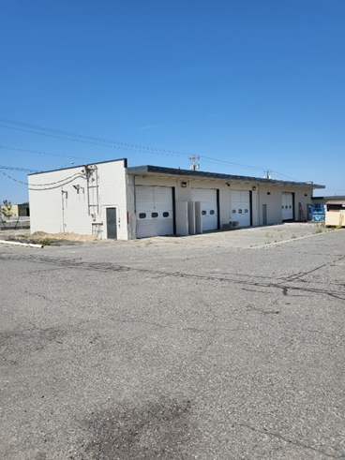
The MRW Facility (see Figure 8-1) was developed by retrofitting portions of the former County Road Maintenance Shops and office area (approximately 3,550 square feet). The remaining areas on the south end of the site, formerly vehicle maintenance bays, may be used for general storage but may not be used for MRW operations or storage.
The cost for construction of the new MRW Facility is estimated at $1.2 million with contributions from Benton County, cities and towns, and grant funding from Ecology. Operations of the facility will be funded with a combination of grant funds and Benton County tipping fee revenues. The new MRW Facility is scheduled to open in late 2023.
Figure 8-1. Benton County MRW Facility

Moderate-Risk Waste Generation
RCW 70A.300(1)(a) requires local governments to prepare hazardous waste management plans that contain an assessment of the quantities, types, generators, and fates of hazardous waste in each jurisdiction. This Plan serves to compile that data for Benton County, and this chapter focuses on the MRW associated with HHW and SQG aspects/quantities of hazardous waste. The quantities, types, and fates of MRW in Benton County are described in Section 8.4. The following subsections focus on the generators of this waste in Benton County.

Hazardous Waste Inventory
The following information helps provide an inventory of hazardous waste management in Benton County by addressing dangerous waste generators (i.e., large-quantity generators), contaminated sites, transporters and processing facilities, and locations where hazardous waste facilities can be sited (“zone designations”).

Dangerous Waste Generators
Ecology records (latest data as of December 2021) show that 104 businesses and institutions in Benton County are registered as hazardous waste generators and reported the generation of waste. Nineteen businesses and institutions in Benton County that are registered with the EPA or have state identification numbers did not report generating hazardous waste in 2021.

Remedial Action Sites
Ecology’s list of confirmed and suspected contaminated sites in Benton County can be found at:
https://apps.ecology.wa.gov/cleanupsearch/reports/cleanup/contaminated
As of November 2022, there were 94 of these sites identified in Benton County.

Hazardous Waste Services (Transporters and Facilities)
Multiple private companies provide transportation and disposal services for a wide range of materials. The current list of these companies can be found at:
https://ecology.wa.gov/Regulations-Permits/Guidance-technical-assistance/Dangerous-waste-guidance/Dispose-recycle-or-treat/Hiring-a-contractor

Inventory of Moderate-Risk Waste Generators
As stated above, MRW generators include HHW from local residents as well as SQG from local businesses and institutions. For residential sources in particular, products may be stored for several years before the resident determines that the material is no longer useful and takes it to an MRW facility. In addition, although quantities and types of MRW collected and shipped are tracked, it is unknown how many residents are recycling or disposing of wastes through drop-off programs and private collection services.

Existing Conditions
This section describes existing programs to manage MRW in Benton County.

Current Moderate-Risk Waste and Oil Programs

MRW Collection
MRW in Benton County has been primarily collected through collection events and drop-off programs. With the opening of the County MRW Facility in 2023, the following are available drop-off programs active in the County, including:
- The County MRW Facility located at 1709 South Ely Street, Kennewick, will accept hazardous wastes from households at no charge. Hours of operation and SQG waste acceptance will be addressed by the County upon opening of the facility.
- Approximately 13 locations throughout the County accept used motor oil for recycling.
- Electronic waste is accepted through the E-Cycle Washington program. Additional information on this program can be found in Chapter 6.0 – Miscellaneous Wastes.
- Mercury-containing lights are accepted through the LightRecycle program.
- Paint is accepted through the PaintCare recycling program.
- The WSDA conducts agricultural chemical waste collection events in Eastern Washington on an as-needed basis. Participants must sign up in advance to bring in wastes, but there is no cost to participate.
- SQGs and large-quantity generators use the services of private companies that collect specific types of wastes, but little information is available on the amounts collected in this manner.
- Hazardous waste generated by the Hanford site is excluded from the planning area.
The County provides the following website to assist in finding HHW disposal and recycling options:
https://www.co.benton.wa.us/pview.aspx?id=7666&catID=0

Processing, Transport, and Disposal
MRW has traditionally been processed, transported, and disposed of through collection events to be shipped off-site for recycling or disposal according to its Washington State Department of Transportation hazard classification (flammable, toxic, acid, corrosive, or reactive). MRW collected at these events is shipped to licensed hazardous waste treatment, storage, and/or disposal facilities. Table 8-2 provides the quantities of MRW processed, transported, and disposed of through collection events in 2019, 2021 and 2022.

Table 8-2. MRW Collection Event Quantities Shipped (in pounds)
Waste Type | 2019 | 2021 | 2022
Acids | 300 | 1,707 | 2,060
Antifreeze | 1,166 | 2,850 | 6,264
Aerosols | 1,200 | 6,812 | 4,483
Oil (All types) | 73 | 7,013 | 1,462
Flammable Gas | 2 | 1,817 | 46
Flammable Liquids | 4,266 | 40,033 | 46,601
Flammable Solids | 14 | 17 | 51
Oxidizers | 123 | 496 | 235
Mercury (All types) | 6 | 179 | 5
Paint – Oil-Based | 5,796 | 0 | 0
Pesticide/Poison | 10,950 | 4,104 | 4,650
Water Reactives | 29 | 279 | 80
Batteries (All types) | 1,896 | 5,094 | 2,950
Other Materials/Non-Regulated | 1,845 | 10.328 | 2,654
TOTAL (in pounds) | 27,666 | 80,729 | 71,541

Compliance and Enforcement
Compliance issues are handled by the Health District, which responds to complaints and other problems as they are identified. The Health District receives LSWFA grant funding for this purpose.

Status of Previous Recommendations
The status of the recommendations made by the 2013 Plan can be found in Appendix D.

Alternatives and Evaluations
There are generally five components for local MRW management programs: two that address educational efforts and three that help fulfill the mandate to prepare a “program to manage moderate-risk waste” (RCW 70.105.220(1)(a)). These five elements are as follows:
- Public education program;
- Technical assistance program for businesses;
- Collection program for HHW and used oil;
- Collection program for business wastes; and
- A plan or program to ensure compliance by SQG and others.
The existing service gaps and other issues connected to these components are discussed below.

Public Education
HHW outreach efforts will be enhanced and increased, including distribution of flyers to households and businesses, at County facilities, and on the County websites. The County will utilize flyers/handouts available from Ecology and the Washington Toxic Coalition to distribute information to residents and businesses about MRW generation and proper disposal techniques. These efforts will be continued on an ongoing basis to reach new residents.
In addition, incorporation of the message into other programs that also benefit from HHW management could be considered. Other programs that have common objectives include programs that deal with storm water, ground water, municipal wastewater treatment, and on-site sewage system. Other facilities should also be participating in HHW messaging education, including the Horn Rapids Landfill and the privately owned and operated transfer station and drop-box sites. By coordinating messaging with other resource protection and waste management programs, the message is repeated, and attention will be focused on multiple benefits of the higher-priority management practices. This coordination effort could be handled by existing County staff in conjunction with current and future promotion and educational activities (as described in Chapter 5.0 – Waste Reduction, Recycling, and Education and Outreach).

Business Technical Assistance
Benton County is not currently providing technical assistance and education to businesses about SQG waste handling and disposal. The level of expertise required to effectively assist many businesses would require significant training for specific types of businesses and is better handled at the state level.

Household Collection
Household collection will be provided through the County MRW Facility scheduled to open in 2023. Other opportunities for HHW management are provided through statewide programs such as PaintCare, LightRecycle Washington, and E-Cycle Washington.

Business Collection
The County is considering the implementation of a program that would offer small businesses the opportunity to bring their wastes to the MRW Facility for proper handling and disposal. Currently, businesses (SQGs) rely on County MRW collection events for recycling and disposal of MRW materials. An alternative for handling business MRW is to charge SQGs to use the MRW Facility, as is done in most other Washington counties. The imposition of fees my cause some of the SQGs to dispose of their MRW by mixing it in with their solid waste or disposing of it in other undesirable ways, which creates human safety issues and/or environmental damage.

Compliance and Enforcement
Compliance and enforcement are currently being conducted on an as-needed basis, and there are no known issues with this approach.

Moderate-Risk Waste Plan Preparation
RCW 70A.300 requires local governments to prepare hazardous waste plans. The County has incorporated the hazardous waste plan update process into the Benton County Solid Waste Management Plan update process to maintain compliance with the rule.

Recommended Actions
The following recommendations are being made for moderate-risk waste:
MRW1) Enhance the public education and outreach program for handling of MRW waste for households. Cross-sector avenues to enhance coordination with other County departments and waste handling and disposal facilities should be considered.
MRW2) Consider options for handling of SQG waste with the opening of the County MRW Facility. Consideration should be given to implementation of potential fees for handling SQG waste to offset costs, educational efforts needed to implement, environmental concerns, and operational adjustments to the MRW Facility.
MRW3) Continue to coordinate the schedule and process for updating the MRW Plan with the solid waste management plan (as is the current practice).

Chapter 9.0 energy recovery

This page intentionally left blank.

Energy Recovery

Introduction
This chapter addresses emerging technologies in energy recovery that increase solid waste diversion and decrease disposal.

Background
Waste processing and conversion technology options can be grouped into the following main technology classes:
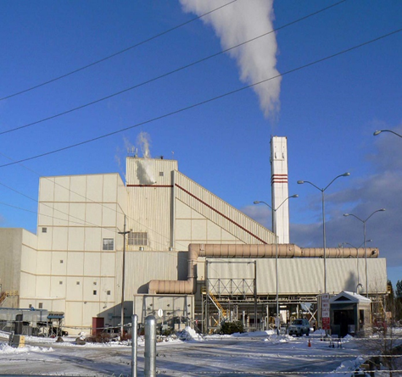
- Thermal Technologies
  - Direct Combustion (various forms of traditional waste-to-energy)
  - Gasification
  - Plasma Arc Gasification
  - Pyrolysis
- Biological Technologies
  - Aerobic Composting
  - Anaerobic Digestion with biogas production for electricity or fuel generation
- Chemical Technologies
Figure 9-1. City of Spokane Waste-to-Energy Plant
  - Hydrolysis
  - Catalytic and Thermal Depolymerization
- Mechanical Technologies
  - Autoclave/Steam Classification
  - Advanced Materials Recovery
  - Refuse-Derived Fuel Production
There are also waste conversion technologies that are a combination of two or more technology classes. For example, mechanical and biological treatment technologies combine mechanical separation and treatment with biological processing, while waste-to-fuel technologies combine mechanical pre-processing with thermal and chemical conversion processes.

Existing Conditions
As discussed in Chapter 4.0 – Waste Transfer and Disposal, MSW from the County is disposed of at multiple landfill facilities including the Horn Rapids Landfill located in the County, Waste Management’s Columbia Ridge Landfill in Gillam County, Oregon, and the Waste Connections’ Finley Buttes Landfill in Morrow County, Oregon.
The Horn Rapids Landfill currently flares landfill gas collected but has an approved facility project with Pine Creek RNG to recover, clean, and reuse the gas collected through an agreement with Cascade Natural Gas.
The Columbia Ridge Landfill manages landfill gas to generate renewable energy, reduce emissions, and prevent odor. The landfill gas collection system collects 9,400 cubic feet per minute of landfill gas through more than 100 wells. A portion of the gas is sent to an on-site energy plant, with the remaining gas managed by flares per federal requirements. The energy plant at Columbia Ridge uses landfill gas to generate renewable energy. Gas collected from the landfill powers 12 engines, which produce 12.8 megawatts (MW) of electricity—enough to power 12,500 homes in Seattle through an agreement with the City of Seattle. Columbia Ridge is also home to 90 wind turbines with the capacity to generate 150 MW of power.
The Finley Buttes Landfill recovers energy through an installed gas collection and recovery system on the landfill site. This system allows for the sale of 25 million kilowatts per year to Pacific Corp and also provides a heat equivalent of 45,000 therms to Cascade Specialties, a local food processing plant.
Energy recovery from MSW should remain a continuing consideration for the County.

Status of Previous Recommendations
The status of the recommendations made by the 2013 Plan can be found in Appendix D.

Alternatives and Evaluations
Existing service gaps and other issues connected to the energy recovery component of solid waste management are discussed below.

Energy Recovery Needs
The County’s waste stream is relatively small for energy recovery and would not economically support the high capital expenditures required for facility construction of waste processing and conversion technology alternatives when compared to the existing disposal program.
As an example, the 2022 MSW tipping fee at the City of Spokane Waste-To-Energy Facility is $117.16 per ton. In comparison, the 2022 MSW tipping fee at Waste Management’s Kennewick Transfer Station is $48.92 per ton, the Basin Disposal Transfer Station in Prosser is $18.00 per yard, and the City of Richland Horn Rapids Landfill is $51.10 per ton for Richland residents and $76.15 for non-residents.
Ample landfill capacity is currently available at the Columbia Ridge Landfill, Finley Buttes Landfill, and Horn Rapids Landfill for County waste. Detailed information regarding landfill disposal is included in Chapter 4.0 – Waste Transfer and Disposal.

Recommended Actions
The following recommendation is made for energy recovery:
ER1) The County will monitor developments and progress in waste processing and conversion technologies in the event that current conditions change.

This page intentionally left blank.

Chapter 10.0 administration, financing, and enforcement

This page intentionally left blank.

Administration, Financing, and Enforcement

Introduction
This chapter addresses the administrative, financing, and enforcement activities related to solid waste.

Background
The County, cities, towns, and several other organizations and agencies are responsible for providing enforcement of federal, state, and local laws and regulations that guide the planning, operation, and maintenance of the region’s solid waste management system. This local enforcement authority ensures that the County system meets applicable standards for the protection of human health and environmental quality in the region.

Existing Conditions
Administrative responsibility for solid waste handling systems in the County is currently divided among several agencies and jurisdictions in local, county, and state governments. Each organization involved in the County solid waste management system is described below.

Benton County Public Works Department - Solid Waste Division
The Washington State Solid Waste Management Act, RCW 70A.205, assigns local government the primary responsibility for managing solid waste. Solid waste handling, as defined in RCW 70A.205, includes the “management, storage, collection, transportation, treatment, utilization, processing, and final disposal of solid wastes, including the recovery and recycling of materials from solid wastes, the recovery of energy resources from solid wastes or the conversion of the energy in solid wastes to more useful forms or combinations thereof.”
RCW 36.58 authorizes the County to develop, own, and operate solid waste handling facilities in unincorporated areas or to accomplish these activities by contracting with private firms. The County also has the authority and responsibility to prepare comprehensive solid waste management plans for unincorporated areas and for jurisdictions that agree to participate with the County in the planning process.
The County has entered into interlocal agreements with all incorporated cities and towns prior to starting the Plan review, update, and adoption process. These agreements address the Plan participation and can be found in Appendix A.
The County exercises its solid waste responsibilities through the Benton County Public Works Department - Solid Waste Division. The specific administrative functions performed include the following:
- Administering, staffing, and operating the MRW Facility.
- Administering and staffing public education programs for waste reduction and recycling.
- Administering contracts.
- Maintaining the Plan as adopted in relation to public health, safety, and sanitation and providing regulations to govern the storage, collection, transfer, transportation, processing, use, and final disposal of solid waste by all persons in the County.
- Providing staff support for the SWAC.
Figure 10-1 illustrates the County Public Works - Solid Waste organizational structure. County Public Works - Solid Waste is staffed by three full-time employees who handle MRW Facility operations and one part-time employee who handles program coordination, education, and outreach activities.
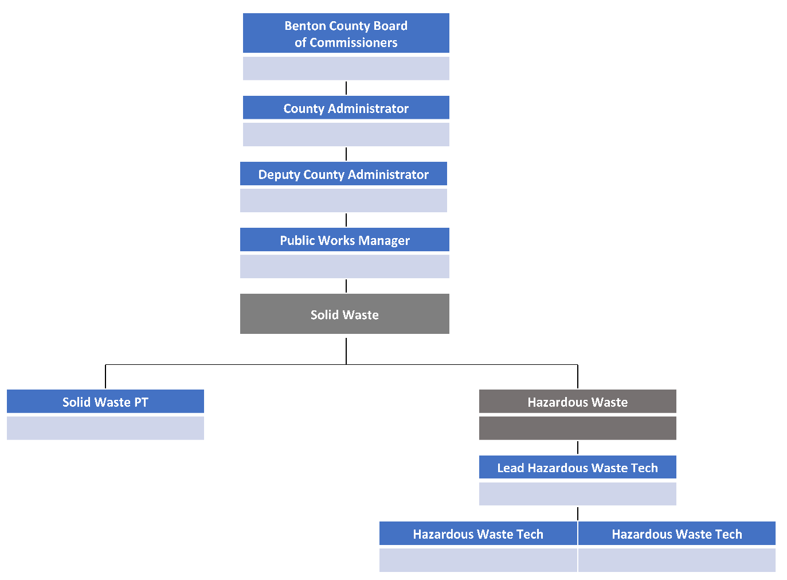
Figure 10-1. Benton County Public Works Department - Solid Waste Organizational Structure

The County Public Works - Solid Waste Fund is funded by the fees collected through the Interlocal Agreements between the County and cities and towns and through Resolution 97-082 and County Ordinance No. 93-056, which provide for a fee assessed on waste collection companies in the amount of 4.5 percent of the annual gross revenues for those collection companies operating in the unincorporated areas of the County. The County also receives grant monies from Ecology for solid waste management planning activities, litter cleanup, and pilot projects. Table 10-1 shows the actual revenues and expenses for fiscal years 2019 through 2020 and for fiscal years 2021 through 2022.

Table 10-1. Benton County Solid Waste Financial Information
 | 1/1/2019 – 12/31/2020 Actual | 1/1/2021 – 12/31/2022 Actual
Revenues
Pollution Control & Remediation Services | $536,338 | $474,552
Solid Waste Services | $50,965 | 0
Grant Revenues | $170,032 | $747,053
Other Miscellaneous Revenues | $179,009 | 0
Other Non-Revenues | $15,731 | $2,990
Total Revenues | $952,075 | $1,224,595
Expenses
Personnel | $4,196 | 0
Supplies | $8,359 | $1,228
Services | $273,481 | $353,884
Interfund Payments | $45,851 | $63,278
Capital Expenses | $106,483 | $1,093,119
Total Expenses | $438,370 | $1,511,509
Total Balance/(Deficiency) | $513,705 | ($286,914)

Benton County Solid Waste Advisory Committee
Per RCW 70A.200, the Board of County Commissioners has appointed the SWAC to help develop solid waste handling programs and policies. The SWAC members are appointed through the Interlocal Agreements between the County and cities and towns, with additional members representing other interested groups appointed directly by the Board of County Commissioners. The SWAC consists of a minimum of nine members and a maximum of 12 members, each with one vote, and membership is outlined in the bylaws to include citizens, public interest groups, businesses, the waste management industry, agriculture, and local elected officials. Additional information regarding the SWAC By-laws can be found in Appendix C.

Incorporated Cities
RCW 35.21.152 empowers cities to develop, own, and operate solid waste handling systems and to provide for solid waste collection services within their jurisdictions. There are seven incorporated cities and towns in Benton County.
One municipality (City of Richland) operates their own collection program, with four private haulers operating within the County boundary and in individual cities and towns as contracted. The City of Richland collection program is operated within the city boundaries, as adjusted periodically by annexations. The private haulers operate in the unincorporated areas and in the other municipalities. Fees charged for the service cover the expenses of the system, although some cities also charge a “utility tax” that assists in funding other city functions. Detailed information about collection in individual cities is included in Chapter 3.0 – Solid Waste Collection.

Benton Franklin Health District
The Benton Franklin Health District (Health District) works with the public, cities, counties, and state agencies to develop and implement plans for the safe storage, collection, transportation, and final disposal of solid waste. The Health District works to ensure compliance with RCW 70A.205 and WAC 173-304 - Minimum Functional Standards for Solid Waste Facilities. The Health District is responsible for the following:
- Permitting solid waste facilities operating in Benton County.
- Ensuring that permits are consistent with the Plan, local ordinances, and appropriate Washington state and federal regulations.
- Oversight of existing permitted facilities.
- Responding to complaints regarding improper storage and disposal of solid waste.
- Investigating illegal dumping and non-permitted dump sites.
Solid waste facility permits are required in accordance with WAC 173-303, 173-350, and 173-351. Facilities are required to obtain solid waste handling permits from the Health District.
The State Environmental Policy Act (SEPA), RCW 43.21C, requires all governmental agencies to consider the environmental impacts of a proposal before making decisions. An Environmental Impact Statement (EIS) must be prepared for all proposals with probable significant adverse impacts on the quality of the environment. In order to determine if an EIS is necessary, an environmental checklist must be completed. For this planning document, a SEPA checklist has been completed and is included as Appendix F.
Applicants for new solid waste permits within the County will notify the Health District. The applicant will submit a permit application and a SEPA checklist to the Health District, which forwards such applications to the Benton County Public Works Department - Solid Waste Division.
The County Public Works - Solid Waste will then request a meeting of the SWAC for the purpose of reviewing the permit application for conformance to the Plan. The SWAC will review the documents and will return its findings to the Health District, which will consider and include those findings in its final decision.
The Health District will forward such findings and comments, along with the SEPA checklist and permit application, to the Benton Franklin County Board of Health. Final approval or disapproval of the application shall rest with the Health District, which shall issue its approval/disapproval of the application within 90 days after its receipt, pursuant to RCW 70A.205.

Washington State Department of Ecology
RCW 70A.205 provides for a comprehensive, statewide solid waste management program and assigns primary responsibility for solid waste handling to local governments. This regulation gives each county, in cooperation with its cities, the task of setting up a coordinated solid waste management plan that places an emphasis on waste reduction and recycling programs. Enforcement and regulatory responsibilities are assigned to cities, counties, or jurisdictional health departments/districts (like the County Health District), depending on the specific activity and local preferences, but Ecology issues permits for land application of biosolids.
Ecology has promulgated WAC 173-350, Solid Waste Handling Standards, which addresses the operational and other requirements for recycling and composting facilities as well as inert and special-purpose landfills. WAC 173-351, Criteria for Municipal Solid Waste Landfills, contains the current standards for MSW landfills.
The Model Litter Control and Recycling Act (RCW 70A.205) prohibits depositing garbage on any property not properly designated as a disposal site. There is also a “litter fund” that has been created through a tax levied on wholesale and retail businesses, and the monies from this fund are being used for education, increased litter cleanup efforts, and contracts to eligible county entities for illegal dump cleanup activities.
Under the Model Toxics Control Act (MTCA) (RCW 70A.300), grants are available to local governments for solid waste management plans and programs, hazardous waste management plans and programs, and remedial actions to clean up existing hazardous waste sites. Solid and hazardous waste planning and programs are funded through the Local Solid Waste Financial Assistance Grants program administered by Ecology’s Solid Waste and Financial Assurance Program. The state rule that governs this program is WAC 173-312 – Local Solid Waste Financial Assistance.

Washington Utilities and Transportation Commission
The WUTC regulates privately owned utilities that provide public services such as electric power, telephone, natural gas, private water, transportation, and refuse collection. WUTC’s authority over solid waste collection is established in RCW 81.77. This authority does not extend to companies operating under contract with any city or town or to any city or town that undertakes solid waste collection. WUTC regulates solid waste collection companies by granting “certificates of convenience and necessity” that permit collection companies to operate in specified service areas. WUTC also regulates solid waste collection, under authority of RCW 81.77.030, by performing the following functions:
- Fixing collection rates, charges, classifications, rules, and regulations.
- Regulating accounts, service, and safety of operations.
- Requiring annual reports and other reports and data.
- Supervising collection companies in matters affecting their relationship to their customers.
- Requiring collection companies to use rate structures consistent with Washington State waste management priorities.
The WUTC requires certificate holders to provide the minimum levels of solid waste collection and recycling services established by a local solid waste management plan and enacted through an ordinance. Solid waste companies operating in the unincorporated areas of a county must comply with the local solid waste management plan (RCW 81.77.040).
At its option, the County may notify the WUTC of its intention to have the G-certificate holder bid on the collection of source-separated recyclable materials from residences in unincorporated areas. Commercial recycling is also regulated by the WUTC under laws that apply in general to motor freight carriers (RCW 81.80), although their oversight is limited to requiring a permit (at $100 per year) and also to requiring companies to carry insurance, conduct drug testing of employees, and conduct a few other activities.
This Plan contains a cost assessment (see Appendix G) prepared according to the WUTC Cost Assessment Guidelines for Local Solid Waste Management Planning (WUTC October 2019). RCW 70A.205 grants the WUTC 45 days to review the Plan’s impact on solid waste collection rates charged by solid waste collection companies regulated under RCW 81.77 and to advise the County and Ecology of the probable effects of the Plan’s recommendations on those rates.

United States Environmental Protection Agency
At the federal level, the Resource Conservation and Recovery Act (RCRA) of 1976, as amended by the Solid Waste Disposal Act Amendments of 1980 (42 United States Code 6901-6987), is the primary body of legislation addressing solid waste. Subtitle D of RCRA deals with non-hazardous solid waste disposal and requires the development of a state comprehensive solid waste management program that outlines the authorities of local, state, and regional agencies. Subtitle D requires that the state program prohibit “open dumps” and provide that solid waste is handled in an environmentally sound manner.

Status of Previous Recommendations
The status of the recommendations made by the 2013 Plan can be found in Appendix D.

Alternatives and Evaluations
Existing service gaps and other issues connected to administration, financing, and enforcement components of solid waste management are discussed below.

Long-Term Funding Needs
Financial resources are necessary to provide for the continuation of recycling and hazardous waste diversion and education programs; for repairs, maintenance, and construction of solid waste facilities; and for compliance with new and more stringent rules and regulations governing solid waste management. These resources may be provided by taxes, solid waste tipping fees, grants, or any combination of these sources.
Solid waste funding for recycling and educational programs in the County are currently reliant on the tipping fees assessed at the solid waste facilities and, on occasion, LSWFA grant funding. Additional funding options (grouped by category) and the associated implementation entities are provided in Table 10-2.

Table 10-2. Benton County Solid Waste Financial Information
Possible Funding Methods | Potential Implementation Entity
Possible Funding Methods | City | County | State | Private Sector
User Fees, Rates, Surcharges
1. Cost-of-Service-Based Rates | X | X |  | X
2. Other Volume-Based Rates | X
3. Fixed Per-Customer Service Rates | X |  |  | X
4. Collection Rate Surcharges | X
5. Planning Fees |  | X
6. Weight or Volume-Based Disposal Fees | X | X |  | X
7. Fixed Per-Customer Disposal Fees | X | X |  | X
8. Disposal Surcharges | X | X
Taxes
9. MTCA Funds, Hazardous Substance Tax |  | (x) | X
10. State Litter Tax |  | (x) | X
11. Disposal Department Excise Tax |  | X
12. Mandatory Collection |  | X
13. Franchise Fees | X |  | X
Other
16. Enforcement Fines/Penalties |  | X
17. Sales of Recyclable Materials | X | X |  | X
18. Recycling Fees/Charges | X | X |  | X
19. Sales of Recovered Energy | X | X |  | X
20. Utility Tax | X
21. General Fund Revenues | X | X
22. Bond Financing |  | X |  | (x)
23. Public Works Assistance Account¹ | X | X
Note: X = Implementing authority, (x) = potentially benefits from funding method but cannot implement it.
¹ The Public Works Assistance Account, commonly known as the Publics Works Trust Fund, was established by WAC 43.155 to be used by the Public Works Board to finance local government infrastructure loans.

Collection and Disposal Districts
RCW 36.58 – Solid Waste Disposal, establishes the counties’ rights and responsibilities regarding solid waste management, including the authority to establish solid waste disposal districts. The authority to establish solid waste collection districts is provided in RCW 36.58A. Either district type can include the incorporated areas of a city or town only with the city’s consent. A solid waste district (for collection or disposal) could centralize functions that are now handled by a variety of county and city agencies, but it may be difficult to develop a consensus on the formation and jurisdiction of either type of district. Either type of district may be able to alleviate illegal dumping and other problems through the institution of mandatory garbage collection (for a collection district only) and different financing structures.
The establishment of a solid waste collection district that can act in a similar capacity is allowed by RCW 36.58A. A collection district can be created following the adoption of a SWMP; however, a collection district does not appear to possess taxing authority. According to RCW 36.58A.040, the revenue-generating authority of a collection district is limited.
A solid waste disposal district is a quasi-municipal corporation with taxing authority set up to provide and fund solid waste disposal services. A disposal district has the usual powers of a corporation for public purposes, but it does not have the power of eminent domain. A county legislative authority (i.e., the Board of County Commissioners) would be the governing body of the solid waste disposal district.
RCW 36.58.130 allows the creation of a disposal district to provide for all aspects of solid waste disposal. This includes processing and converting waste into useful products, but specifically does not allow the collection of residential or commercial garbage. A disposal district may enter into contracts with private or public agencies for the operation of disposal facilities and then levy taxes or issue bonds to cover the disposal costs. Thus, a disposal district established in the County could assess each resident or business in the unincorporated area (in incorporated areas only with the city’s approval) a pro rata share of the cost of disposal. This could help discourage illegal dumping by covering at least part of the disposal cost through mandatory payments so that the additional expense for proper disposal would be lower than it is currently. In other words, the assessment by the disposal district would be paid regardless of where the resident or business dumped the waste or whether it was self-hauled or transported by a commercial hauler, and the latter two options would be less expensive by the amount of disposal costs already paid.
RCW 36.58.140 states that a disposal district may “collect an excise tax on the privilege of living in or operating a business in the solid waste disposal taxing district, provided that any property which is producing commercial garbage shall be exempt if the owner is providing regular collection and disposal.” The disposal district has a powerful taxing authority, since it may attach a lien to each parcel of property in the district for delinquent taxes and penalties, and these liens are superior to all other liens and encumbrances except property taxes.
The funds obtained by a disposal district tax may be used “for all aspects of disposing of solid wastes...exclusively for district purposes” (RCW 36.58.130). Potential uses include:
- Cleanup of roadside litter and solid wastes illegally disposed of on unoccupied properties within the district.
- Public information and education about waste reduction and recycling.
- Defraying a portion of the cost of disposal.
- Subsidizing waste reduction/recycling activities.
- Subsidizing the MRW Facility and collection events.
- Closure and post-closure costs for landfills and for other solid waste facilities.
- Solid waste planning.

Staffing
Adequate funding should be provided to maintain and/or increase staff at County levels, as needed, for the primary responsibility for solid waste management and for the Health District to monitor, permit, and enforce solid waste facilities and programs.

Permit Review
The SWAC may be included in the review of all new solid waste facility permit requests within Benton County, although final approval shall continue to reside with the jurisdictional Health District. Such permit requests, after review by the SWAC, will be forwarded to the Health District with comments. This review will ensure adherence to the Plan per RCW 70A.205.

Recommended Actions
The following options were selected by the SWAC for recommended implementation:
AE1) Consider pursuing some of the additional funding strategies listed in Table 10-2 that can be implemented by the County directly and independently from other alternatives.
AE2) Continue to adopt interlocal agreements between the County and the cities and towns to promote consistent service and funding levels for management of the solid waste programs.
AE3) Consider the adoption of a solid waste disposal district to ensure that adequate funding is collected for implementation and management of solid waste programs.
AE4) Provide adequate funding to maintain or increase staff at County and city levels, as needed.
AE5) The Health District may include the SWAC in the review of all new solid waste facility permit requests.

This page intentionally left blank.

Chapter 11.0 IMPLEMENTATION PLAN

This page intentionally left blank.

Implementation Plan
This chapter of the Plan provides information about the cost and schedule for implementing the recommendations made in this Plan. Information is also provided on monitoring progress and maintaining the Plan.

Recommended Strategies, Implementation Schedule, and Budget
The recommendations made in previous chapters of this Plan are repeated below for convenient reference. Table 11-1 provides the approximate County budget for Plan recommendations that incur additional costs above and beyond current status quo costs and programs, proposed implementation schedule, and primary responsibility. More details about specific recommendations can be found in the respective chapters.
Table 11-1. Summary of Recommendations, Implementation Schedule, and Budget
Recommendation | Implementation Responsibility | Projected Implementation Costs | Implementation Schedule
3. Solid Waste Collection
- SWC1) Encourage the use of carted curbside collection services, when possible, and ensure that collection services are available to all residents. | County, Cities, and Waste Haulers | $0 | Ongoing
- SWC2) Review collection contracts to confirm compliance with the Plan. | Cities | $0 | Ongoing
- SWC3) Coordinate residential and commercial curbside collection programs with recycling program recommendations as implemented. | County, Cities, and Waste Haulers | $0 | Ongoing
4. Waste Transfer and Disposal
- WTD1) The County should monitor population growth and tonnage projections to ensure that capacity for waste transfer and disposal continues to be adequate for the waste handling and disposal needs of County residents. | County | $0 | Ongoing
5. Waste Reduction, Recycling, Education and Outreach and CROP
- WRR1) Refresh educational materials and seek to harmonize messaging. | County, Cities, and Waste Haulers | $20,000 | 2024–2029
- WRR2) Distribute informational materials to households and businesses. | County, Cities, and Waste Haulers | $0 | Ongoing
- WRR3) Update and expand on digital education through websites, social media, and newsletters. | County, Cities, and Waste Haulers | $10,000 | 2024–2029
- WRR4) Provide multifamily technical assistance. | County and Cities | $20,000 | 2024–2029
- WRR5) Expand business technical assistance. | County and Cities | $10,000 | 2024–2029
- WRR6) Offer school technical assistance. | County and Cities | $10,000 | 2024–2029
- WRR7) Adopt the updated list of designated materials and maintain it through periodic review and updates. | County | $0 | Ongoing
- WRR8) Establish a waste reduction and recycling goal of 40 percent for this planning period. | County and Cities | $0 | Ongoing
- WRR9) Focus recycling and diversion efforts on waste streams that represent significant tonnage disposed and coordinate messaging and efforts to reduce contaminants on materials recycled. | County, Cities, and Waste Haulers | $0 | Ongoing
- WRR10) Support private sector programs, forums, or other methods, such as existing reuse and reusable materials exchange programs, to facilitate material exchanges. | County, Cities, Private Industry, Commercial and Businesses and Stakeholders | $0 | Ongoing
- WRR11) Increase promotion of existing reuse programs through newsletters, community reuse events, guidebooks, and community-based social marketing. | County, Cities and Non-Profit Groups | $0 | Ongoing
- WRR12) Incorporate and expand the education and promotion program. | County and Cities | $20,000 | 2024–2029
- WRR13) Work cooperatively with County, City and hauler staff to create and implement recycling contamination reduction campaigns for curbside and drop-box recycling programs. | County, Cities and Waste Haulers | $20,000 | 2024–2029
- WRR14) Work cooperatively with cities and towns to develop guidelines and revise building codes to establish standards that promote commercial waste reduction recycling. | County and Cities | $0 | Ongoing
- WRR15) Encourage signatory cities to modernize curbside recycling programs with convenient, efficient carted service to increase diversion and safety and reduce litter. | Cities | $0 | Ongoing
- WRR16) Maintain and update the CROP as needed during this Plan cycle. | County and Cities | $0 | Ongoing
6. Organics
- O1) Continue to develop and distribute educational materials related to organics management as programs are established and implemented. | County and Cities | $10,000 | 2024–2029
- O2) Advocate that adequate funding is provided by the State to develop and implement programs for organics and food waste collection and processing as required by RCW 70A.205.715 and HB 1799. | Ecology | $0 | Ongoing
- O3) Consider initiating a study to determine program and infrastructure needs necessary for implementation of additional yard waste and food waste collection and processing programs. | County and Cities | $50,000 | 2024
- O4) Evaluate a pilot food waste and edible food waste collection program for potential implementation based on participation and customer satisfaction and consider expanding the program as appropriate. | County and Cities | $25,000 | 2025
- O5) Consider developing a County-wide Christmas tree recycling pilot program to assess public interest and participation. | County | $5,000 | 2024
- O6) Evaluate recommendations from the Use Food Well Washington Plan and implement as appropriate. | County, Cities, Private Industry, Non-Profit Groups, Ecology, Commercial Businesses, and Stakeholders | $0 | Ongoing
7. Miscellaneous Wastes
- MW1) Continue to dispose of miscellaneous wastes through a cooperative effort with the Health District, waste haulers, transfer stations, landfills, the County, and Ecology. | County, Cities, Health District, Waste Haulers, Facility Owners, and Ecology | $0 | Ongoing
- MW2) Promote proper reuse, recycling, and disposal of C&D wastes. | County and Cities | $0 | Ongoing
- MW3) Partner with private organizations such as the Benton Habitat for Humanity ReStore to promote recycling and reuse of C&D wastes and building materials. | County, Cities, Private Industry, and Non-Profit Groups | $0 | Ongoing
- MW4) Develop an internal plan for handling disaster debris, in coordination with the Benton County Emergency Management Department. | County | $50,000 | 2024
8. Moderate Risk Waste
- MRW1) Enhance the public education and outreach program for handling of MRW for households. Cross-sector avenues to enhance coordination with other County departments and waste handling and disposal facilities should be considered. | County | $25,000 | 2024-2029
- MRW2) Consider options for handling of SQG waste with the opening of the County MRW Facility. Consideration should be given to implementation of potential fees for handling SQG waste to offset costs, educational efforts needed to implement, environmental concerns, and operational adjustments to the MRW Facility. | County | $0 | Ongoing
- MRW3) Continue to coordinate the schedule and process for updating the MRW Plan with the Solid Waste management Plan (as is the current practice). | County | $0 | Ongoing
9. Energy Recovery
- ER1) The County will monitor developments and progress in waste processing and conversion technologies in the event current conditions change. | County | $0 | Ongoing
10. Administration, Financing, and Enforcement
- AE1) Consider pursuing some of the additional funding strategies listed in Table 10-2 that can be implemented by the County directly and independently from other alternatives. | County | $0 | Ongoing
- AE2) Continue to adopt interlocal agreements between the County and the cities and towns to promote consistent service and funding levels for management of the solid waste programs. | County and Cities | $0 | Ongoing
- AE3) Consider the adoption of a solid waste disposal district to ensure that adequate funding is collected for implementation and management of solid waste programs. | County and Cities | $0 | 2024
- AE4) Provide adequate funding to maintain or increase staff at County and city levels, as needed. | County and Cities | $100,000¹ | 2024
- AE5) The Health District may include the SWAC in the review of all new solid waste facility permit requests. | County | $0 | Ongoing
Total |  | $375,000
¹ One additional staff added in 2024 that would need to be funded on a continuing basis for future years. Costs include only initial year of funding.

State Environmental Policy Act
Ecology requires that the potential impacts of this Plan be evaluated according to the SEPA process. The checklist has been prepared to fulfill that requirement and is included as Appendix G. The SEPA checklist is a “non-project proposal” intended to address new programs recommended by the Plan. As a non-project proposal SEPA checklist, it is unable to fully address the potential impacts of facilities proposed in this Plan. Any new facility will need to undergo its own SEPA review process.
Benton County issued a determination of non-significance that the recommendations in the Plan will not have a probable significant adverse impact on the environment. A copy of this determination is included in Appendix H.

Twenty-Year Implementation Program
Solid waste management in Benton County will continue to evolve based on changes in population, demographics, the local, state, and national economy, regulations, and advancements in waste handling and recycling. Fortunately, the County’s current solid waste management system is functioning effectively.
If, in the future, it becomes advisable to seek additional sources of funding, Chapter 10 – Administration, Financing, and Enforcement provides a list of potential funding sources.

Draft Plan Review
Benton County provided the draft 2023 Plan for review to stakeholders. Comments were received from Ecology, WSDA, WUTC, and stakeholders. Comments received and responses to comments by the County are included as Appendix I.

Procedures for Amending the Plan
The Solid Waste Management-Reduction and Recycling Act (Chapter 70A.205 RCW) requires local governments to maintain their solid waste plans in current condition. Plans must be reviewed and revised, if necessary, at least every 5 years. This Plan should be reviewed in 2029. Before that time, the Plan can be kept in current condition through amendments. An “amendment” is defined as a simpler process than a revision. If there is a significant change in the solid waste system, however, a revision may be necessary before the 5-year period is done.
Changes in the Plan may be initiated by the County, working with the SWAC to develop and review proposed changes, or by outside parties. For the latter, individuals or organizations wishing to propose plan amendments before the scheduled review must petition the County’s Public Works Manager in writing. The petition should describe the proposed amendment, its specific objectives, and explain why immediate action is needed prior to the next scheduled review. The Public Works Manager will investigate the basis for the petition and prepare a recommendation.
If the Public Works Manager determines the petition warrants further consideration, the petition will be referred to the SWAC for review and recommendation. The Public Works Manager will draft the proposed amendment together with the SWAC. Whether the proposed amendment has been initiated by the County or an outside party, the proposed amendment must be submitted to the legislative bodies of all participating jurisdictions and Ecology for review and comment. Adoption of the proposed amendment will require the concurrence of all affected jurisdictions.
The Public Works Manager may develop reasonable rules for submitting and processing proposed plan amendments, and may establish reasonable fees to investigate and process petitions. All administrative rulings of the Public Works Manager may be appealed to the Board of County Commissioners.
Minor changes may occur in the solid waste management system, whether due to internal decisions or external factors. These can be adopted without going through a formal amendment process. If there is uncertainty about whether or not a change is “minor,” it should be discussed by the SWAC and a decision made based on the consensus of that committee.
Implicit in the development and adoption of this Plan is the understanding that in the future, the County may need to take action for various reasons, and that these actions can be undertaken without the need to amend this Plan beforehand. These include the introduction of new state, federal, and international government regulations and policies, advancements in technology, and changes in product use and design. Consequently, the County may need to adjust the recommendations in this Plan or add new action items to the implementation strategy to effectively address them before the Plan is updated again in 2029. When these issues arise, the Plan may need to be amended or revised to address them and will be referenced in our next Plan update in 2029.
In that case, the Public Works Manager will endeavor to inform the SWAC and other key stakeholders as soon as feasibly possible, but not necessarily before new actions are implemented. If the emergency results in permanent and significant changes to the solid waste system, an amendment to this Plan will be prepared in a timely fashion. If, however, the emergency actions are only undertaken on a temporary or short-term basis, an amendment may not be considered necessary. Any questions about what actions may be considered “temporary” or “significant” should be brought to the SWAC for their advice.
Similar to the allowance for emergency action discussed above, the County will need to make operational decisions and expenditures to comply with future regulatory changes and update permit requirements as applicable. Plan update and coordination with the SWAC will not be required or initiated for these future actions, as they are considered operational activities.

Appendix A:
Executed Solid Waste Interlocal Agreements

This page intentionally left blank.

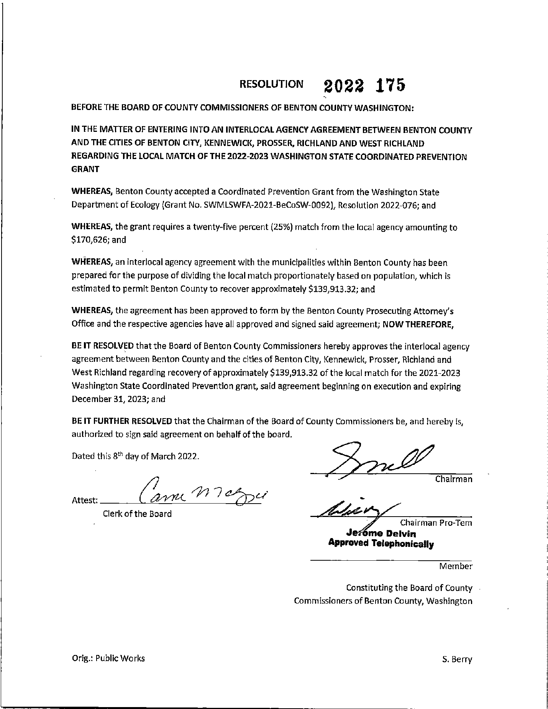
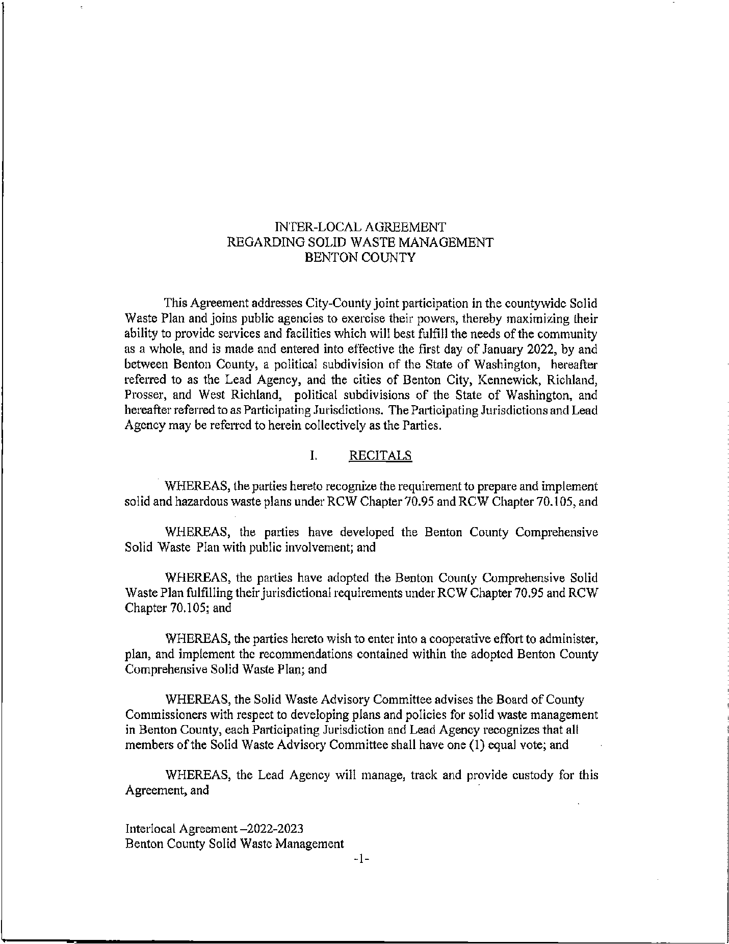
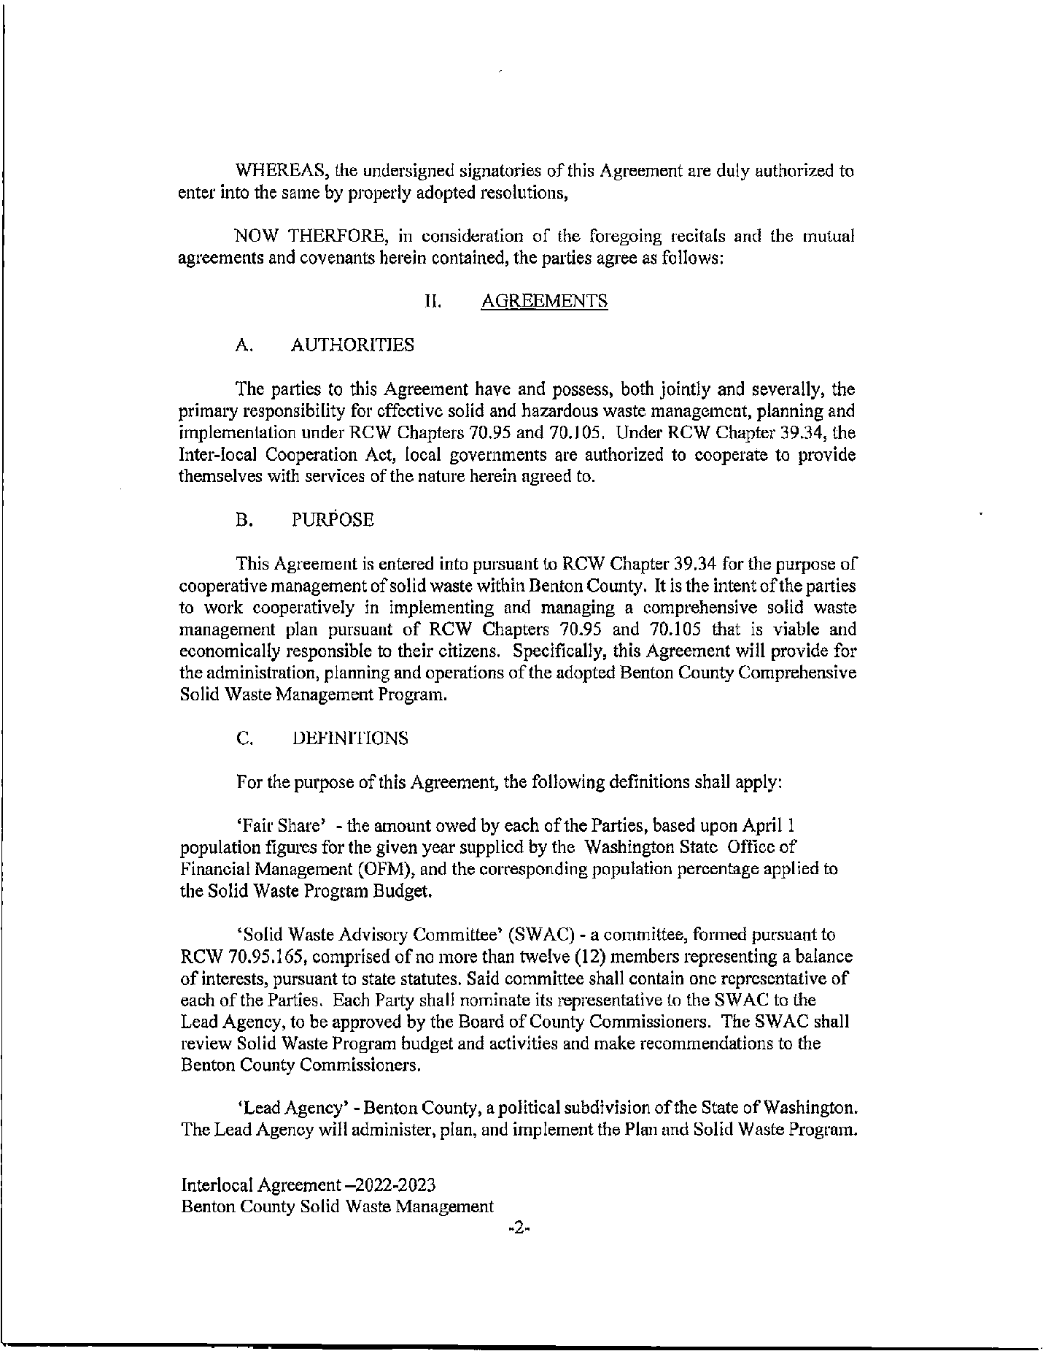
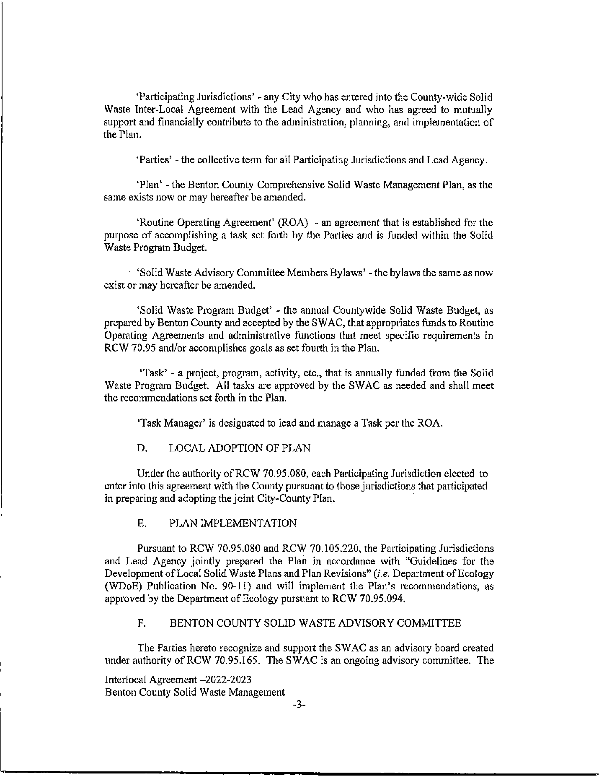
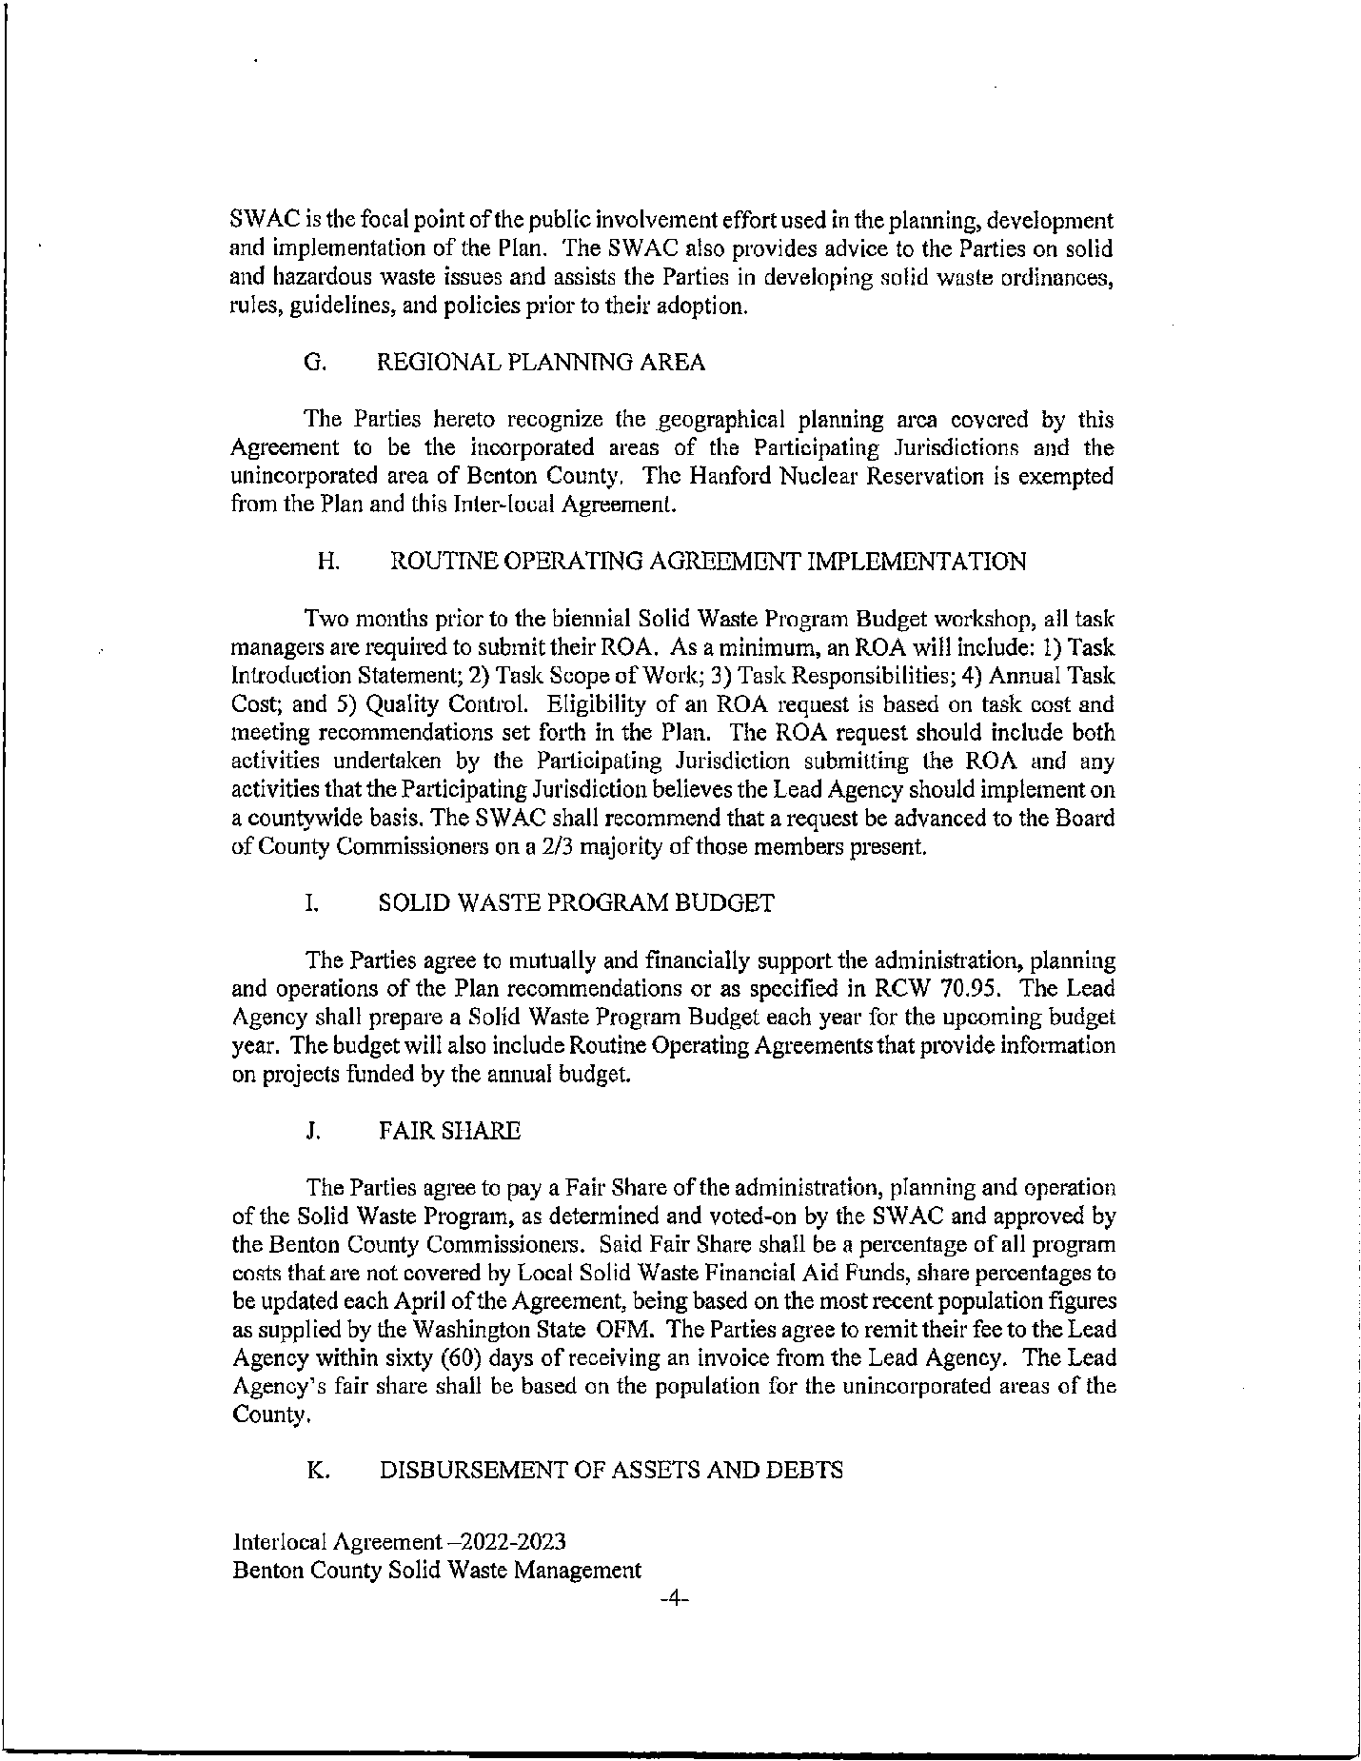
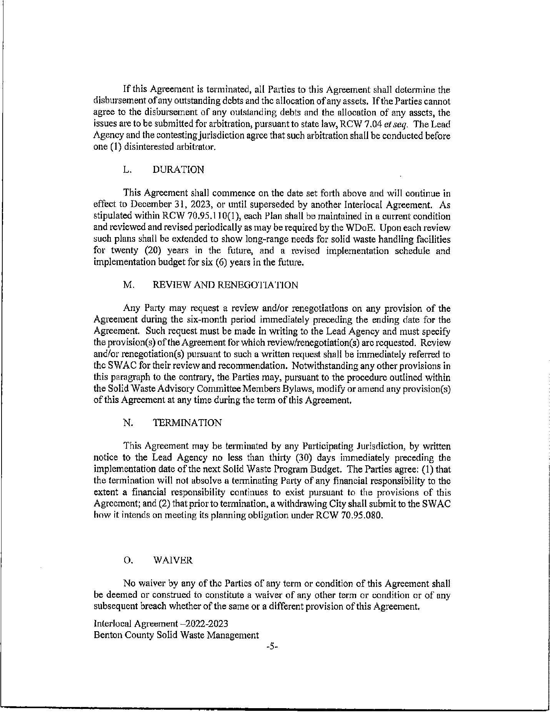
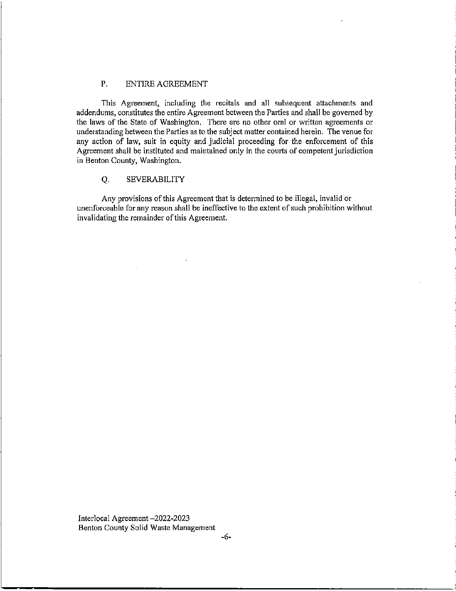
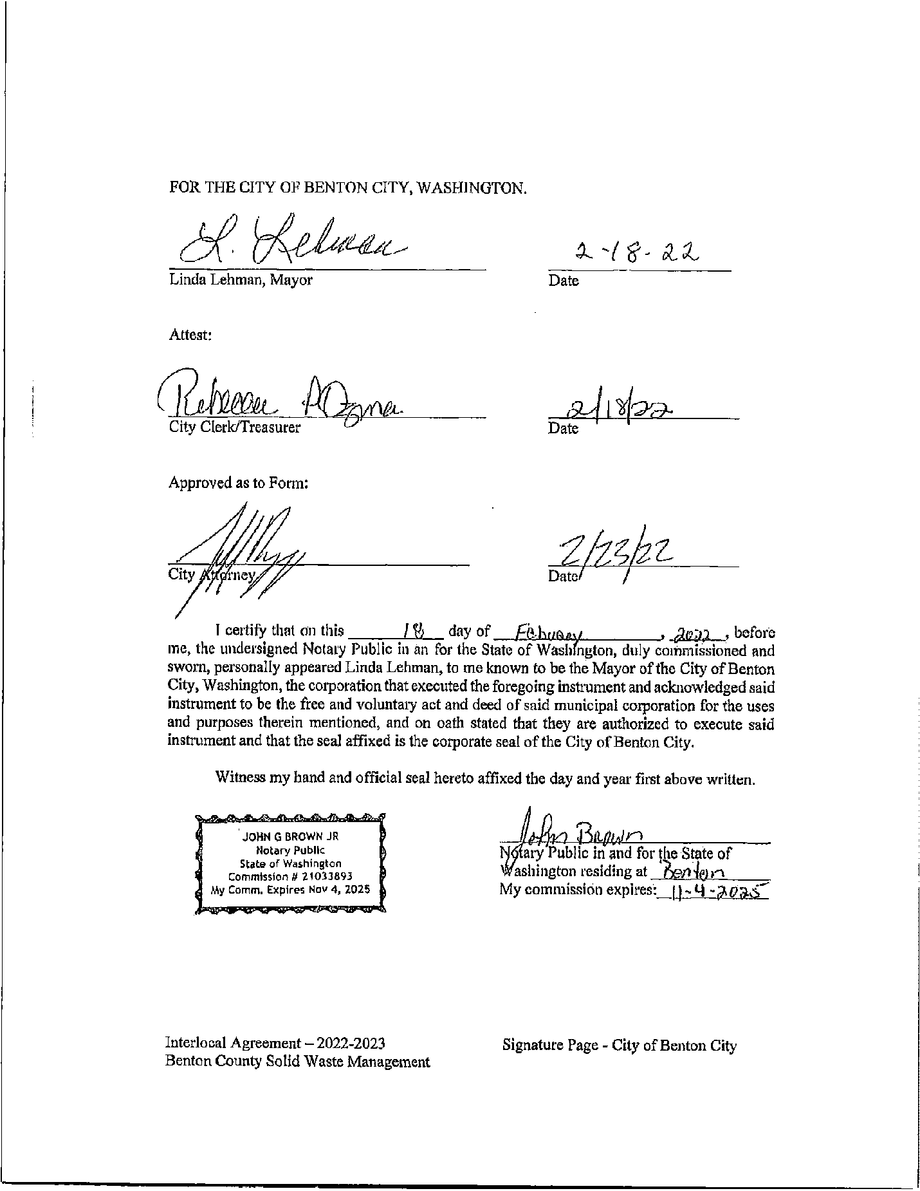
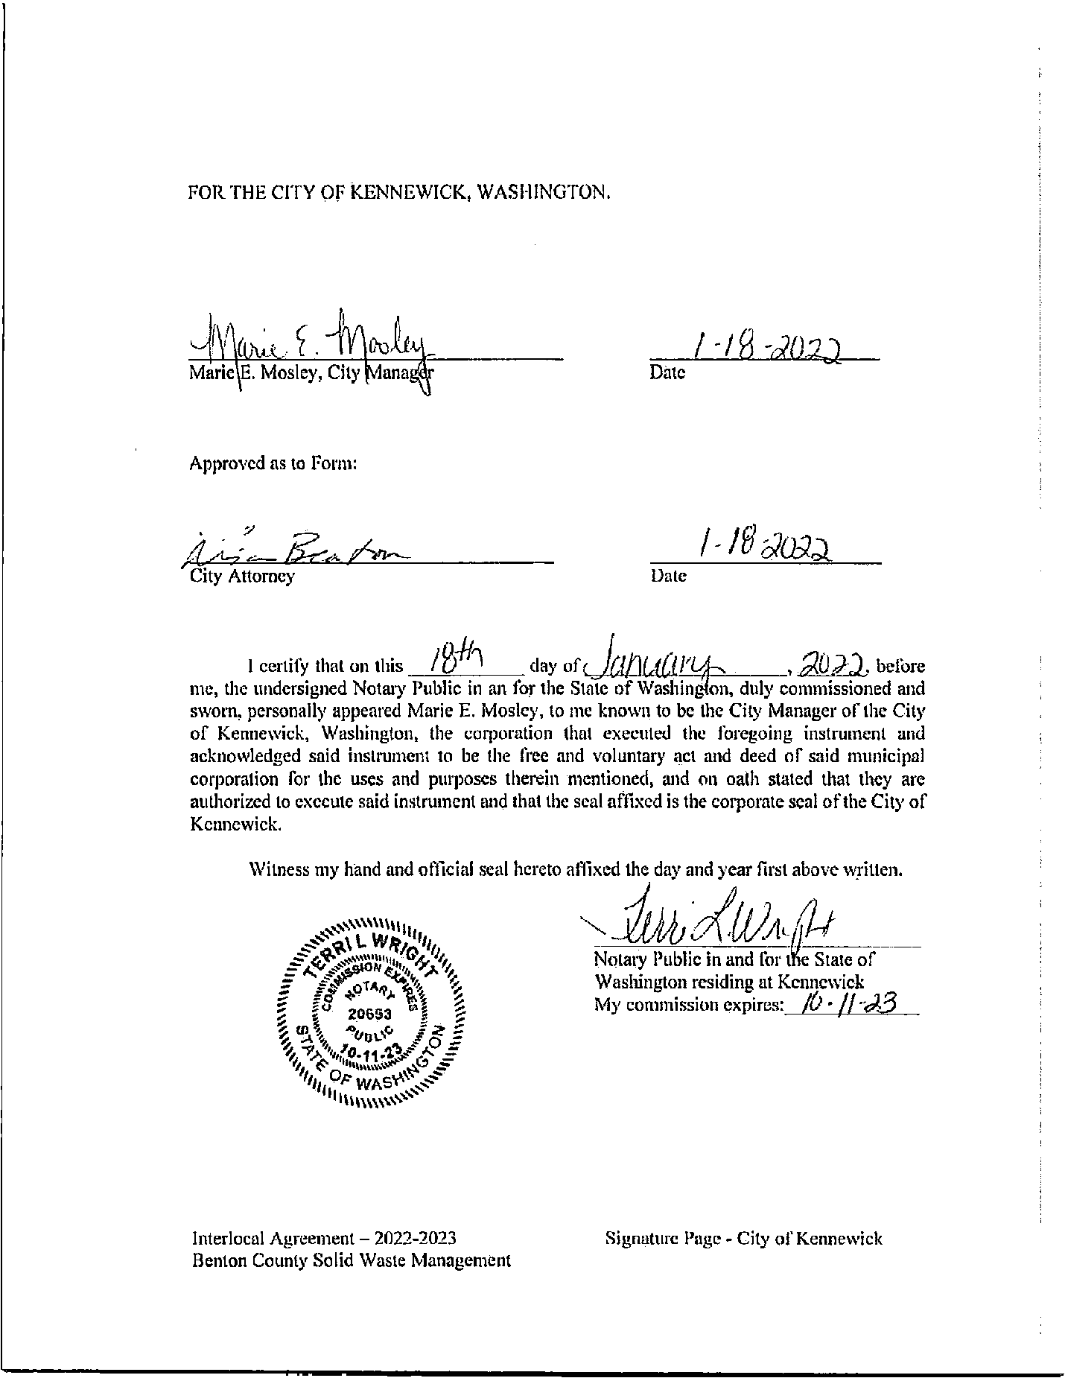
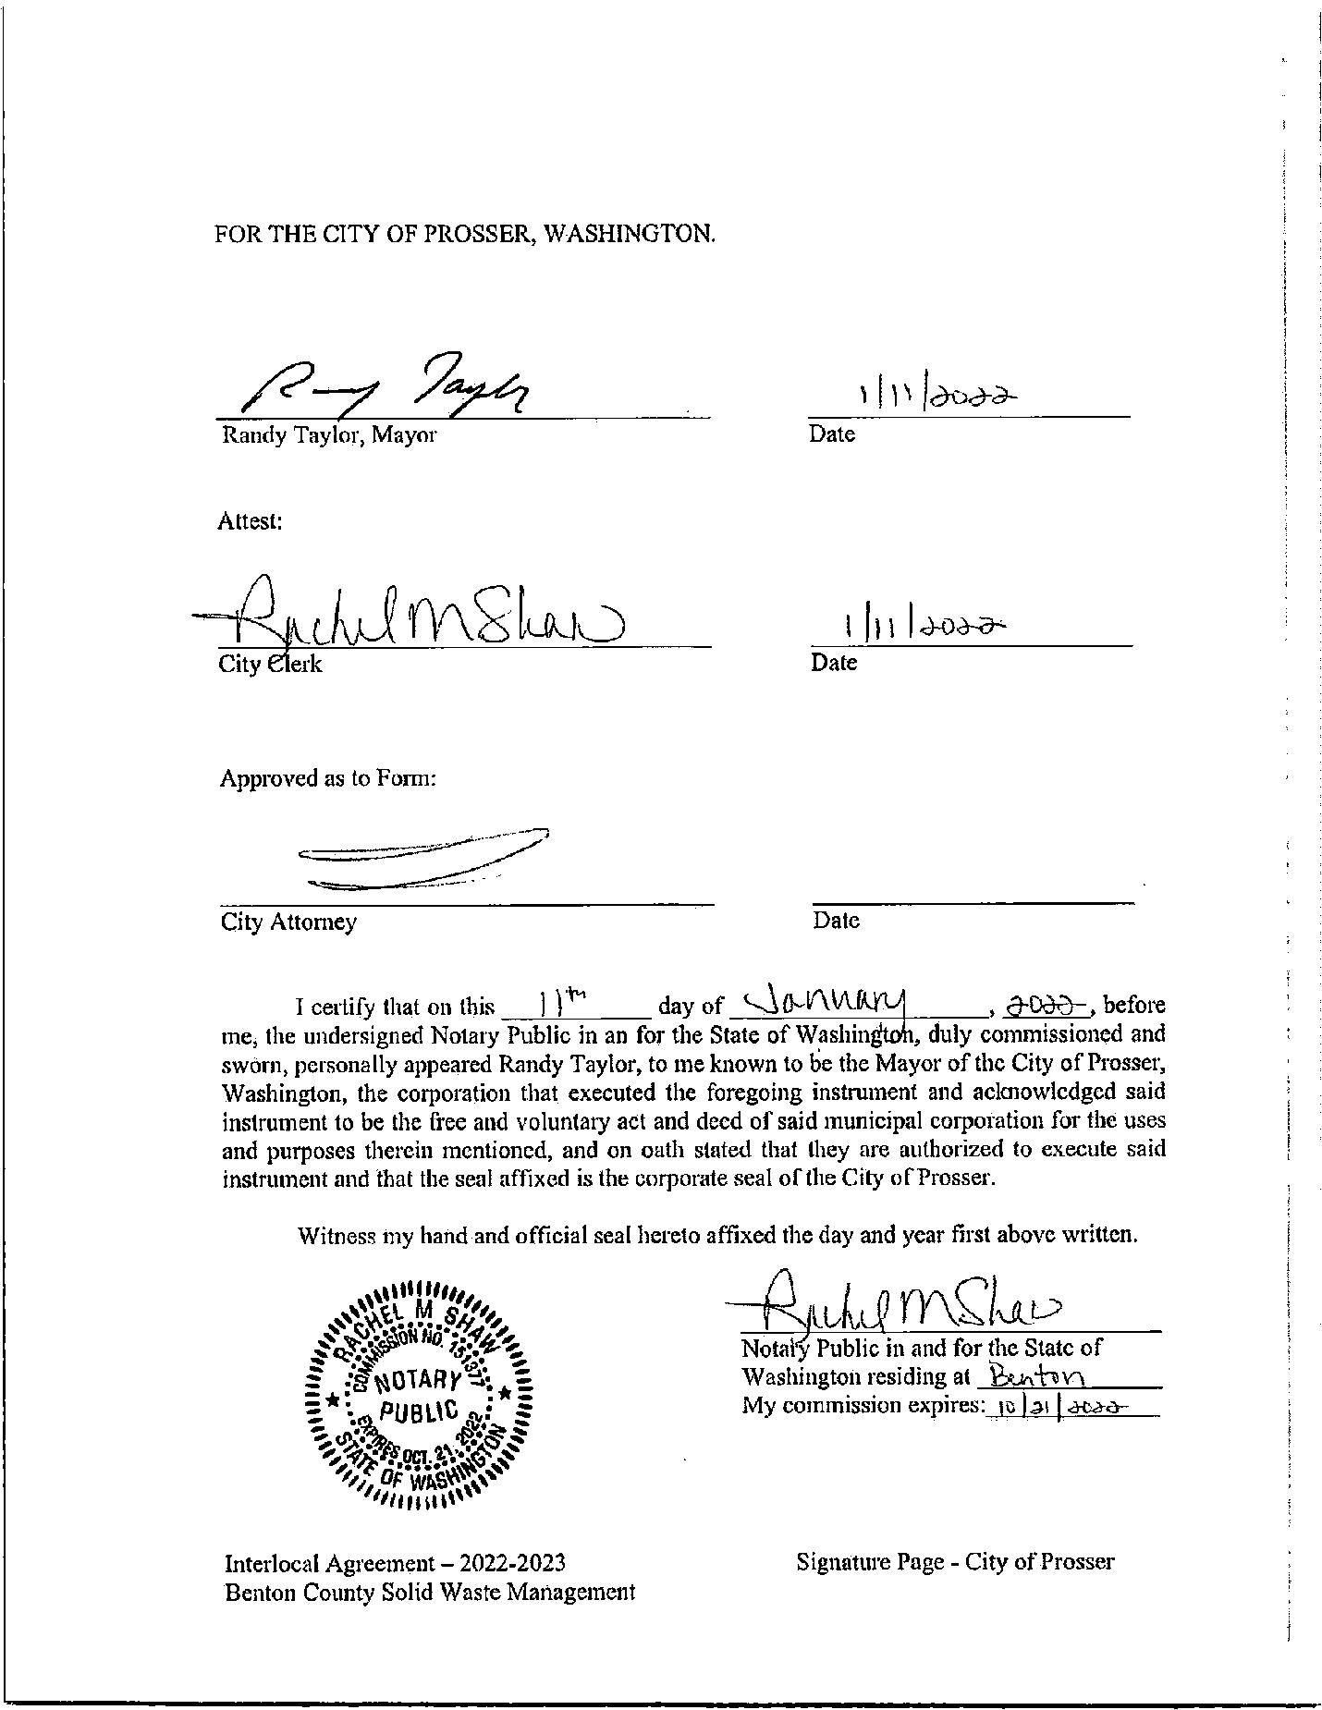
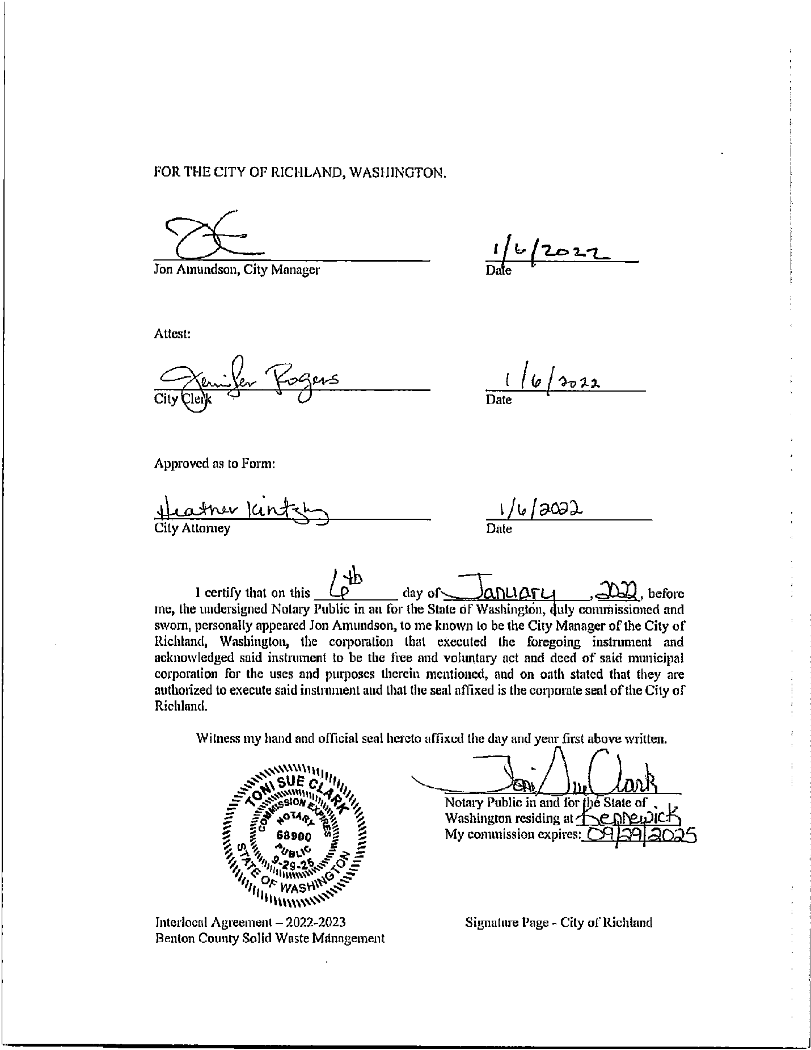
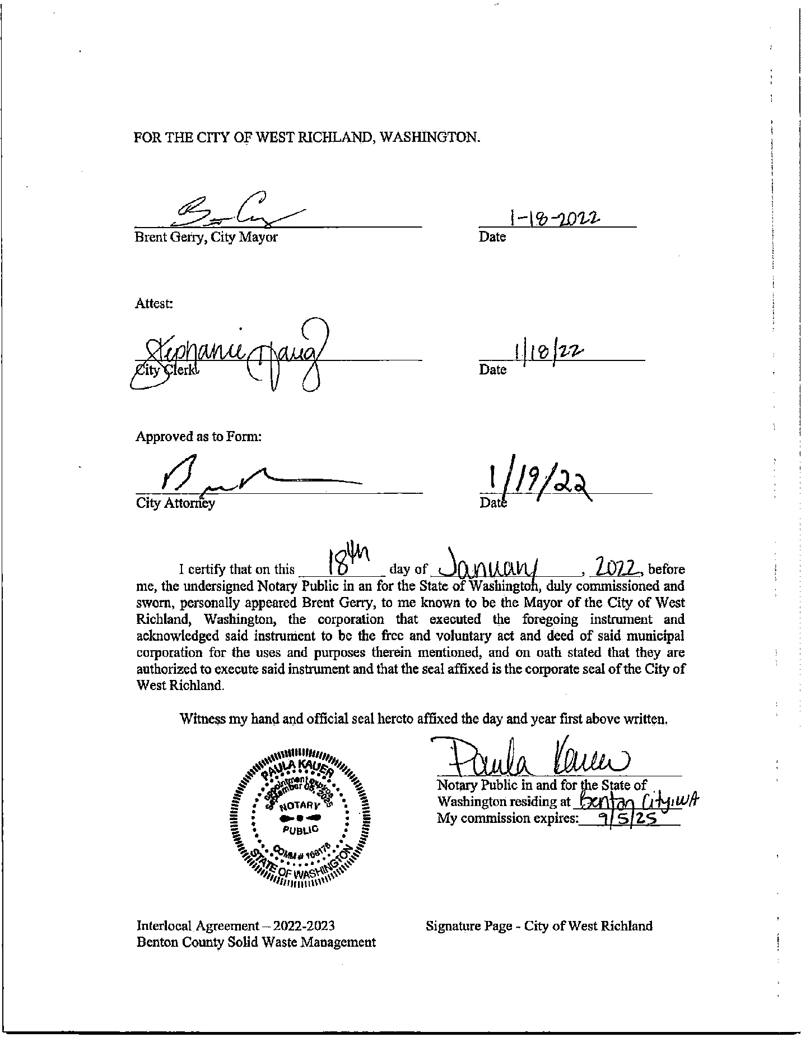
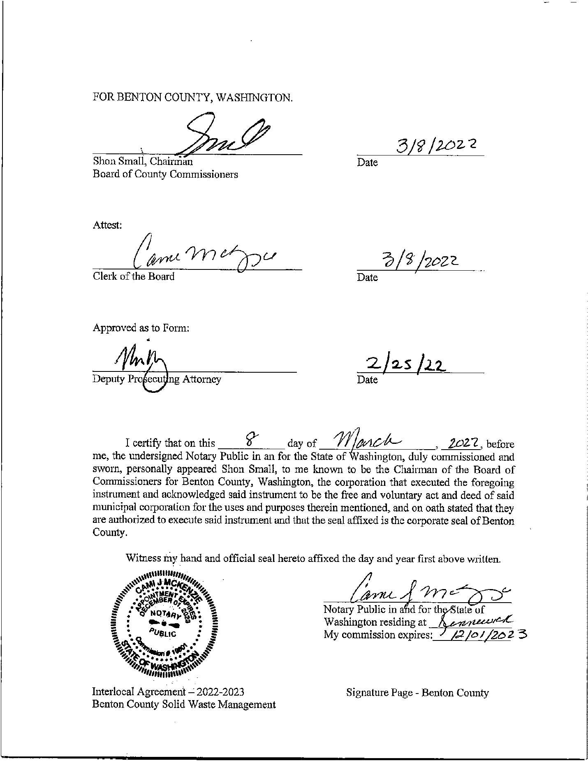

This page intentionally left blank.

Appendix B:
Resolutions of Adoption for this Plan

This page intentionally left blank.
Appendix C:
Information on the SWAC

This page intentionally left blank.

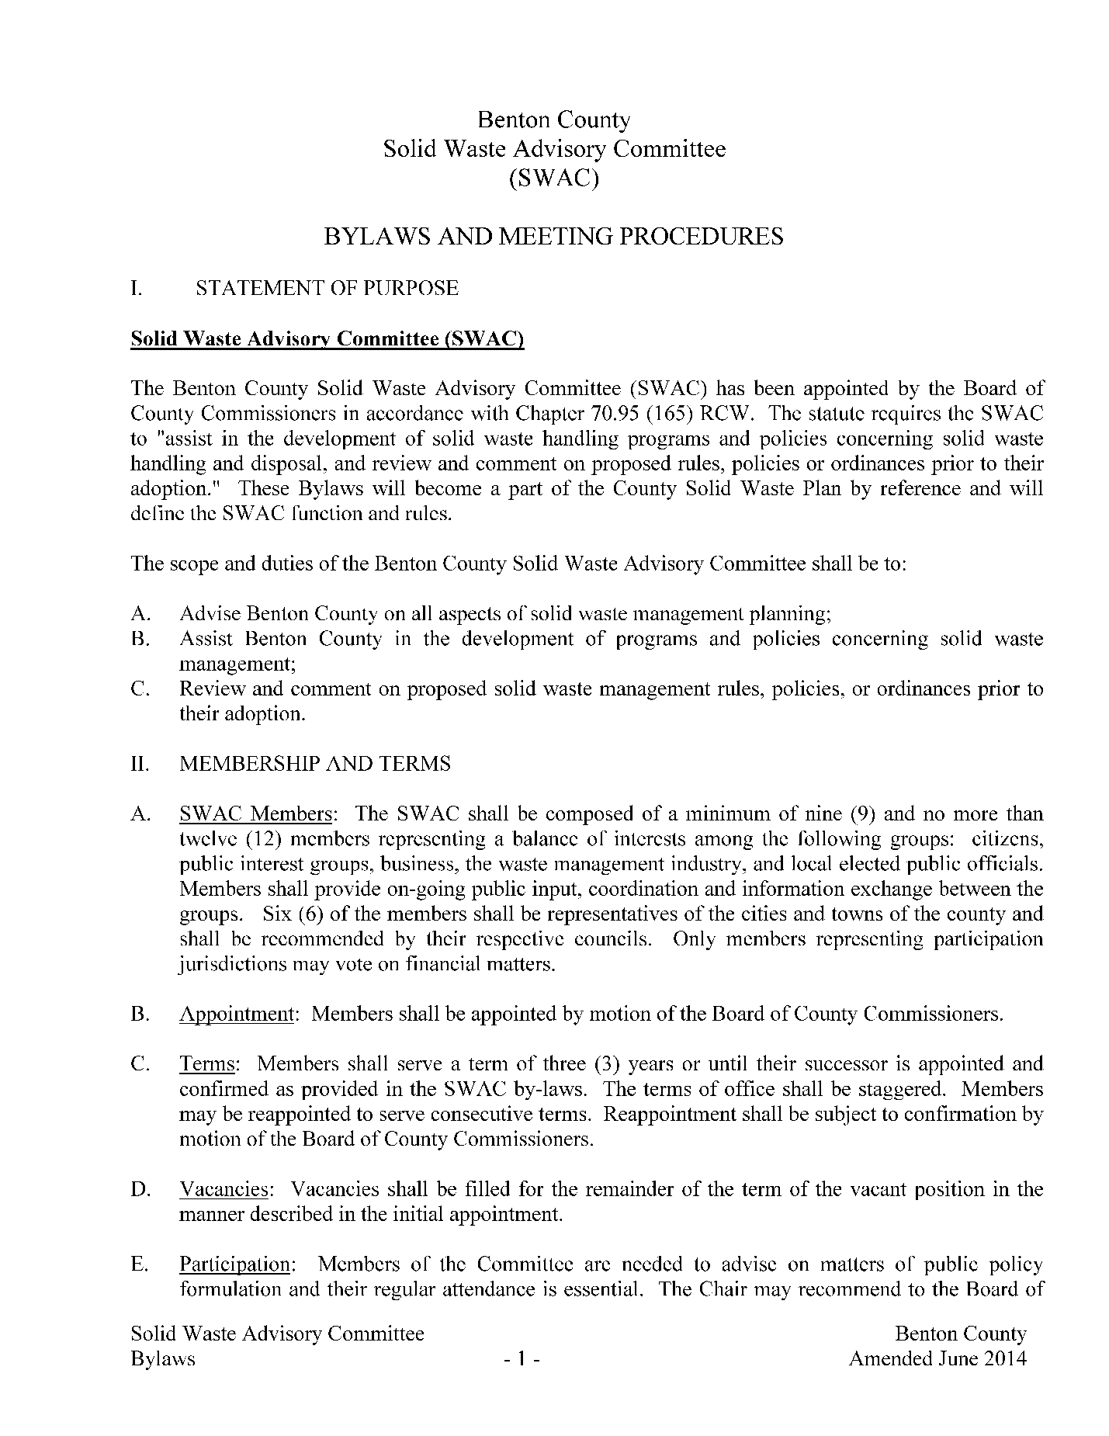
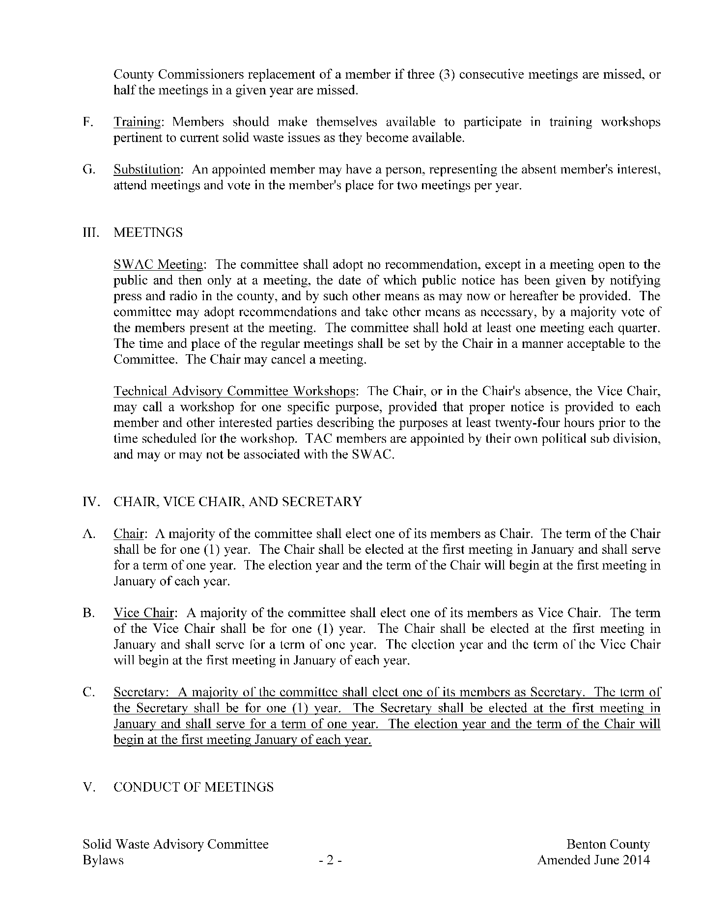
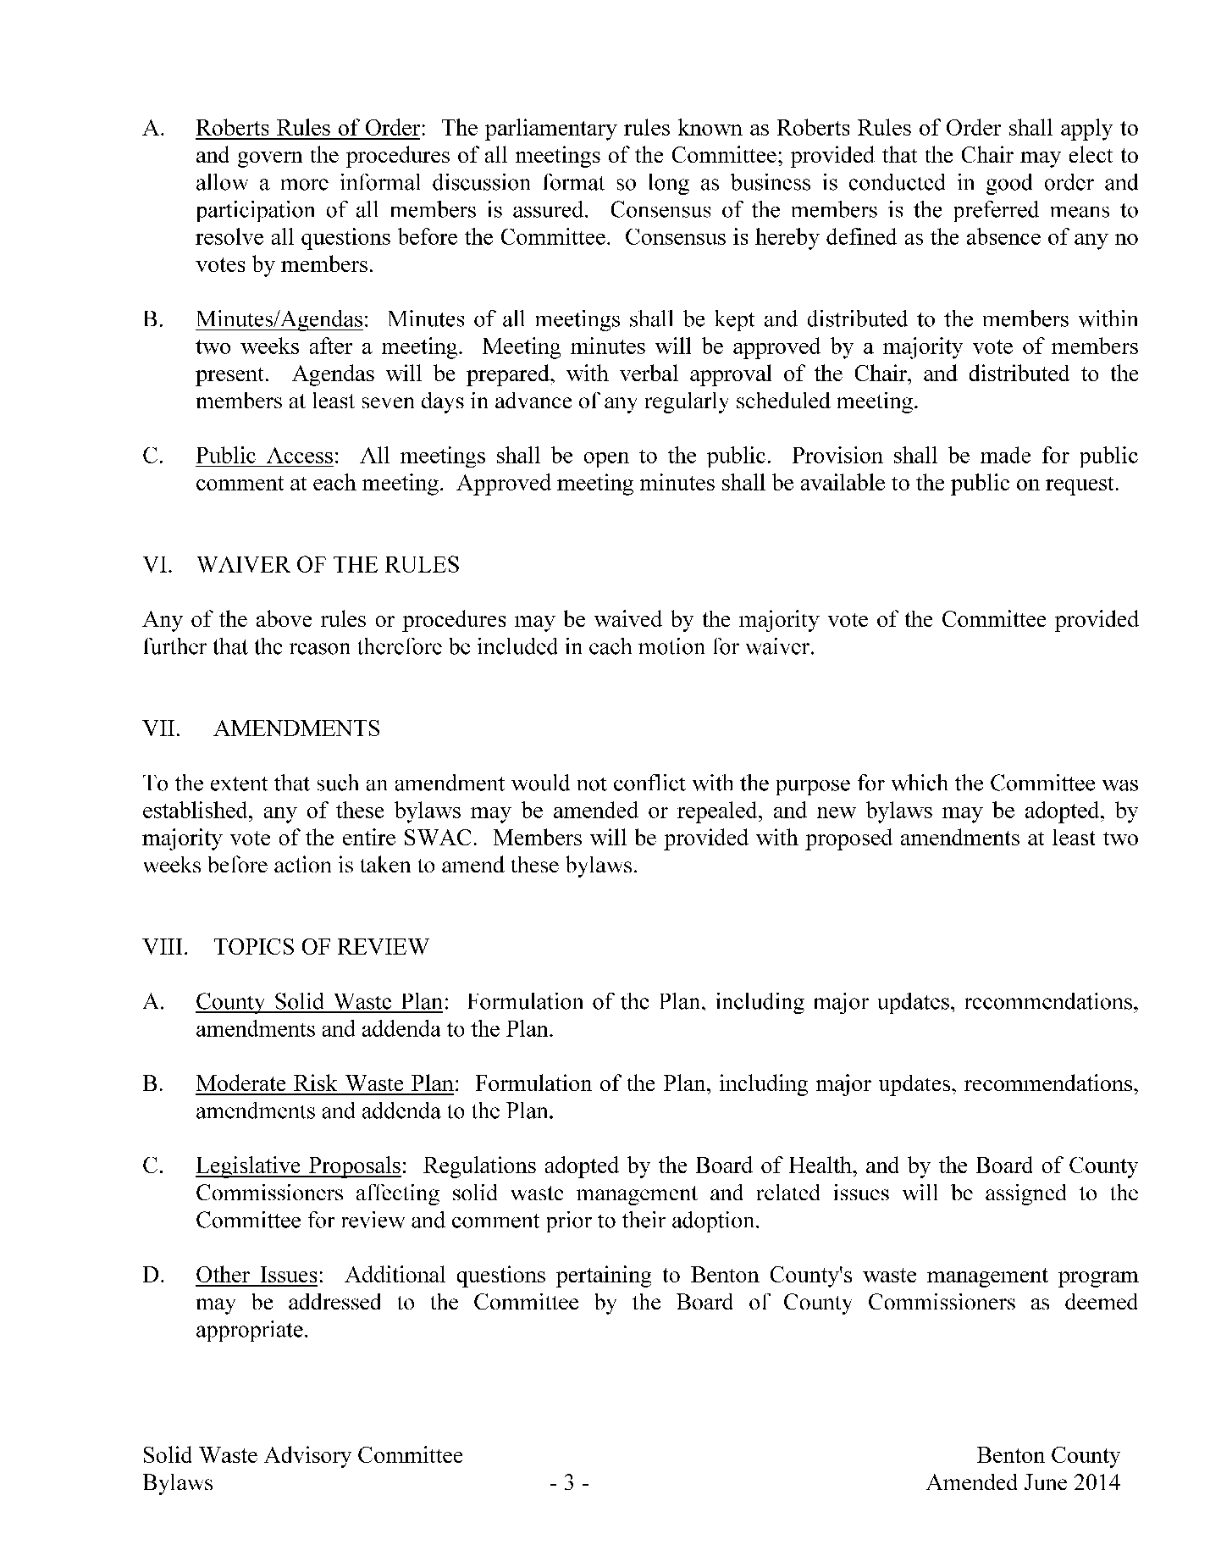
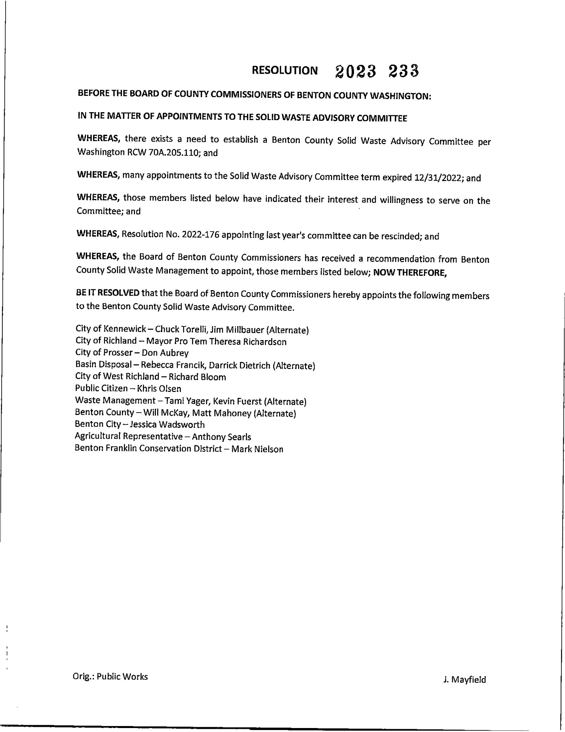

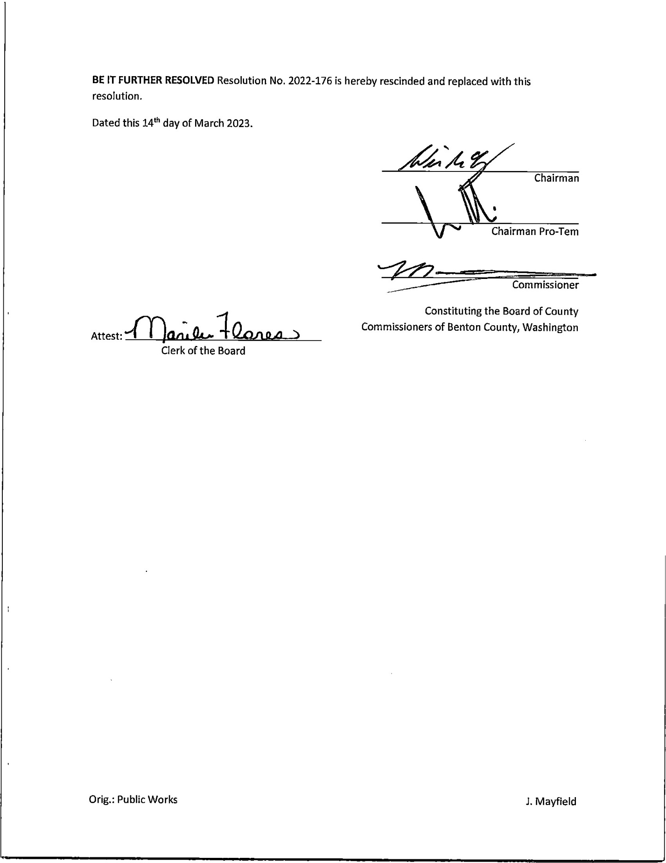

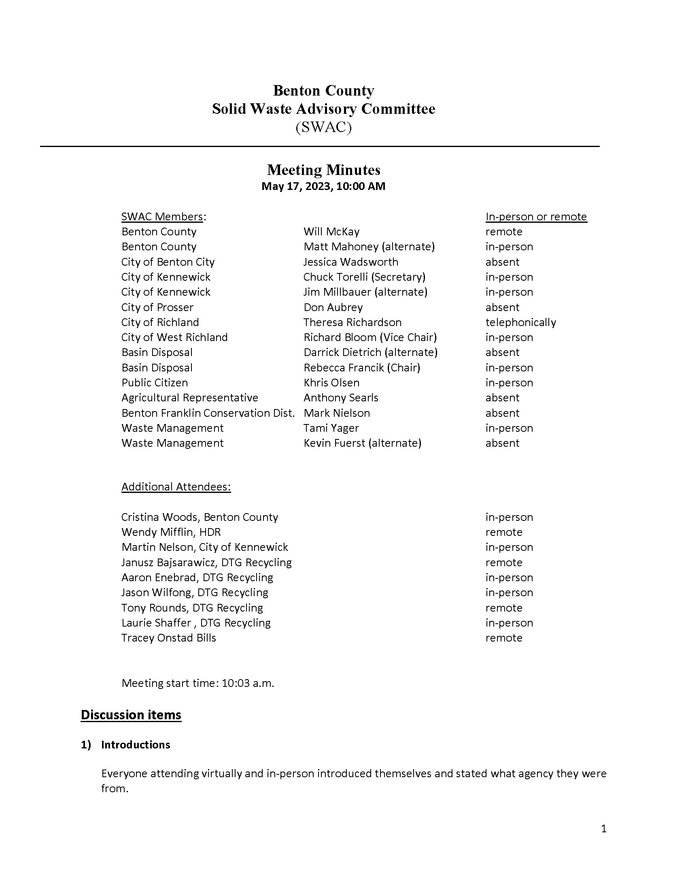

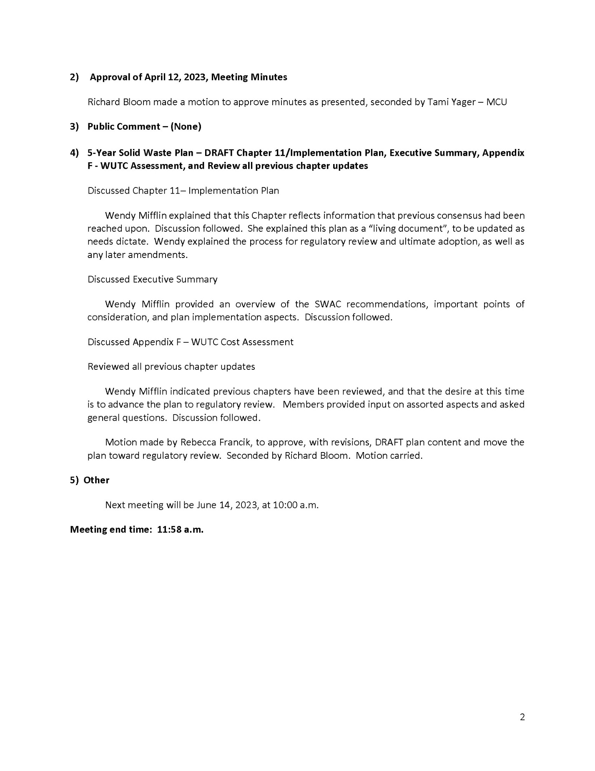

This page intentionally left blank.
Appendix D:
Status of 2013 Plan Recommendations

This page intentionally left blank.

Appendix D – Status of Recommendations – 2013 Benton County Solid Waste Management Plan
Chapter | Recommendation | Implementation Status
3. Outreach and Education | 1. Update Website. | Ongoing
3. Outreach and Education | 2. Provide Technical Assistance to Schools and Businesses. | Ongoing
3. Outreach and Education | 3. Arrange Recycling Facility Tours/Interactive Education. | Ongoing
3. Waste Reduction | 1. Support Product Stewardship and Extended Producer Responsibility Policies. | Ongoing
3. Waste Reduction | 2. Promote Environmentally Preferable Products Preference and Purchasing. | Ongoing
3. Waste Reduction | 3. Promote Waste Reduction Practices in County and City operations. | Ongoing
3. Waste Reduction | 4. Promote Use of Online Materials Exchanges. | Ongoing
3. Waste Reduction | 5. Encourage Use of Reuse Stores and organizations. | Ongoing
3. Waste Reduction | 6. Consider Implementing Waste Reduction Requirements for New Developments. | Not Accomplished
3. Waste Reduction | 7. Monitor Progress and Efficacy of Waste Management and Reduction Measures. | Done at Time of Plan Updates
3. Recycling | 1. Evaluate Need for Additional Materials and New Locations for Drop-Box Program. | Ongoing
3. Recycling | 2. Consider Implementing a Rewards Program for Residential Recyclers. | Accomplished
3. Recycling | 3. Provide Commercial Waste Assistance as Needed. | Ongoing
3. Recycling | 4. Evaluate Recycling Opportunities Related to the Wine Industry. | Not Accomplished
3. Organics | 1. Expand Yard Waste Chipping Program as Funding and Markets Become Available. | Ongoing
3. Organics | 2. Encourage Curbside Green Waste Collection for Commercial Customers. | Ongoing
3. Organics | 3. Evaluate Diversion Opportunities for Organic Waste from Wine Industry. | Not Accomplished
4. Collection Systems | 1. Consider Mandatory Collection in Unincorporated Areas. | Not Accomplished
4. Collection Systems | 2. Further Evaluation of Recycling Service Level Changes for County Unincorporated Area. | Under Consideration
5. Transfer and Disposal | 1. The County will monitor, and where appropriate and feasible, provide input into the City of Richland’s process evaluating the feasibility of expanding Horn Rapids Landfill. | Ongoing as Requested
6. Agricultural waste | 1. Continue to Work Cooperatively with Port of Benton and Regional Agencies to Identify Opportunities for Beneficial Use of Organic Residuals from Agriculture. | Not Accomplished
6. Asbestos | 1. Encourage BCAA to Increase Enforcement of Asbestos Waste Disposal Activities. | Not Accomplished
6. Asbestos | 2. Provide Education to Homeowners on Proper Handling and Disposal. | Ongoing
6. Biomedical Waste | 1. Provide educational materials for correct management of medical waste generated by residents. | Ongoing
6. Biomedical Waste | 2. Evaluate feasibility of sharps and outdated pharmaceuticals collection at household hazardous waste collection sites. | Not Accomplished
6. Construction and Demolition Debris | 1. Provide waste reduction, green building and debris management information to contractors. | Not Accomplished
6. Construction and Demolition Debris | 2. Evaluate establishing C&D and Inert Waste Diversion Specifications for private Projects. | Not Accomplished
6. Construction and Demolition Debris | 3. Evaluate establishing C&D and inert waste diversion specifications for public (city and county) projects. | Not Accomplished
6. Construction and Demolition Debris | 4. Develop a Disaster Management Plan for Benton County. | Not Accomplished
6. Construction and Demolition Debris | 5. Provide additional Oversight of Small Inert Waste Fill Projects. | Ongoing
6. Petroleum Contaminated Waste | 1. Maintain Existing System. | Ongoing
6. Street Wastes | 1. Evaluate Potential Reuse of Street Wastes. | Accomplished
6. Tires | 1. Develop a Plan for Management of Tires accumulated on individual properties. | Accomplished
6. Tires | 2. Evaluate implementation of County and City Purchasing Programs for Recycled Tire Products. | Accomplished
6. Tires | 3. Implement Programs to Reduce Tire Waste. | Not Accomplished
 | 4. Initiate Public Education Programs. | Ongoing
6. Electronic Waste | 1. Monitor E-cycle program effectiveness and submit annual satisfaction report when feasible. | Reviewed Annually
6. Electronic Waste | 2. Provide E-cycle information on website. | Ongoing
6. Electronic Waste | 3. Update website with e-waste collection and recycling information. | Ongoing
7. Moderate Risk Waste | - Household Hazardous Waste Collection- Develop New MRW Facility  - Land purchase  - Permits, site plans, retrofitting for minimal collection only  - Construction of larger facility to allow for processing and storage; operation & labor expenses | Currently Being Implemented
7. Moderate Risk Waste | 2. Continue, and expand as possible, public outreach and education efforts. | To Be Implemented Upon Completion of MRW Facility
7. Moderate Risk Waste | 3. Provide technical assistance, as possible, to small Business. | To Be Implemented Upon Completion of MRW Facility
7. Moderate Risk Waste | 4. Provide opportunities for small business to dispose of small quantities of waste at future facilities. | To Be Implemented Upon Completion of MRW Facility
 | 5. Contact business to sponsor collection events. | Not Implemented
8. Administration and Enforcement | 1. Facilitate interagency relationships on issues related to solid waste management. | Ongoing
8. Administration and Enforcement | 2. The various agencies in the county involved in solid waste management will work together to coordinate  enforcement activities. | Ongoing
8. Administration and Enforcement | 3. The county, cities, and other relevant public agencies, to the extent practicable, will coordinate programs regarding illegal dumping cleanup, education, and prevention. | Ongoing
8. Administration and Enforcement | 4. Implement a coordinated public outreach and education program addressing illegal dumping and related problems. | Ongoing

Appendix E:
SEPA Checklist

This page intentionally left blank.
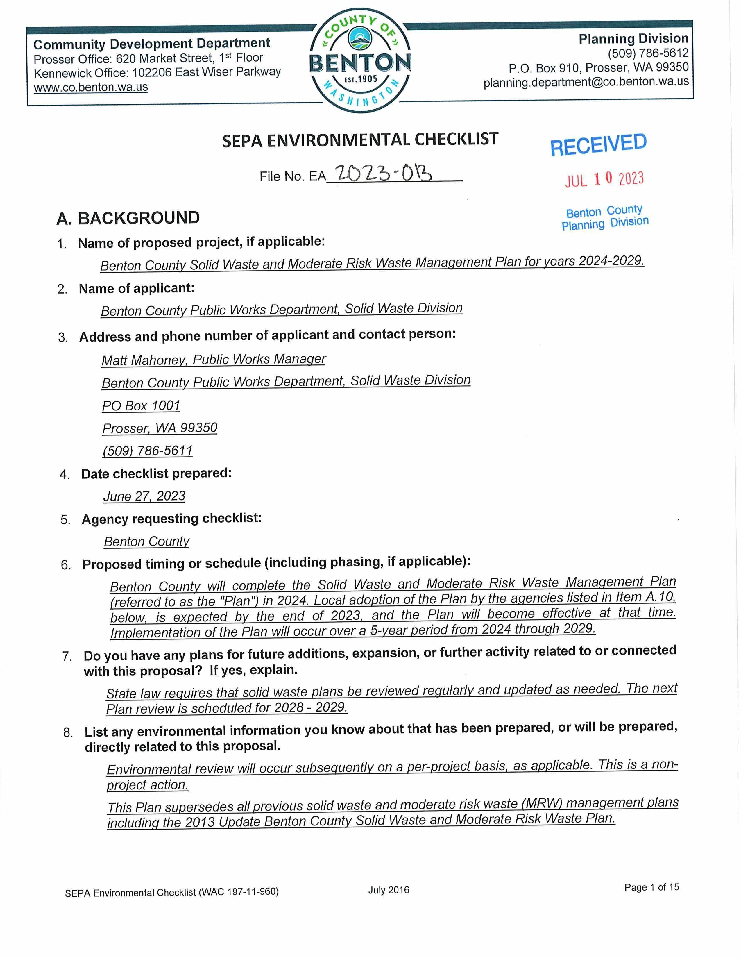
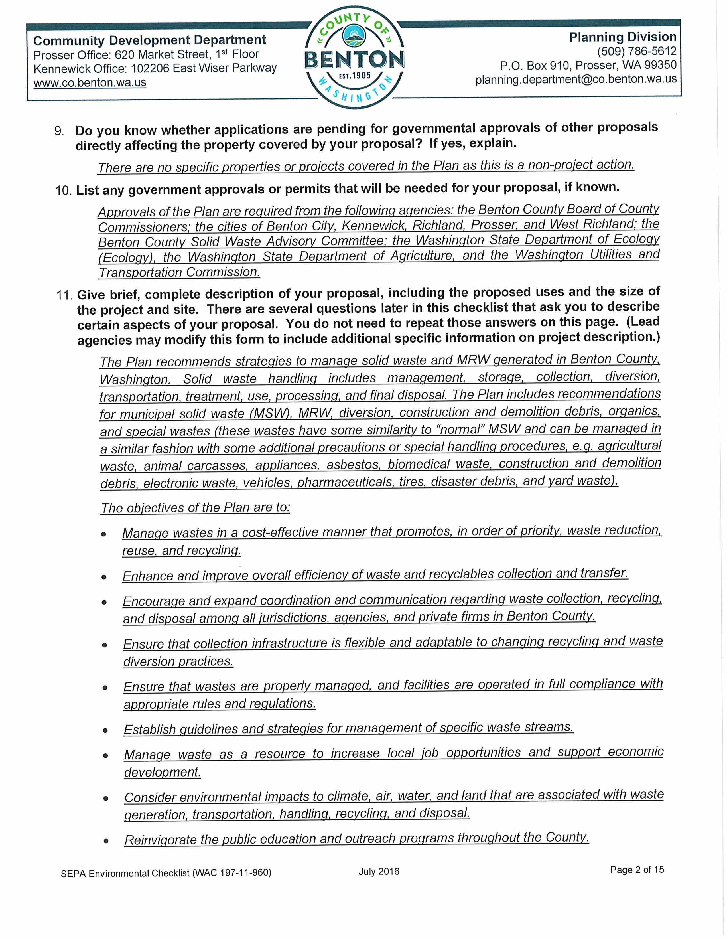
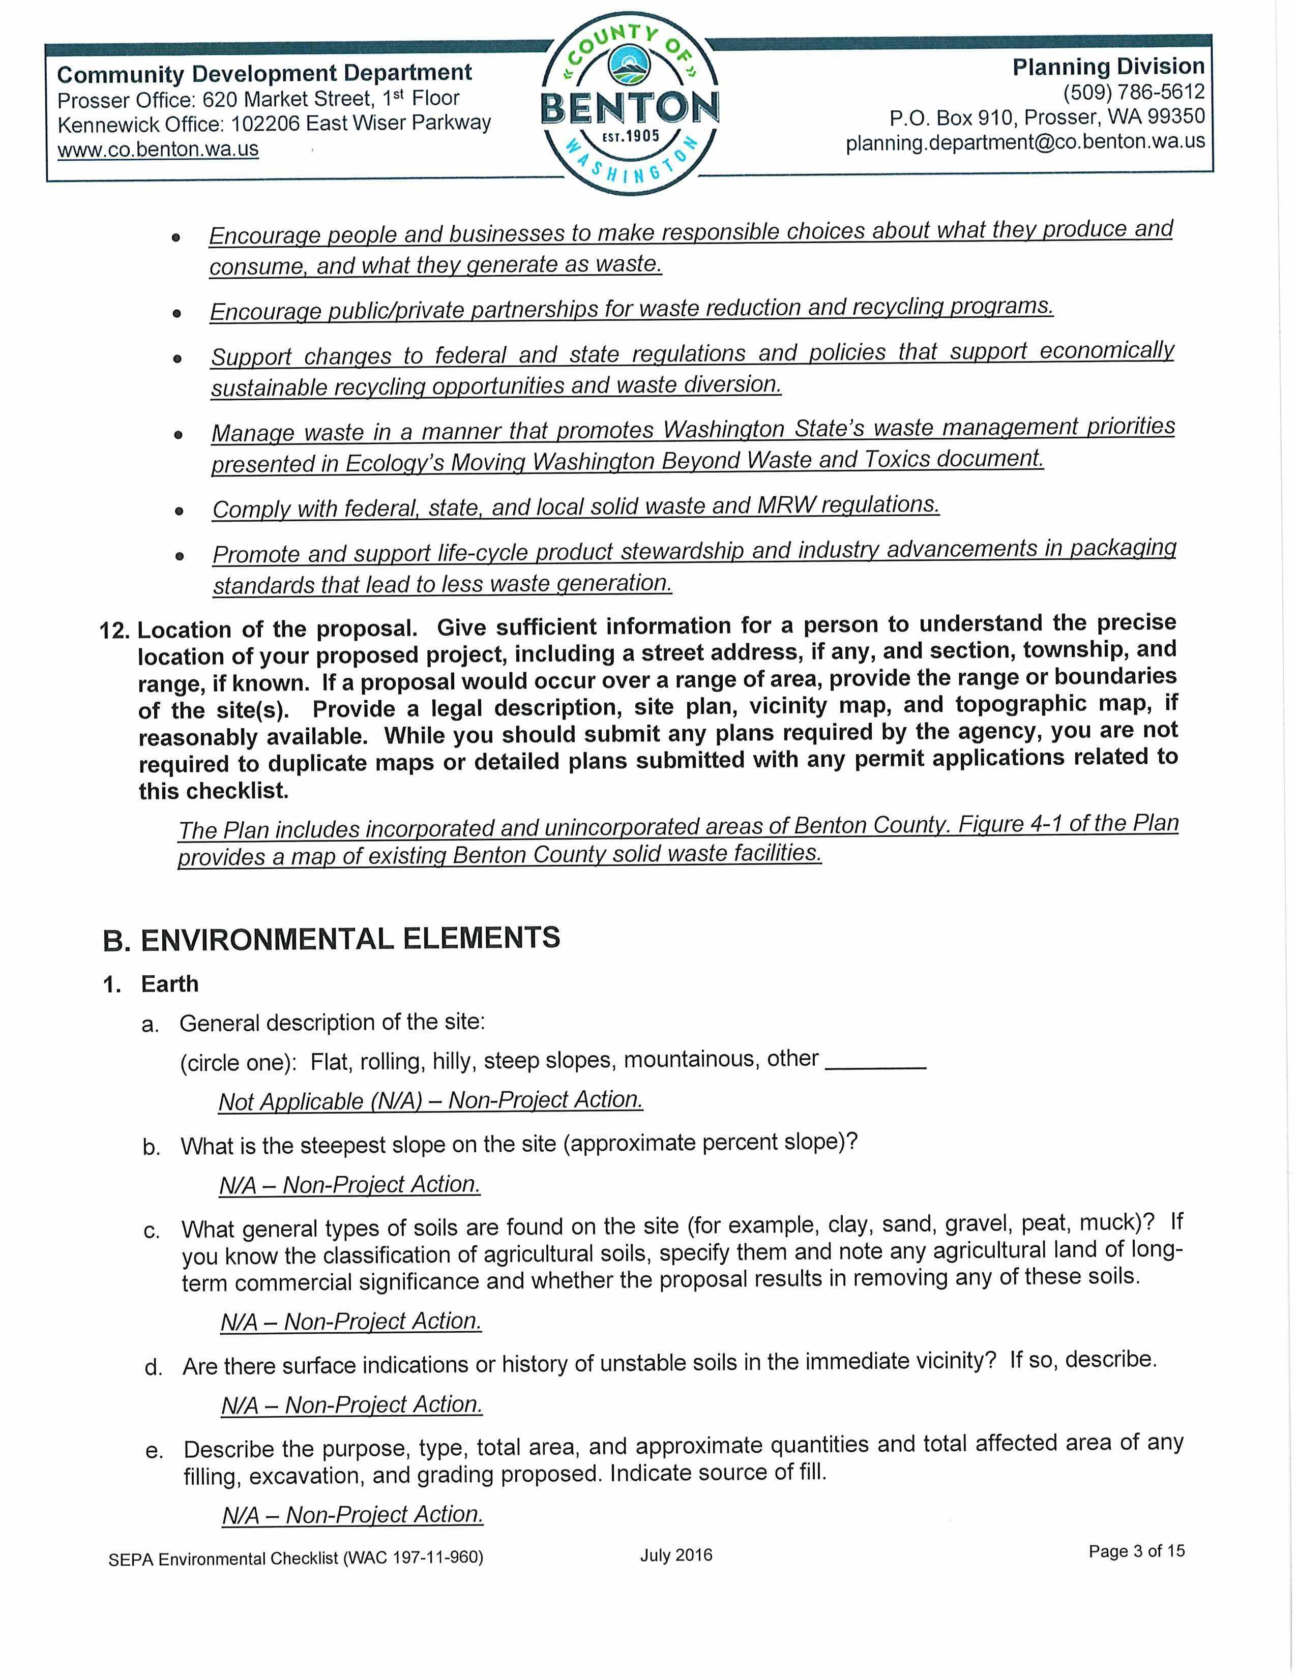
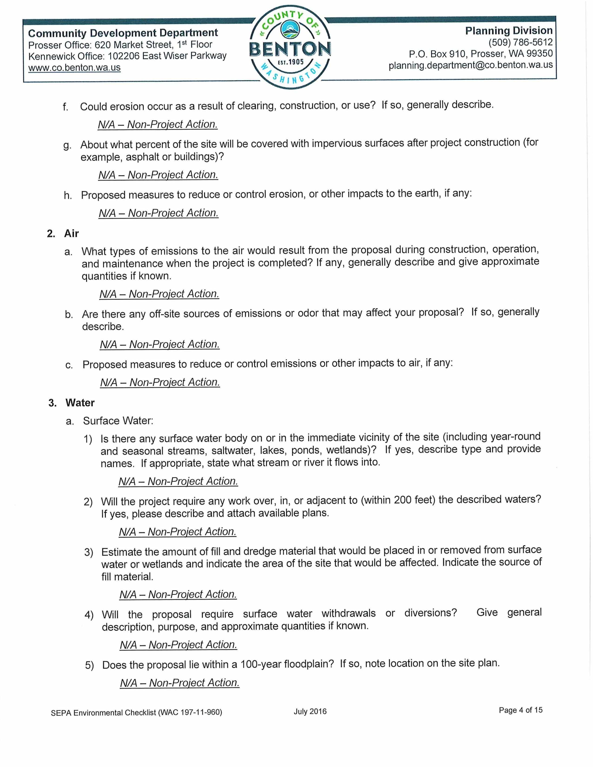
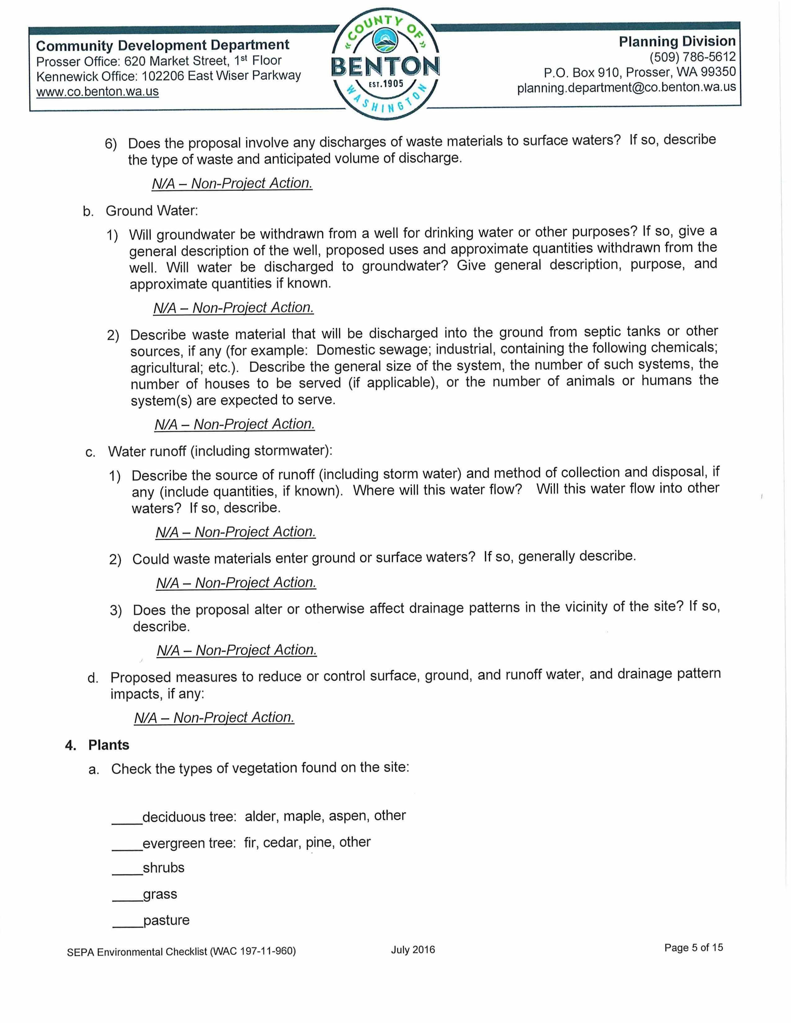
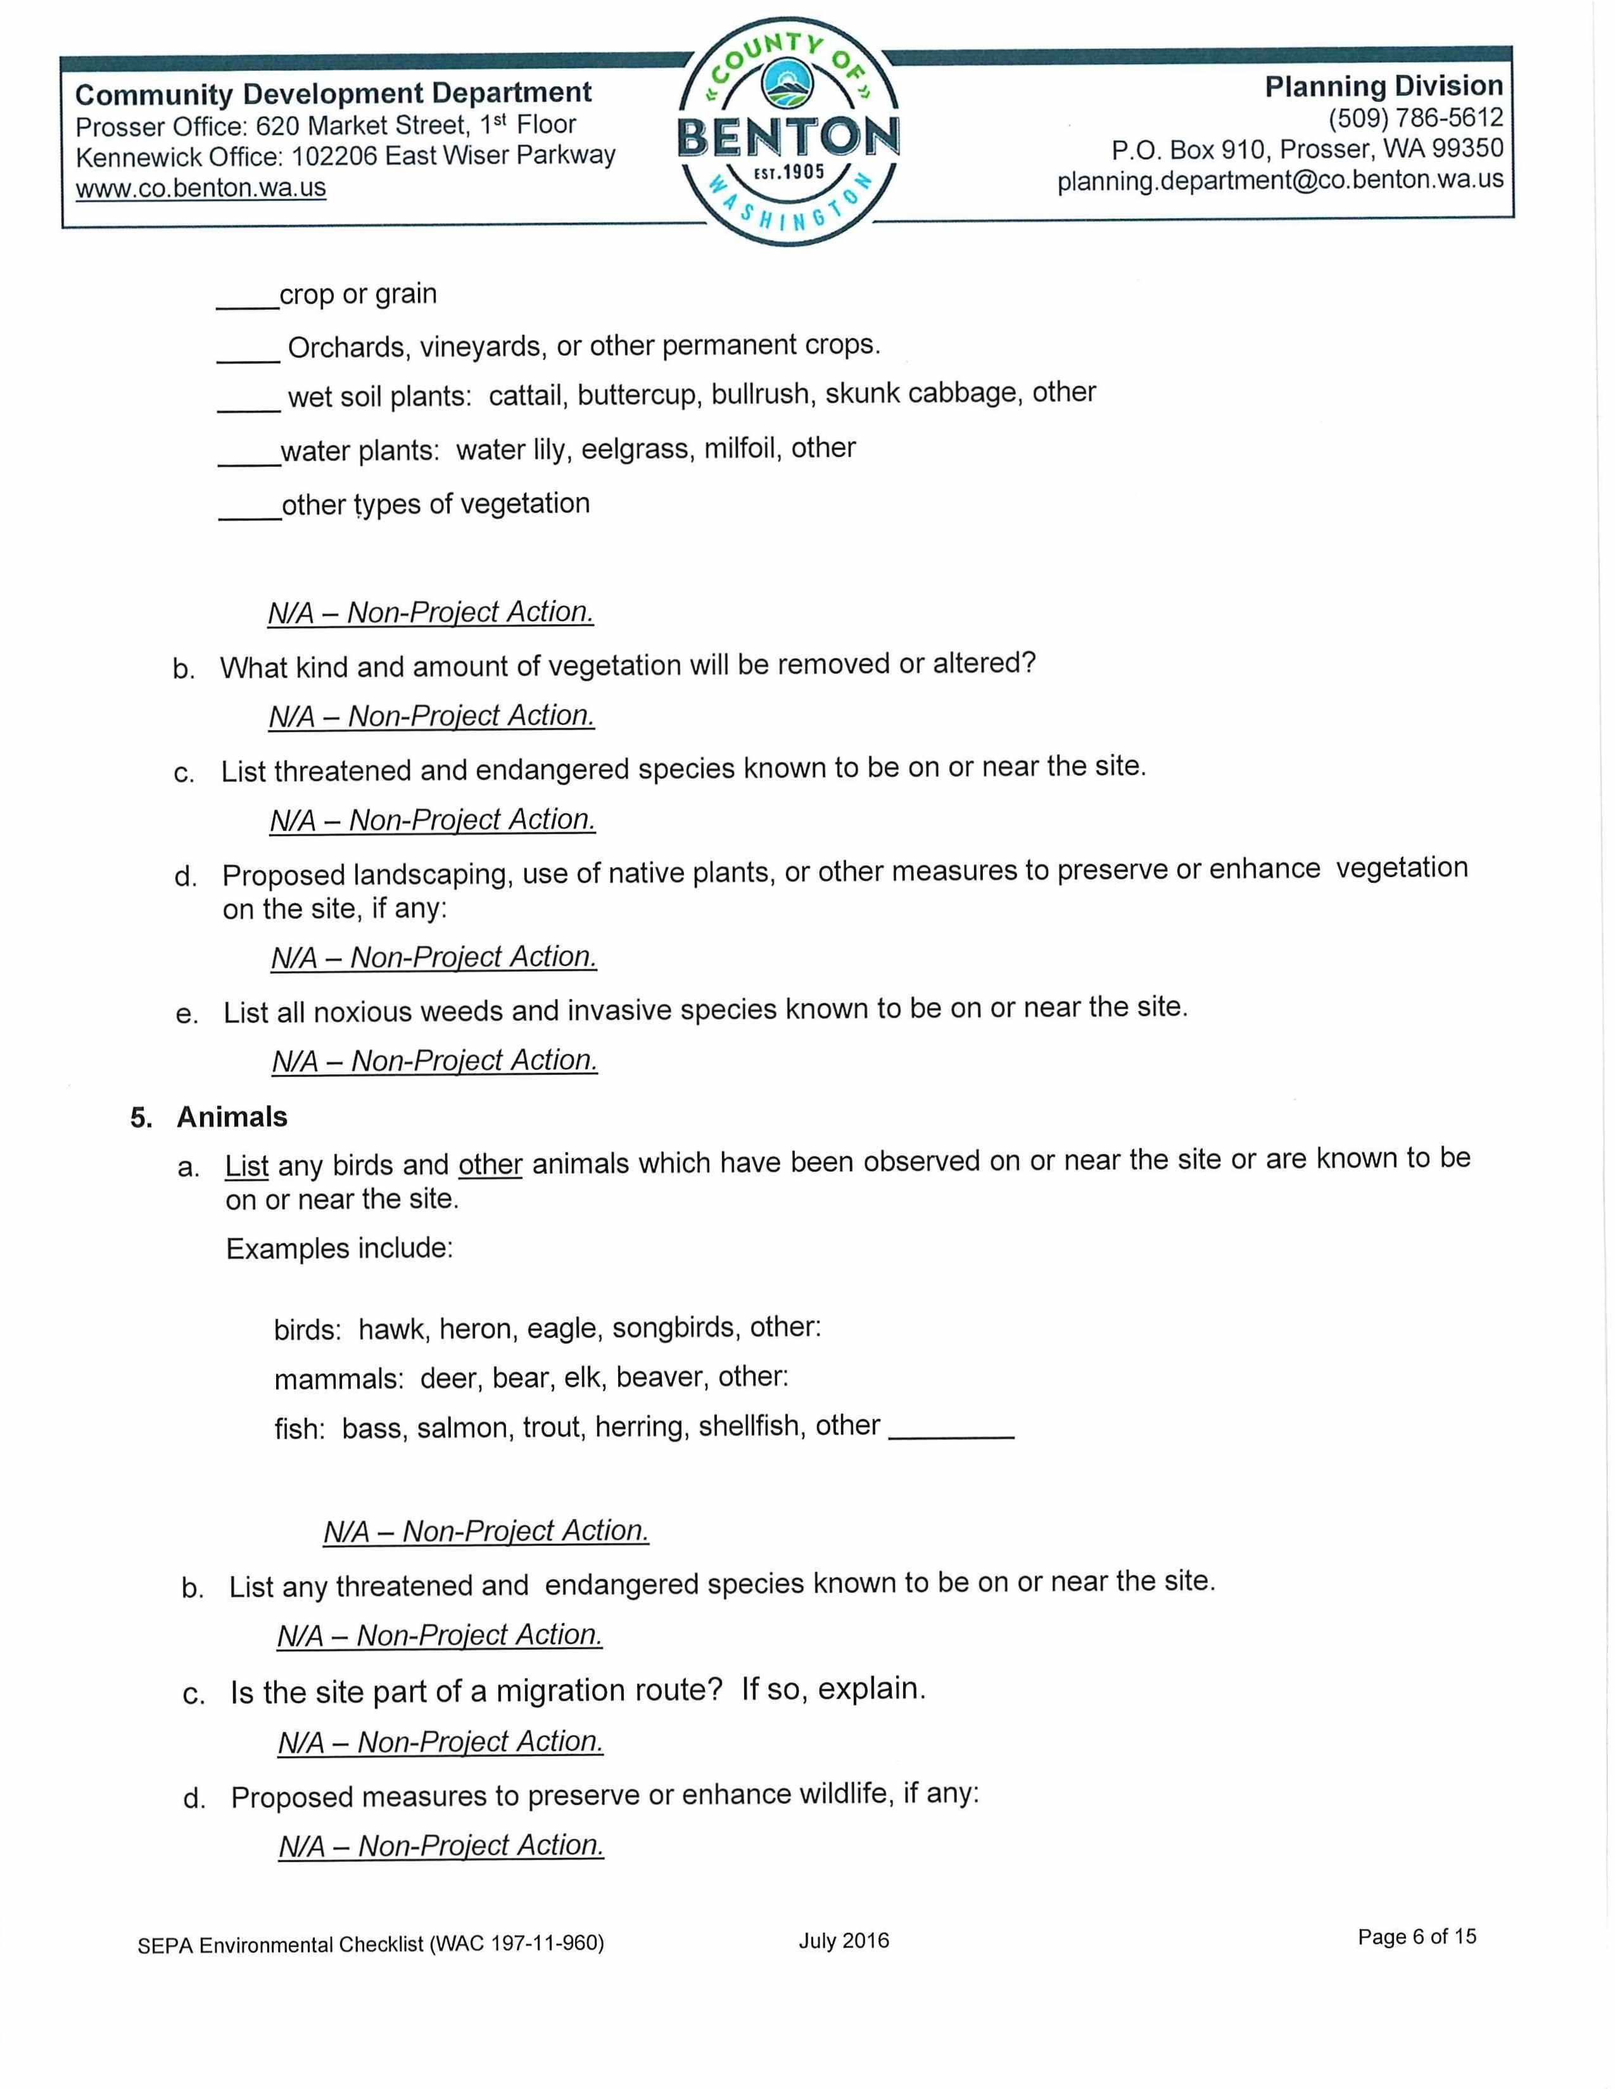
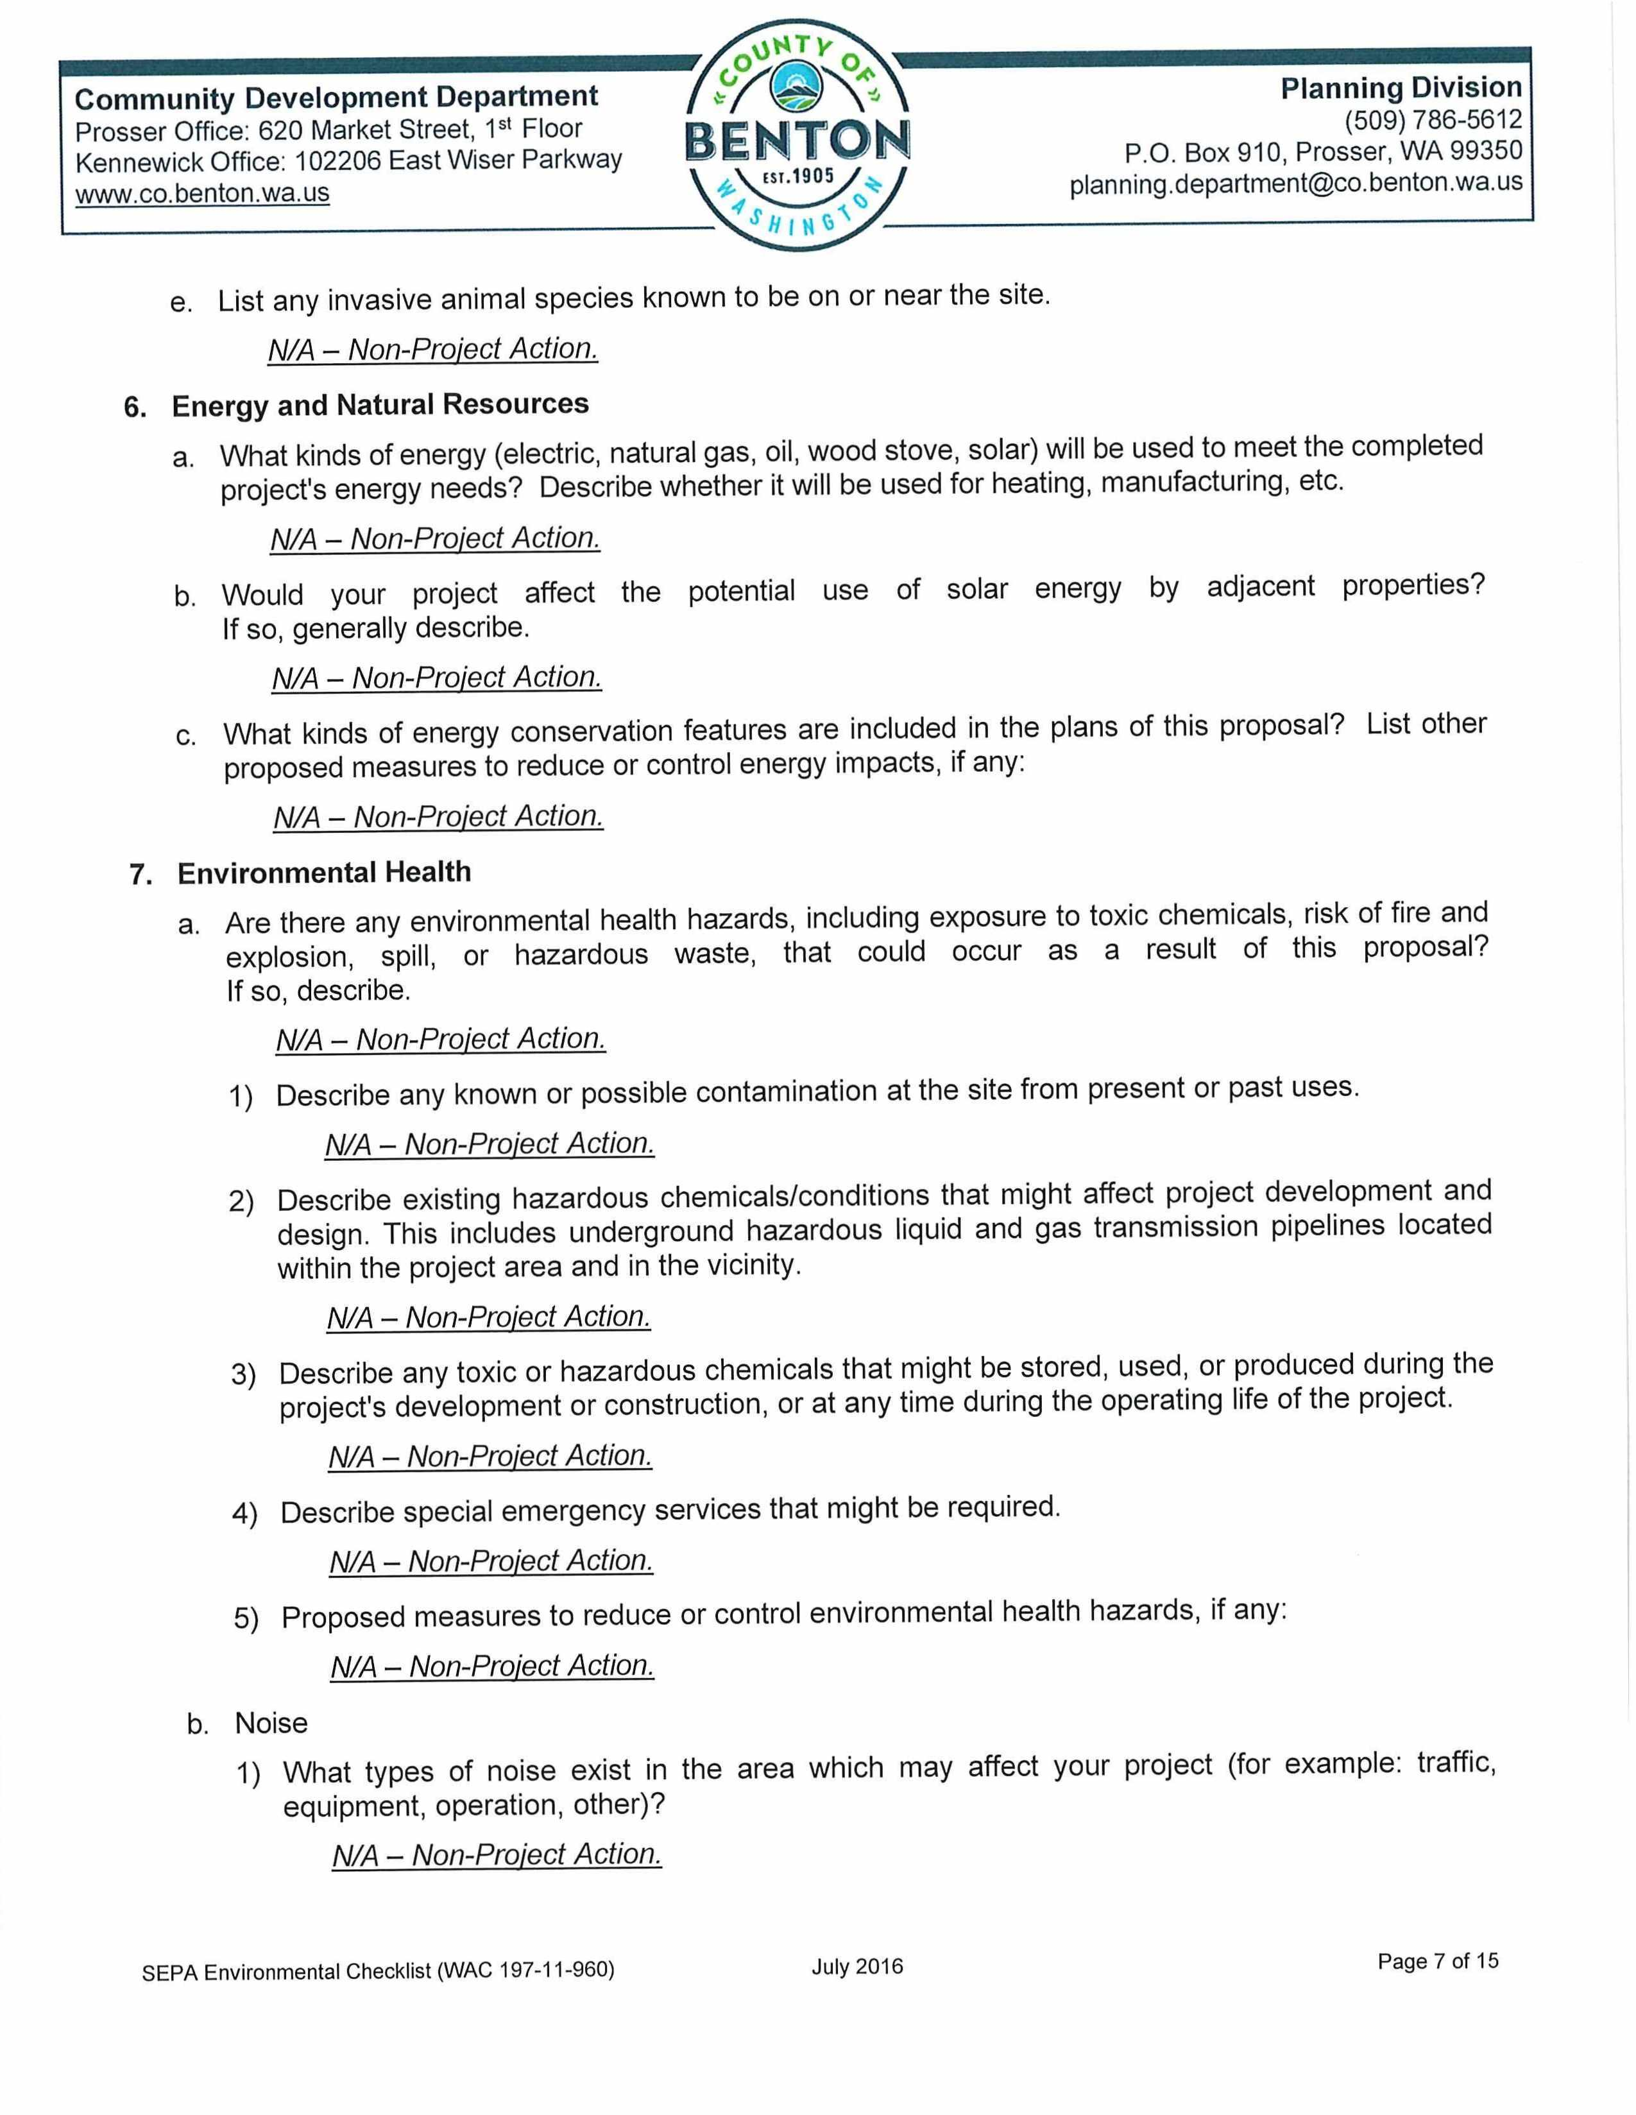
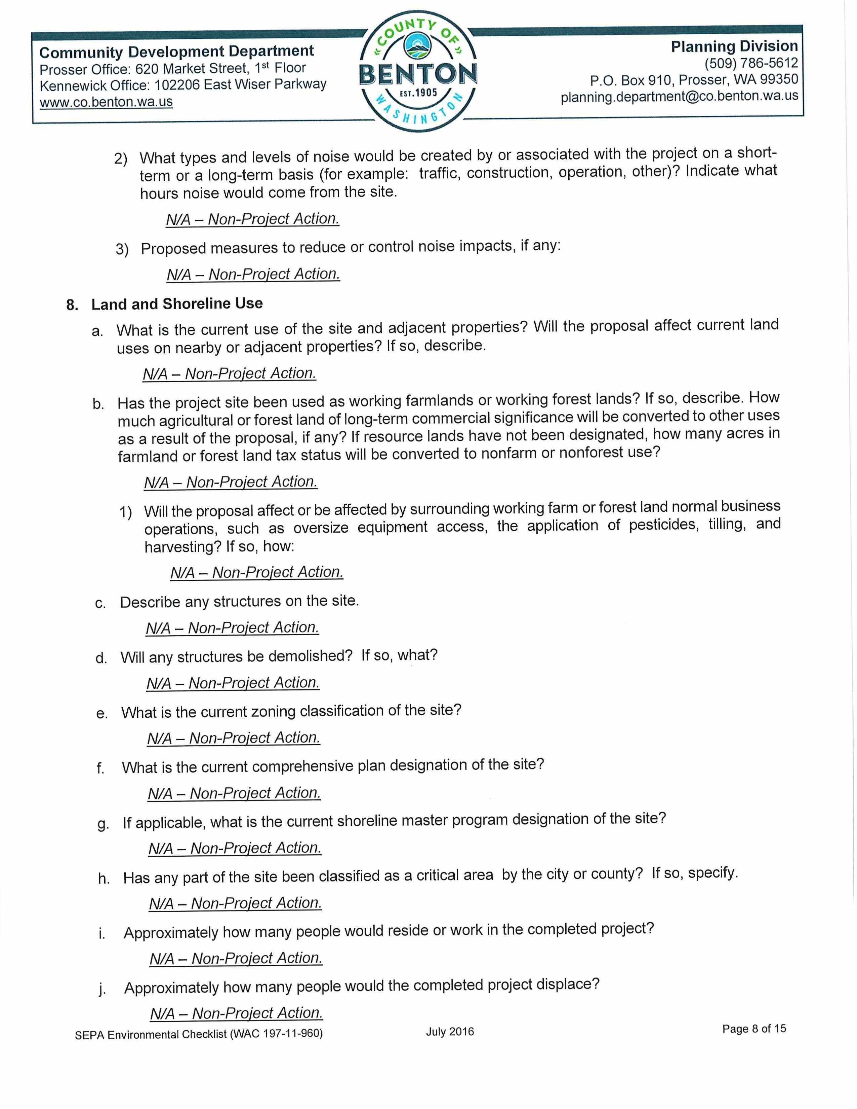
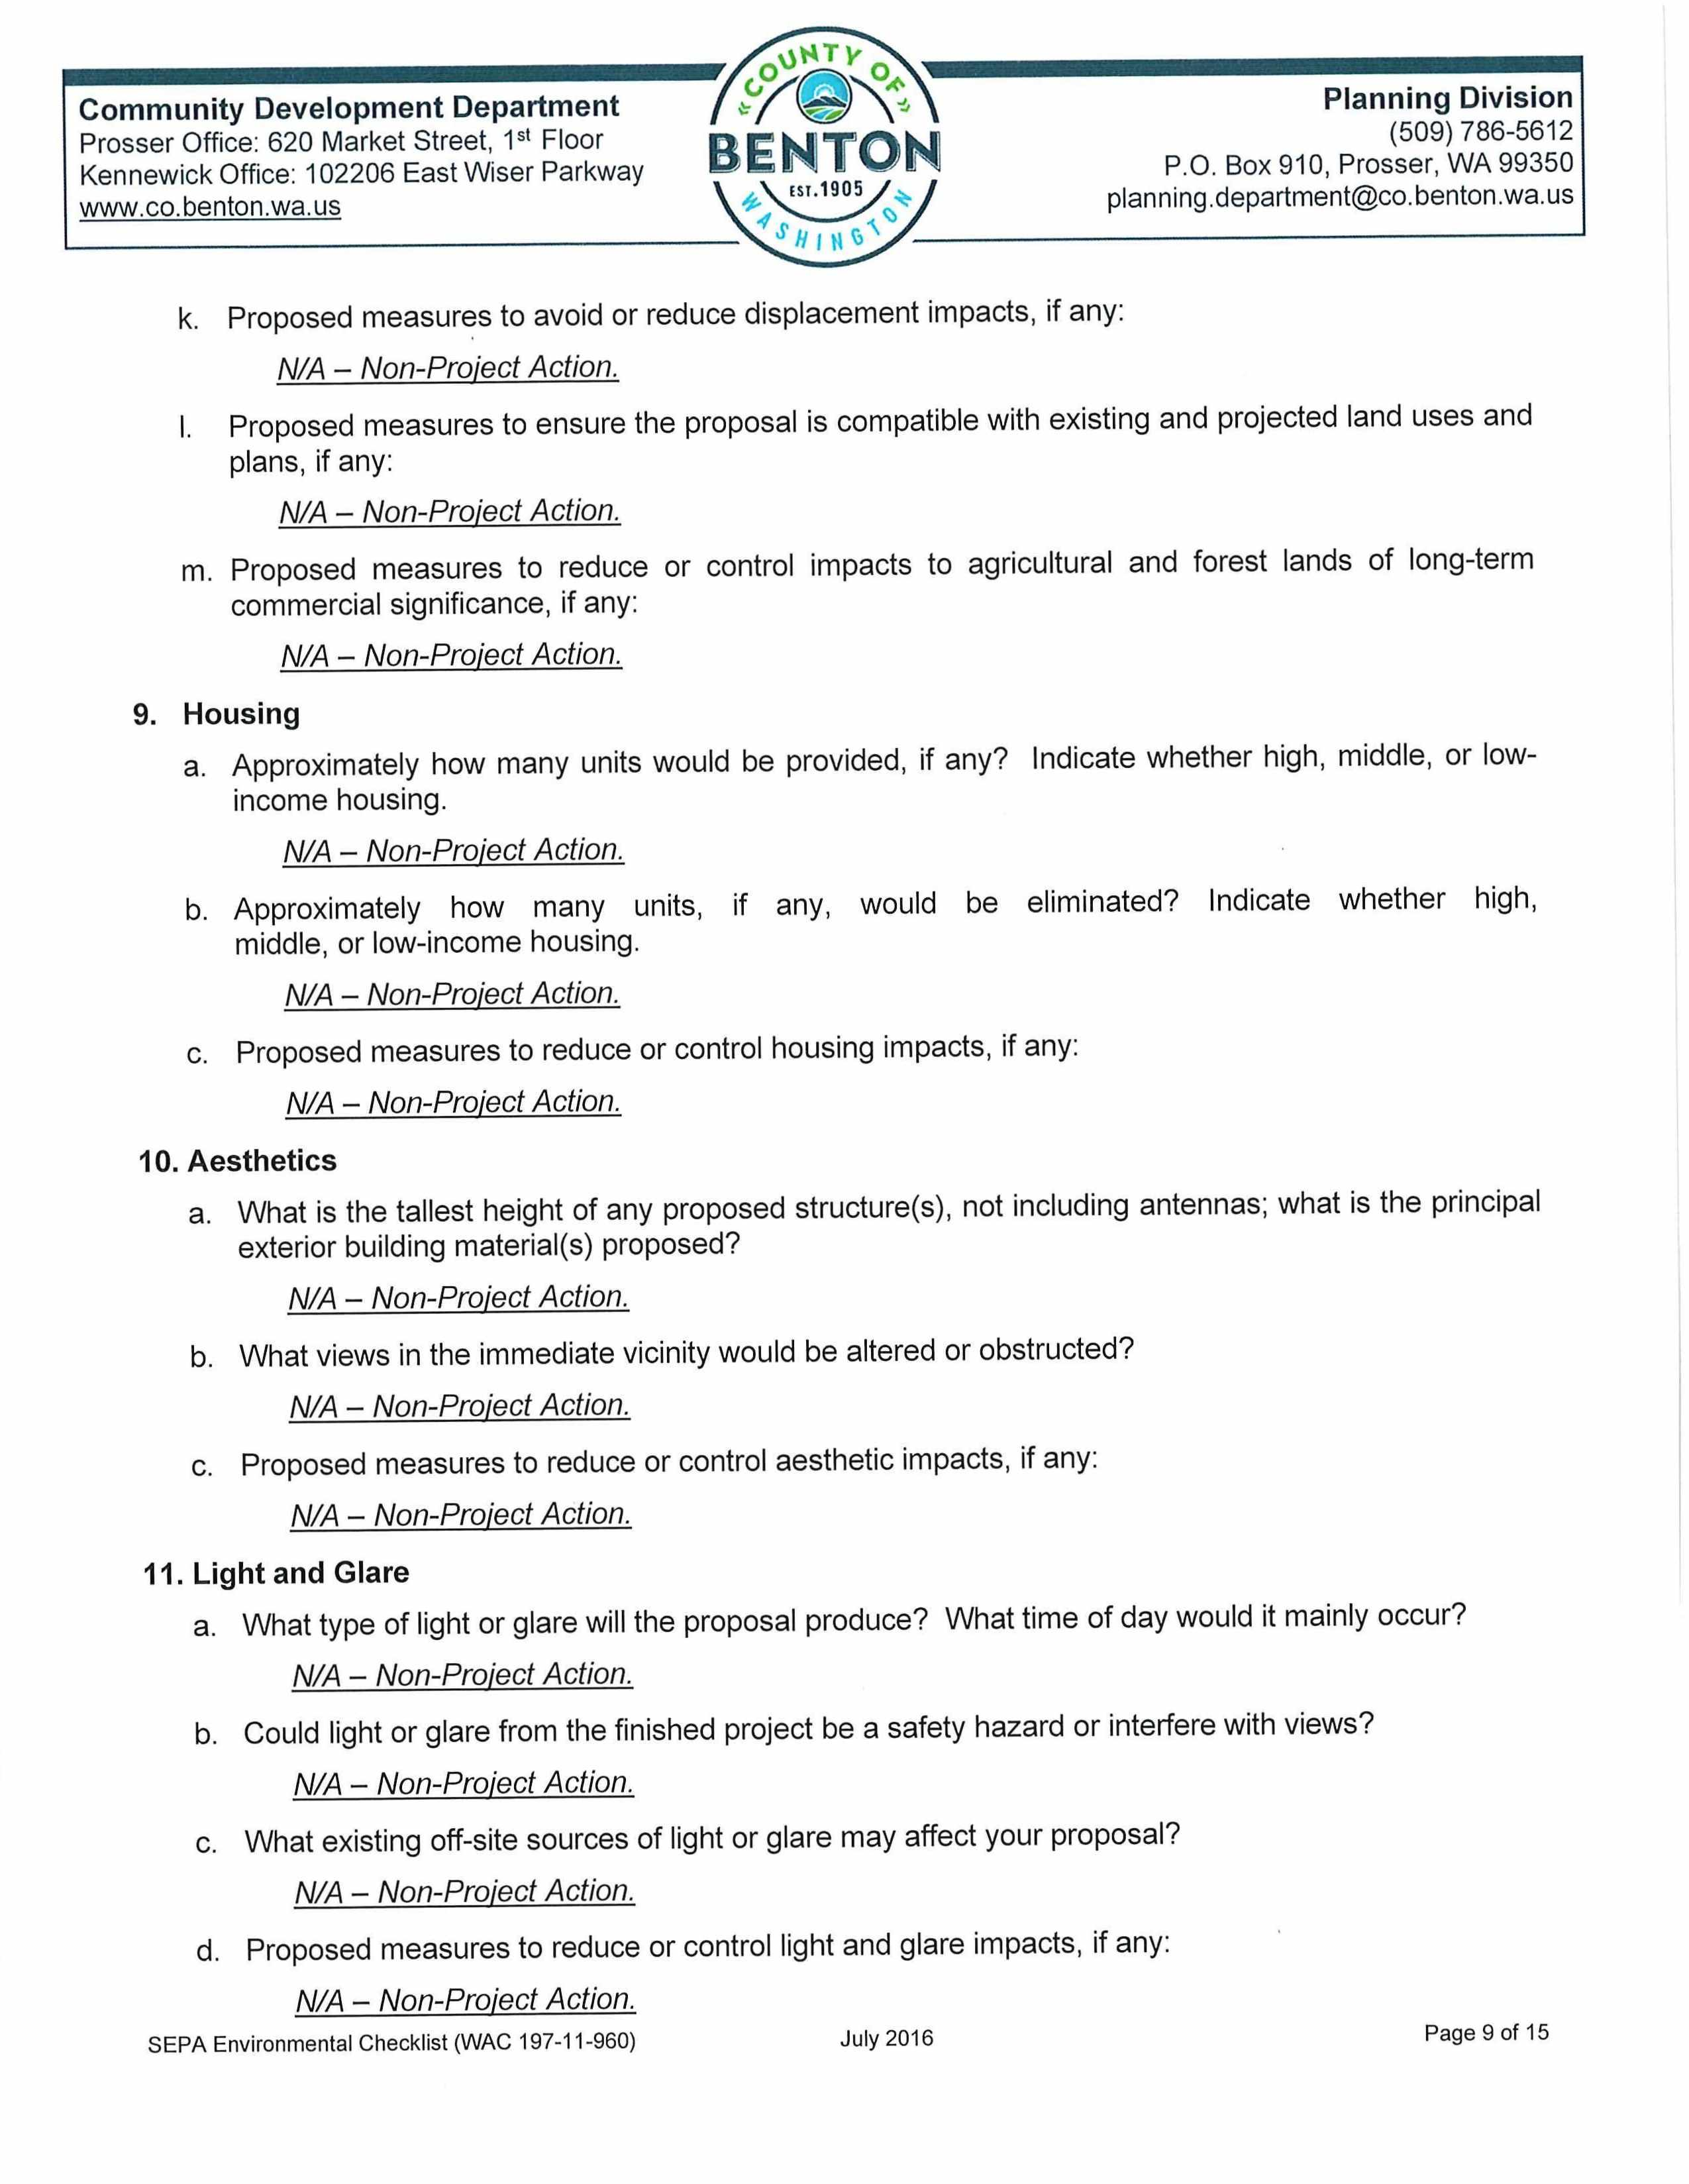
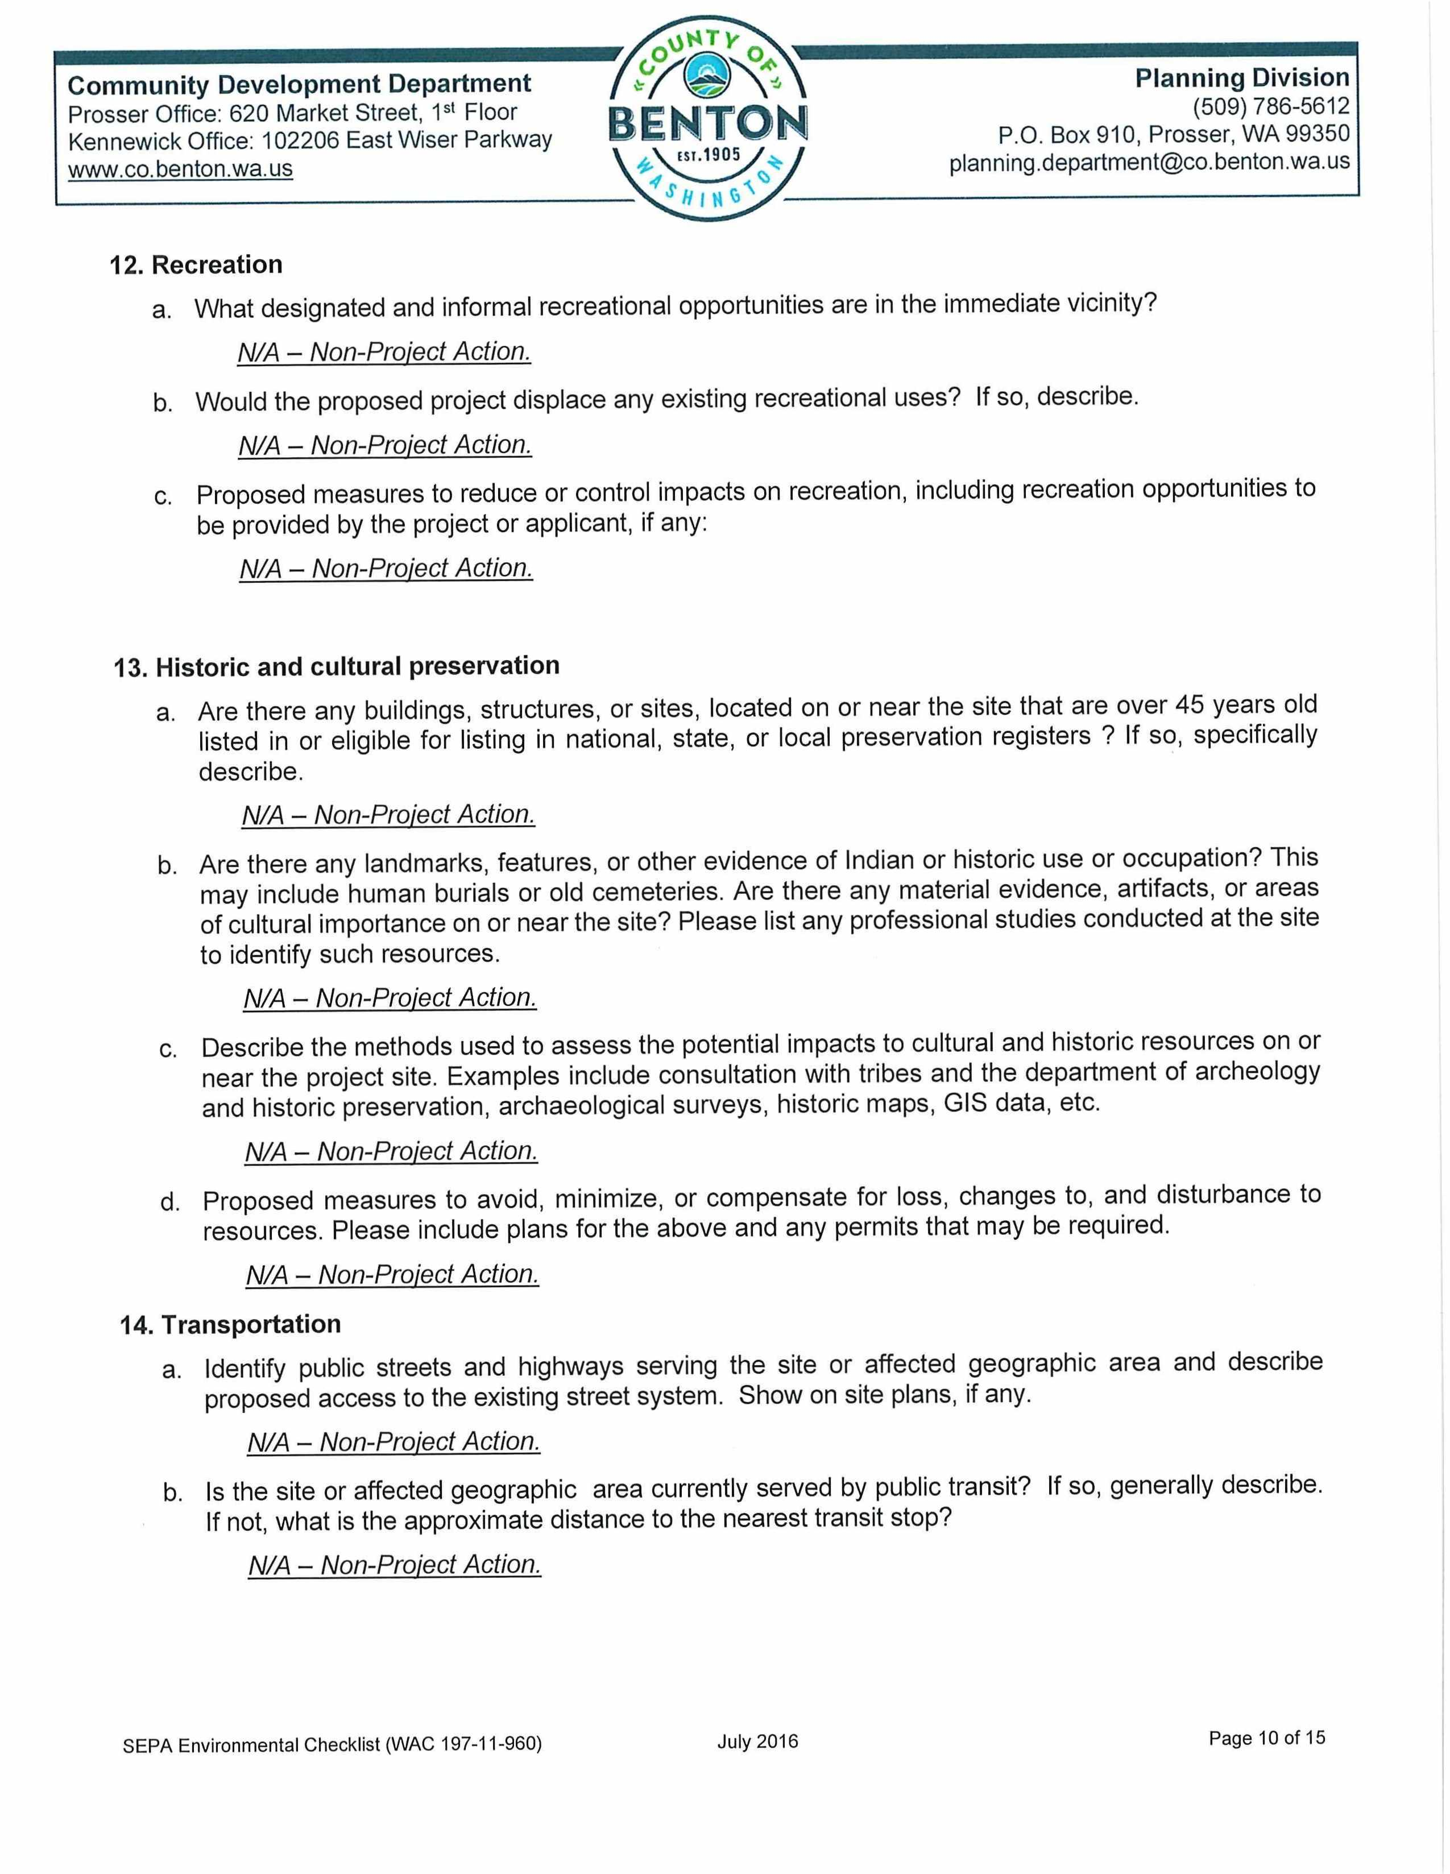
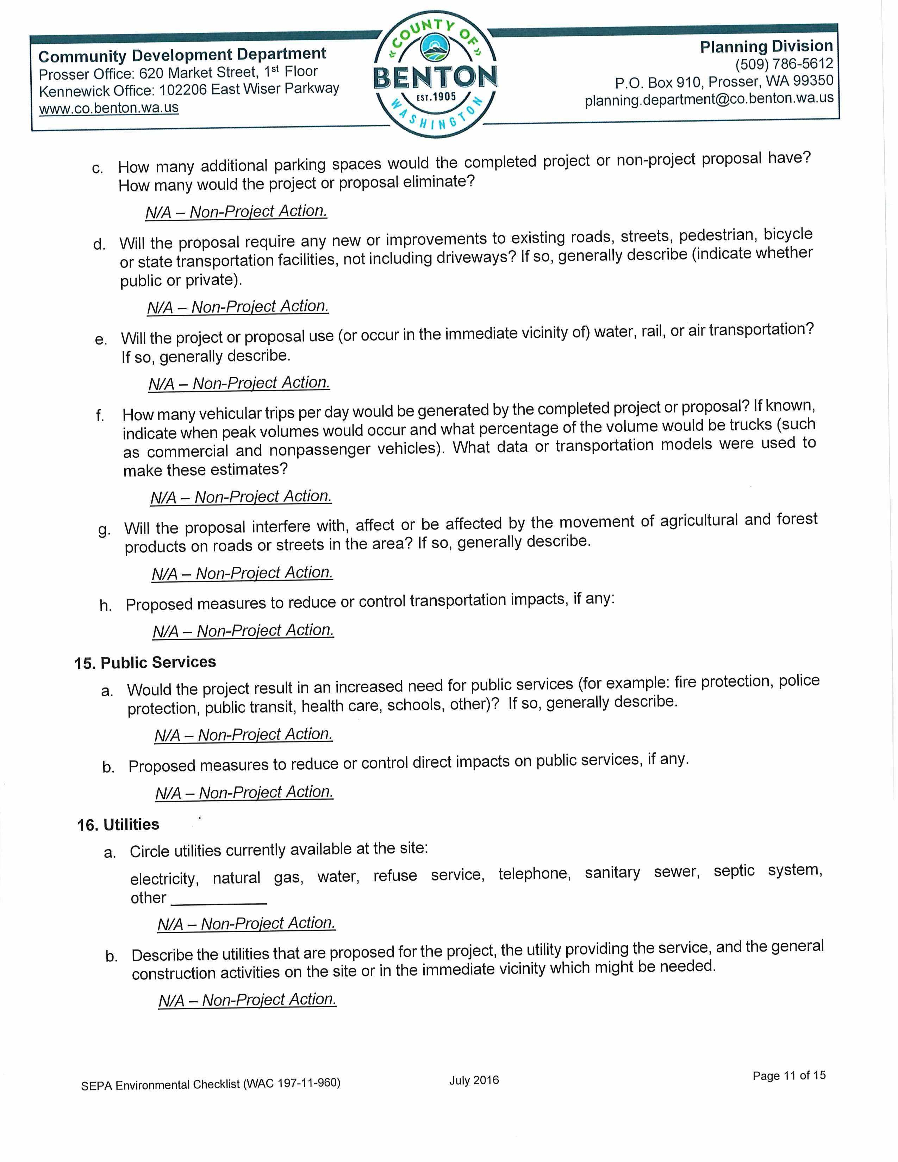
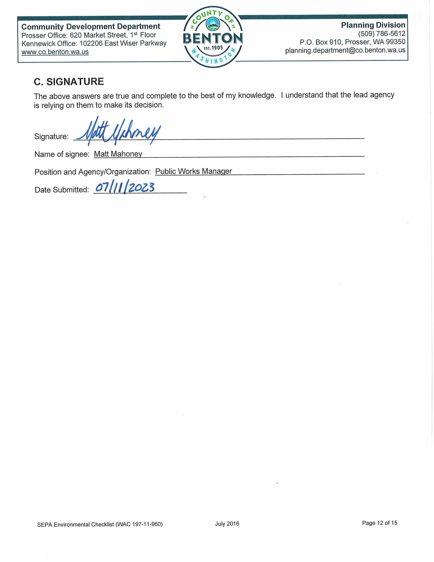
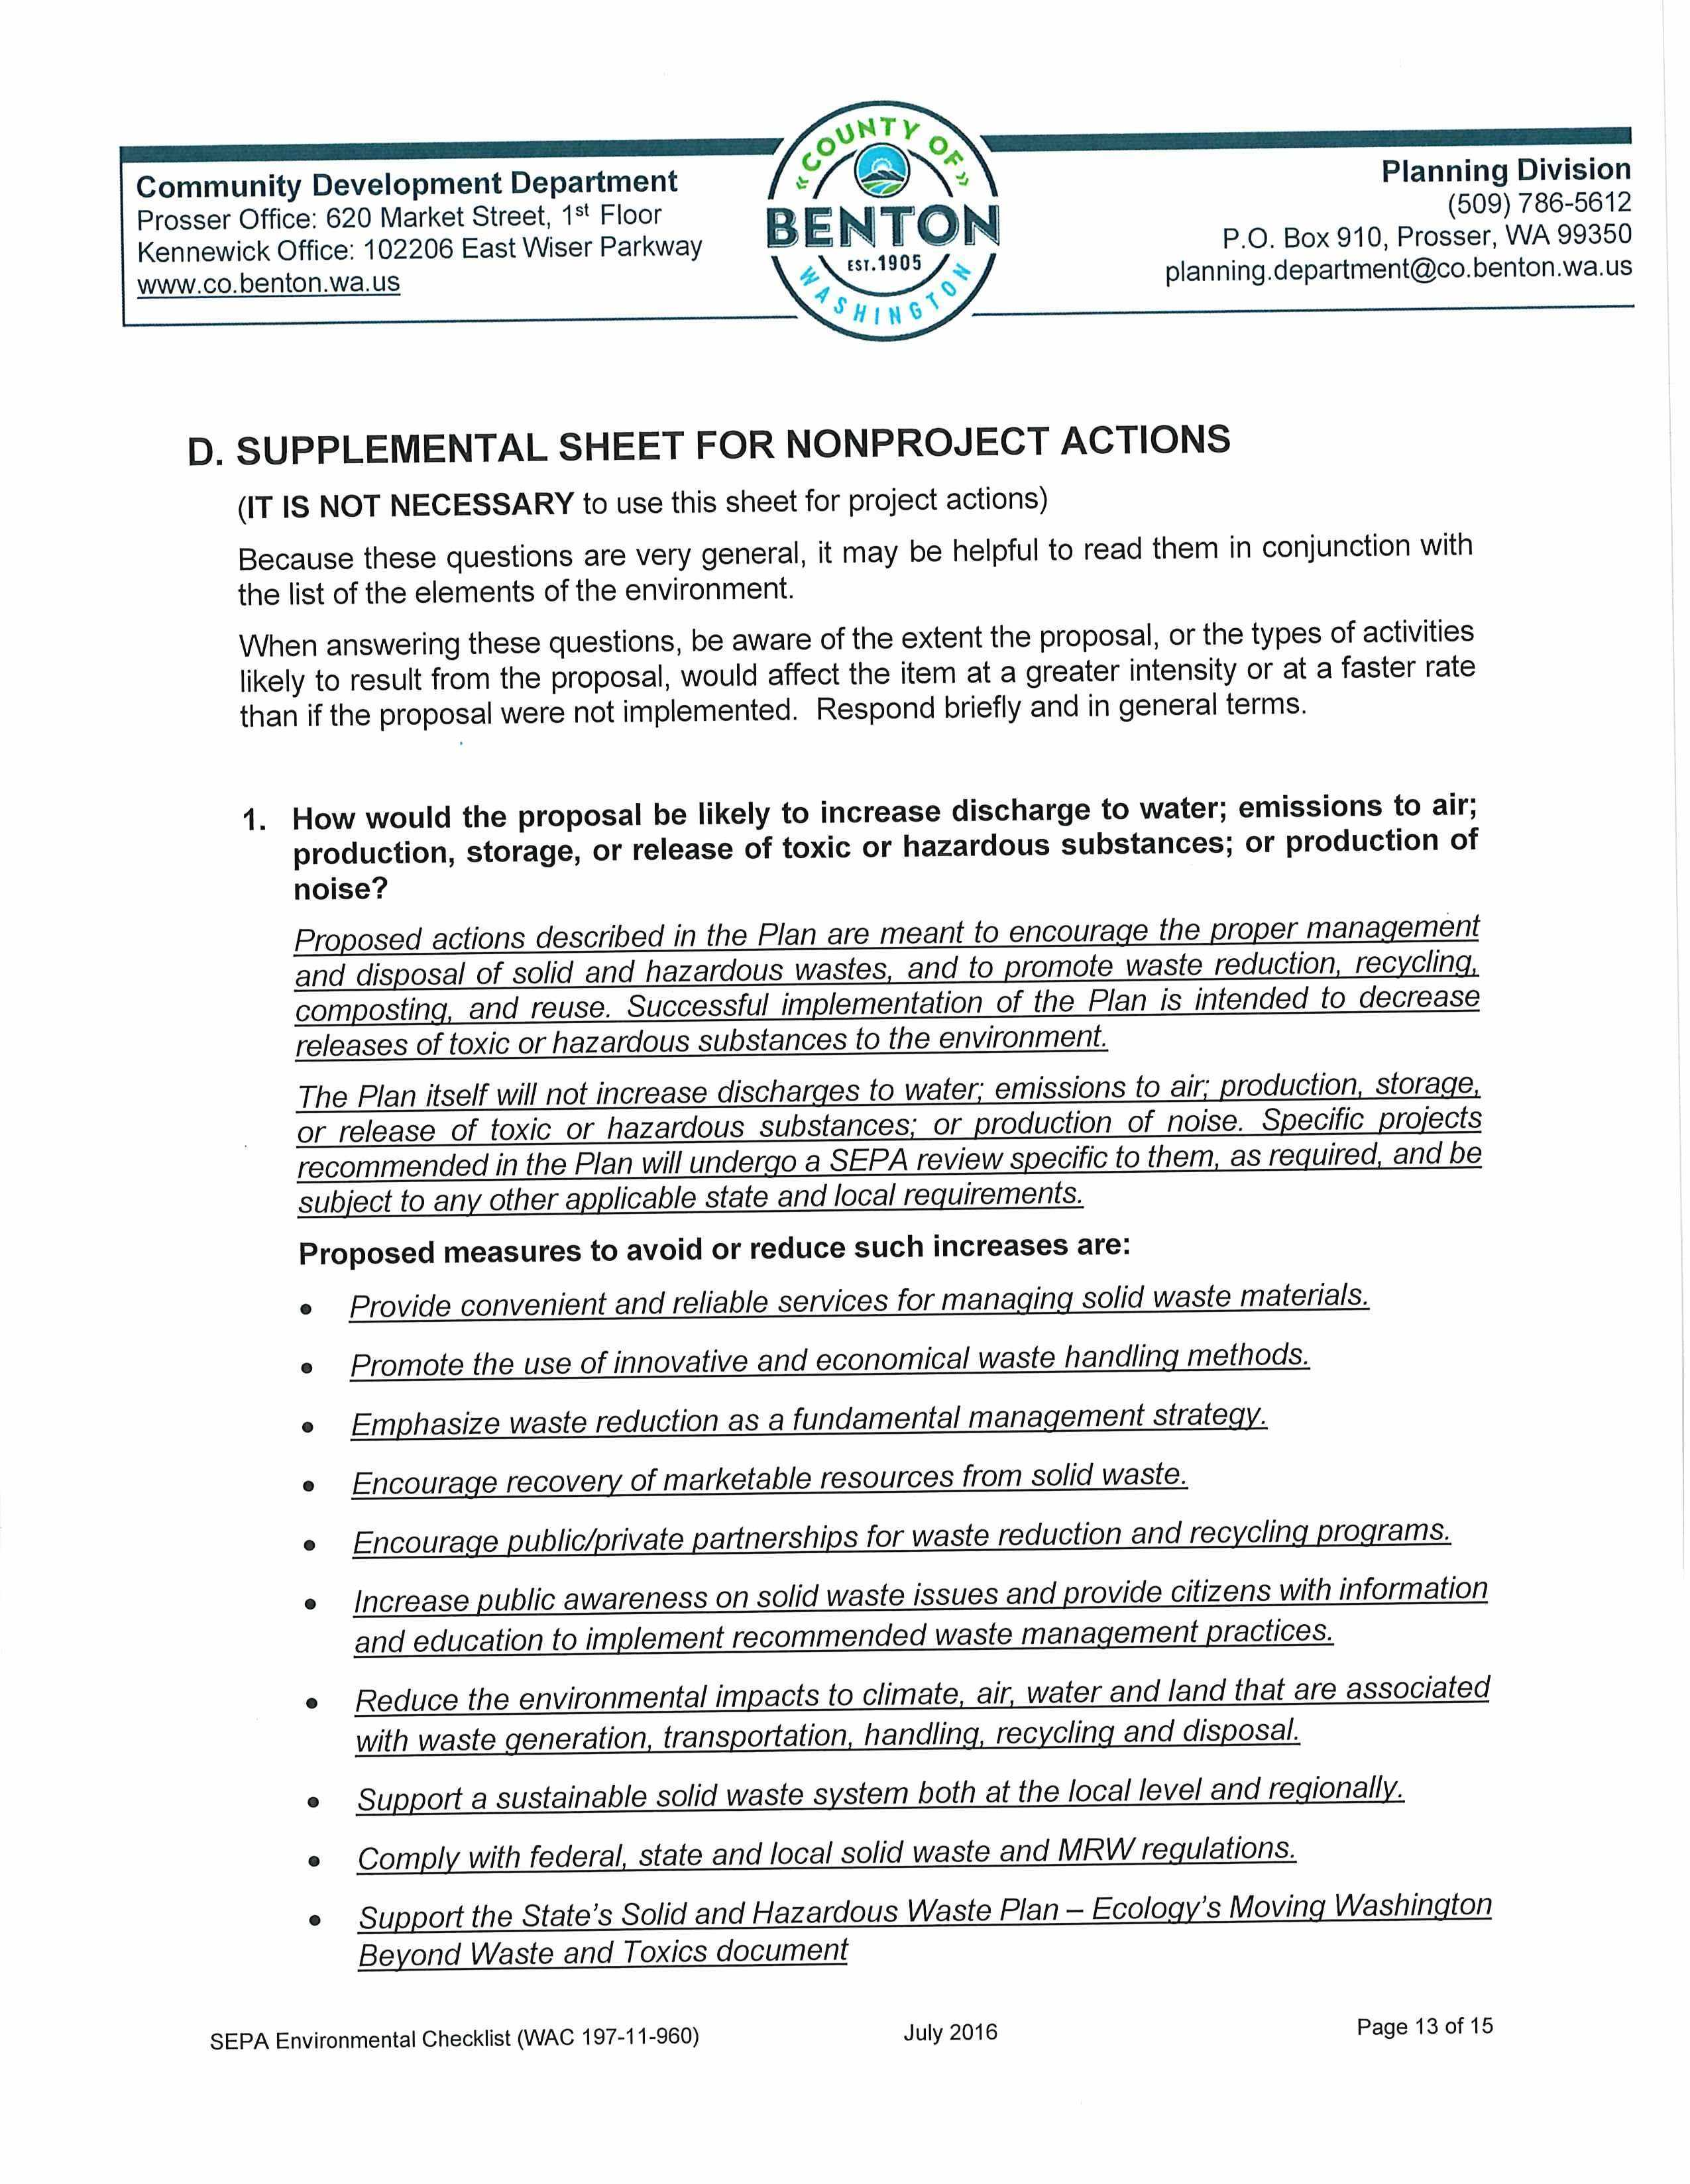
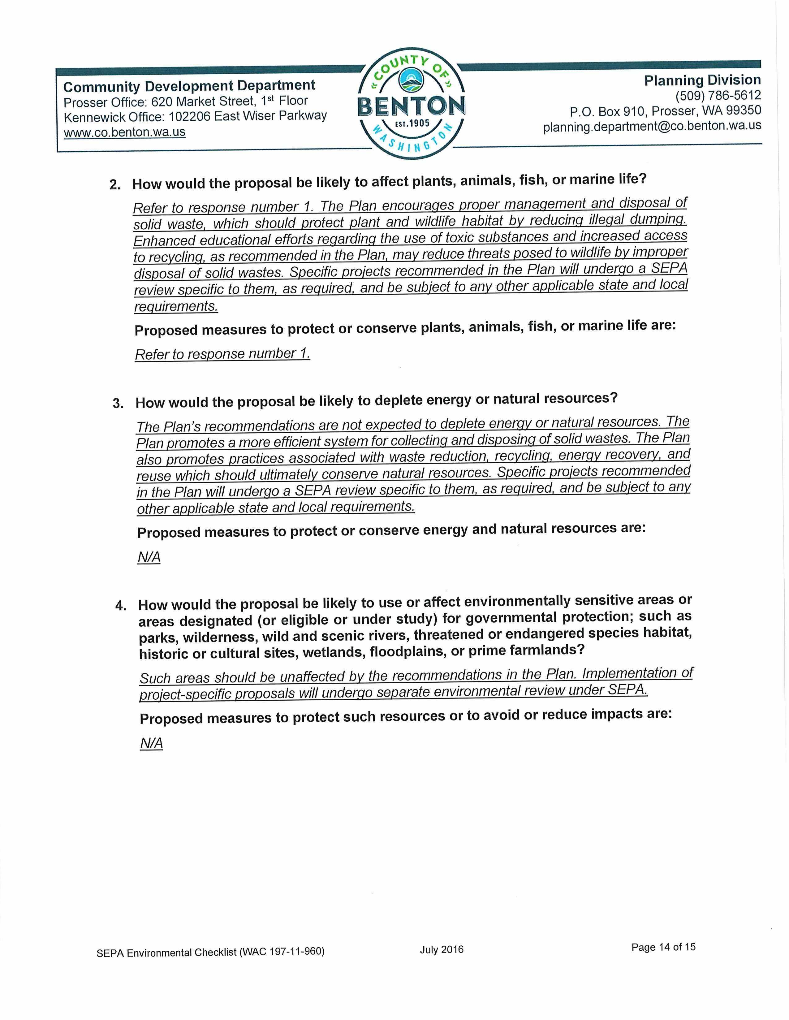
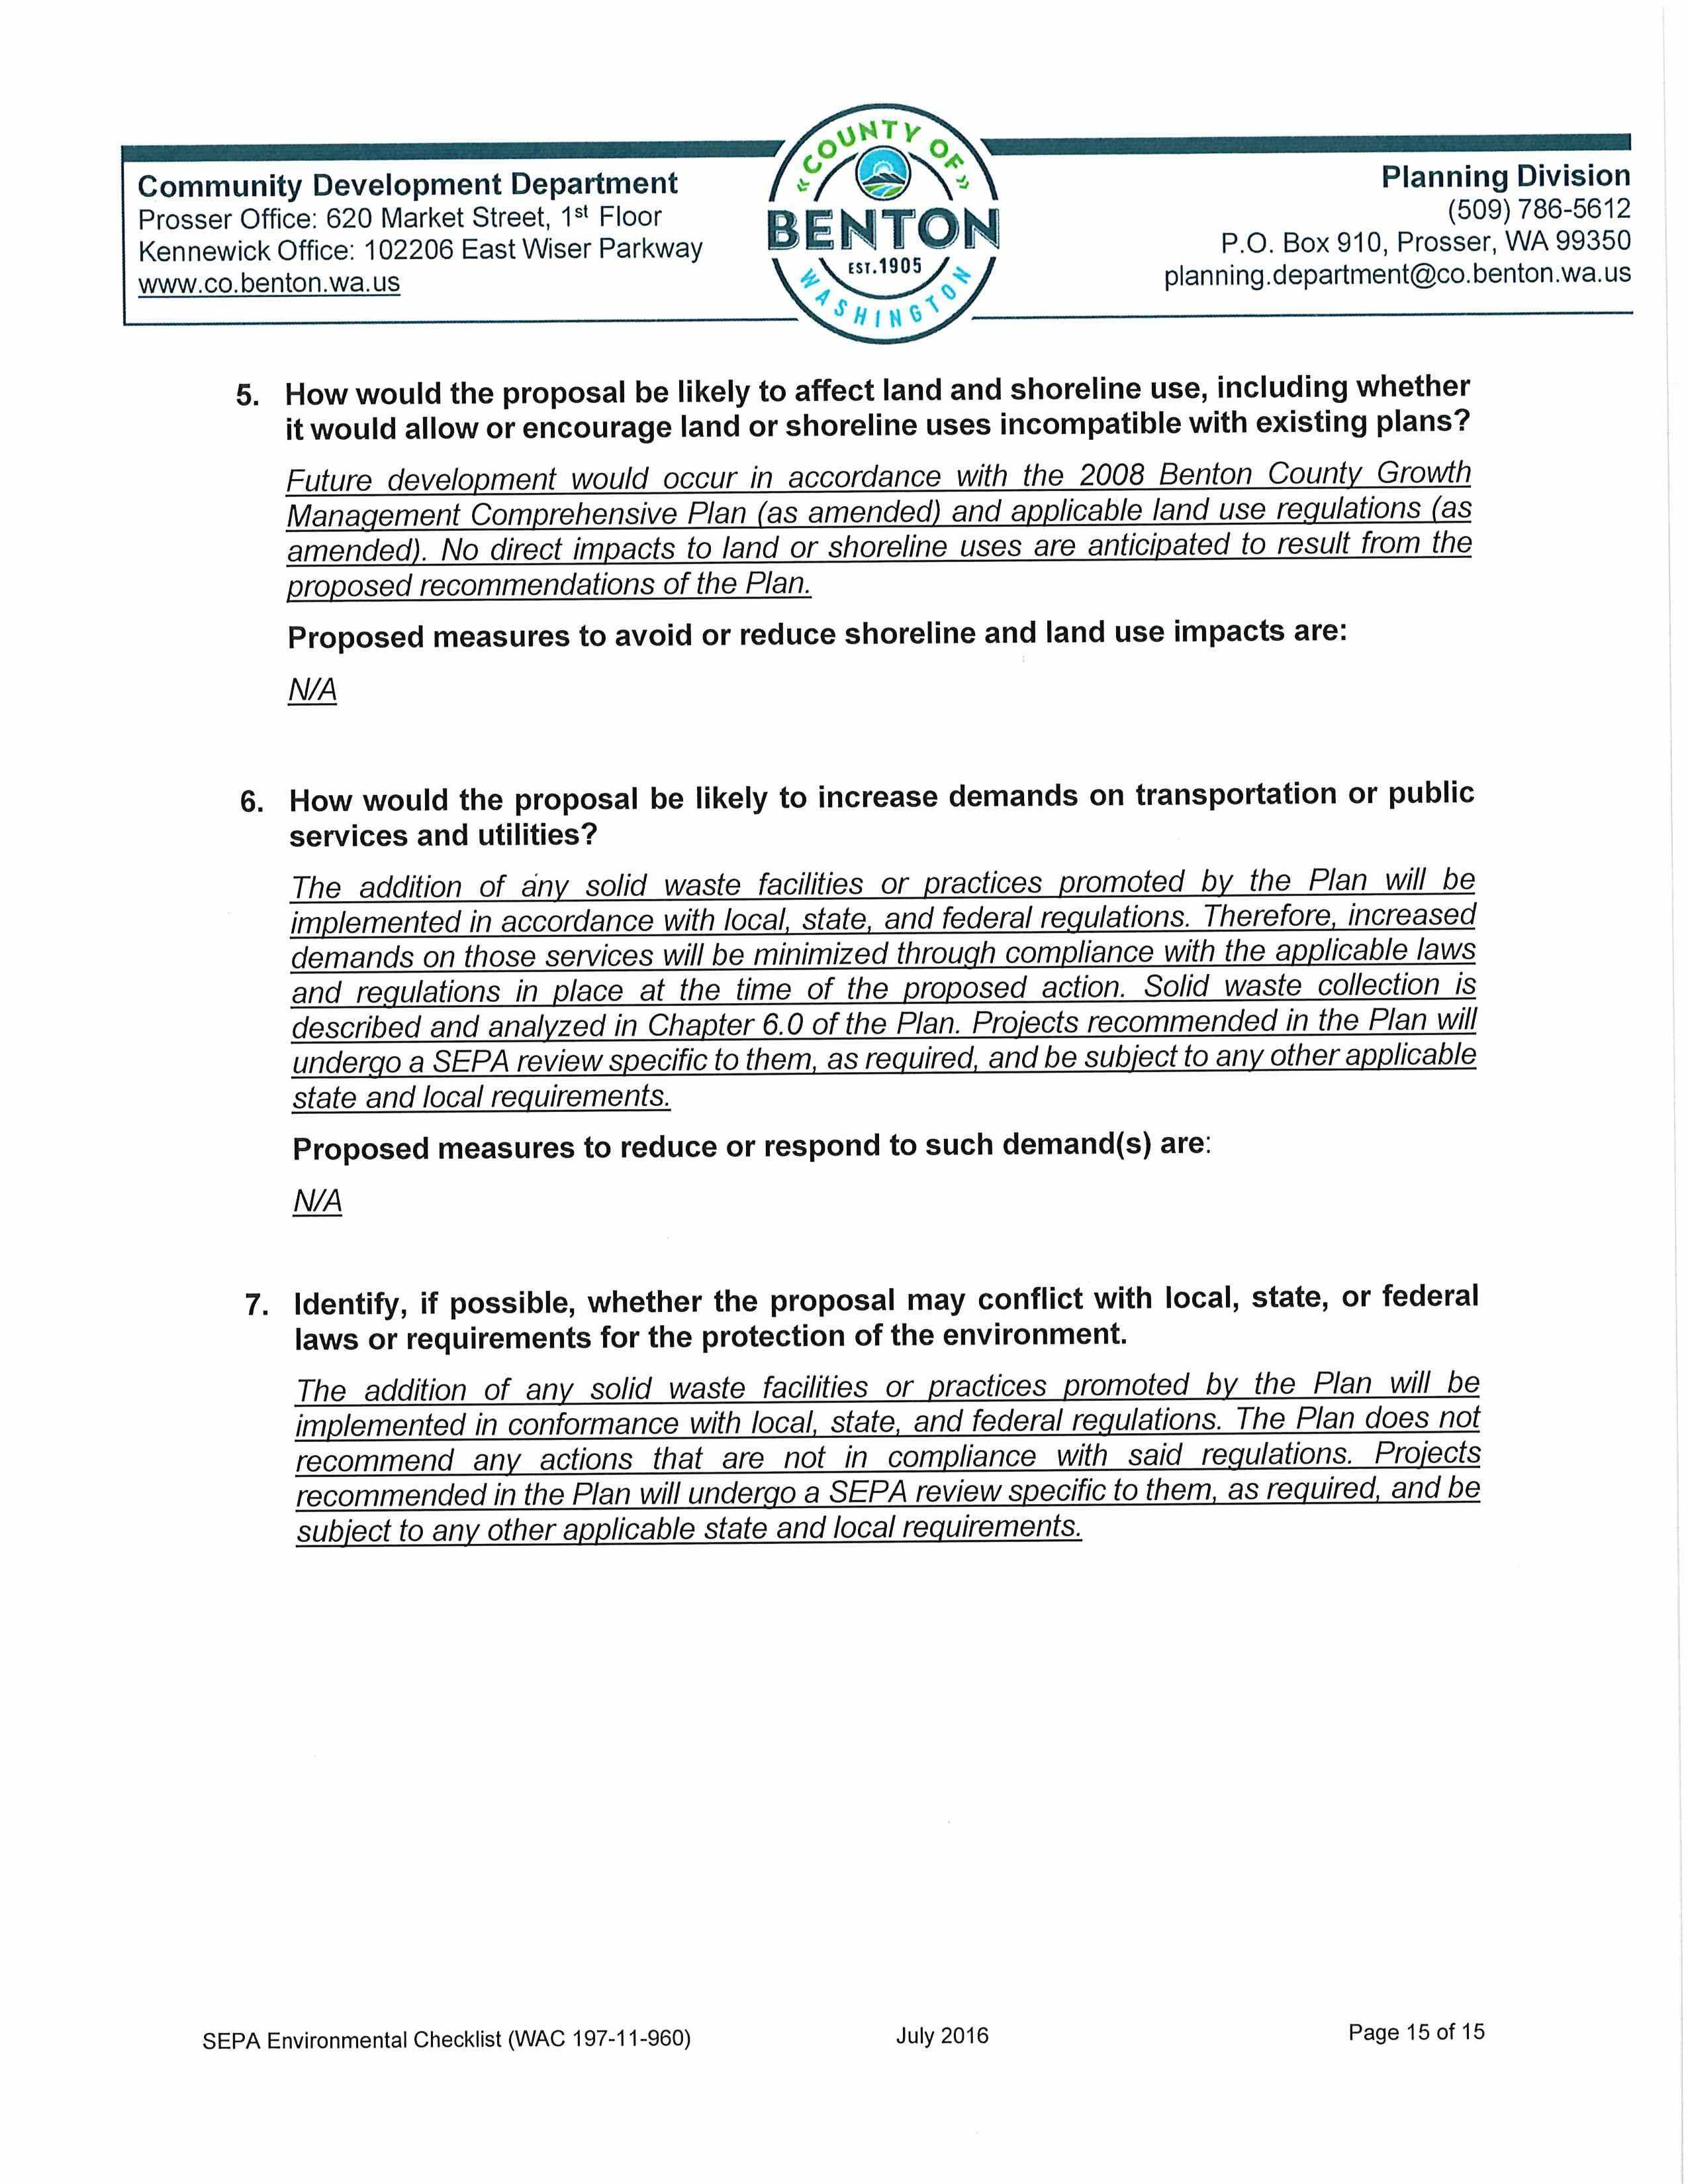

This page intentionally left blank.
Appendix F:
WUTC Cost Assessment

This page intentionally left blank.

APPENDIX F - WUTC COST ASSESSMENT QUESTIONNAIRE
INTRODUCTION
By state law (RCW 70A.205), solid waste management plans are required to include:
“…an assessment of the plan’s impact on the costs of solid waste collection. The assessment shall be prepared in conformance with guidelines established by the Utilities and Transportation Commission (WUTC or Commission). The Commission shall cooperate with the Washington state association of counties and the association of Washington cities in establishing such guidelines.”
The following WUTC Cost Assessment Questionnaire (Questionnaire) has been prepared in accordance with the guidelines prepared by the WUTC (WUTC 1997). The purpose of this Questionnaire is not only to allow an assessment of the impact of proposed activities on current garbage collection and disposal rates, but to allow projections of future rate impacts as well. The WUTC requests this information in order to review the plan’s impacts to the waste haulers that it regulates. For these haulers, WUTC is responsible for setting collection rates and approving proposed rate changes. Hence, WUTC will review the following cost assessment to determine if it provides adequate information for rate-setting purposes and will advise Benton County (County) as to the probable collection rate impacts of proposed programs. Consistent with this purpose, the cost assessment focuses primarily on those programs (either implemented or recommended) with potential rate impacts.
Benton County Cost Assessment Questionnaire
Prepared By: Josiah Close, HDR
Telephone: (360) 570-7294
Email: Josiah.Close@hdrinc.com
Date: April 28, 2023
Definitions: The Solid Waste and Moderate Risk Waste Management Plan (Plan) is a long-term strategy that includes management, storage, collection, diversion, transportation, treatment, use, processing, and final disposal of the County’s solid waste. The Plan covers a twenty-year span and the Questionnaire has defined the period of review for the cost assessment in the table 1 below.

Year | Plan Year
1 | 2024
2 | 2025
3 | 2026
4 | 2027
5 | 2028
6 | 2029

Benton County’s fiscal year is the same as the calendar year (CY) - that is - January through December. The County worked in conjunction with local governments and citizens as well as HDR to develop a county wide comprehensive plan. No other jurisdictions have developed a plan exclusive of Benton County.
Demographics
The data source for population projections used in the development of the plan is the Washington State Office of Financial Management (OFM). In order to maintain a conservative yet accurate approach, the population projections utilize the “medium” case figures from the OFM. The base year and the associated populations are detailed in the table below as well as the assumed percentage increases from the Plan years one through six. The 2021 population of 209,400 was taken from Table 2-1 of the Plan and is utilized as the starting point. This figure was then projected for 2024 through 2029 by extrapolating the projected population growth with the help of addition projection data from OFM for 2025 and 2030. The table below shows the population projection by year.

Year | Plan Year | Benton County Population | Percentage  Change
1 | 2024 | 214,191 | 0.8%
2 | 2025 | 215,740 | 0.7%
3 | 2026 | 218,113 | 1.1%
4 | 2027 | 220,512 | 1.1%
5 | 2028 | 222,938 | 1.1%
6 | 2029 | 225,390 | 1.1%
Waste Stream Generation
The following table details the estimated waste generation and recycling tonnage for the County. Waste generation is estimated at 9.26 pounds per person per day, based on Table 2-2 in the Plan.

Year | Plan Year | Waste Generation (Tons) | MSW Disposed (Tons) | Recycled & Diverted (Tons) | Other Waste (Tons)
1 | 2024 | 361,972 | 228,676 | 126,690 | 6,606
2 | 2025 | 364,590 | 230,329 | 127,606 | 6,654
3 | 2026 | 368,600 | 232,863 | 129,010 | 6,727
4 | 2027 | 372,655 | 235,425 | 130,429 | 6,801
5 | 2028 | 376,754 | 238,014 | 131,864 | 6,876
6 | 2029 | 380,898 | 240,632 | 133,314 | 6,952

It is important to note that the recycling rate is assumed at 34.6% which is an unrounded version of the figure from the Plan of 35%. This was done in order to maintain the appropriate relationships in the projection of solid waste tonnages, specifically for the non-recyclables or other waste.
Waste Generation Assumptions
  - Figures, except the “Year” and “Plan Year”, are shown as tons per year (TPY). Projected waste generation figures for 2024 through 2029 are based on the waste generation rate for 2018 (9.26 pounds per person per day) which is the most recent available and based on Ecology tonnage records in conjunction with the population forecasts from OFM.
  - The projected amounts of recycling and diversion, disposed municipal solid waste (MSW), and other wastes assume the same percentage of the total waste generated as in 2018
  - MSW Disposed per person per day is 5.85 pounds or 2,135 pounds per year (based on 2018 data)
  - Other wastes include construction, demolition, and land clearing wastes disposed at limited purpose landfills and special wastes
System Program Component Costs
System costs reported in this questionnaire are funded by County revenues and through nominal grants.

Waste Reduction Programs
Existing education and outreach waste reduction programs implemented by the County:
  - “Pay-as-you-throw” rates
  - Public education and outreach
  - Drop box sites
  - Public event recycling
The costs of providing the waste reduction programs are included within the County’s solid waste budget and are funded through County revenues or via interlocal agreements.
Solid Waste Collection Programs
Curbside collection of MSW is mandatory within city and town limits of the County but not mandatory in the unincorporated areas. Collection is conducted by a number of private entities including Ed’s Disposal, Inc., Basin Disposal, Inc., Waste Management, Sanitary Disposal, Inc., and the City of Richland’s Solid Waste Division. The following table details information about the WUTC-regulated collection in the County.

MSW and Recycling Collection within Benton County
Collection  Entity |  | 2024 | 2025 | 2026 | 2027 | 2028 | 2029
Incorporated | Pop | 176,590 | 177,867 | 179,824 | 181,802 | 183,801 | 185,823
Incorporated | Tons | 188,532 | 189,895 | 191,984 | 194,096 | 196,231 | 198,390
Unincorporated | Pop | 37,601 | 37,873 | 38,290 | 38,711 | 39,137 | 39,567
Unincorporated | Tons | 40,144 | 40,434 | 40,879 | 41,329 | 41,783 | 42,243
Total Population |  | 214,191 | 215,740 | 218,113 | 220,512 | 222,938 | 225,390
Total Tons |  | 228,676 | 230,329 | 232,863 | 235,425 | 238,014 | 240,632
* Projected 2024 through 2029 data based on assumed waste generation rates and population growth rates applied to 2021 population and 2018 tonnage data

There is currently one transfer station in Benton County which is operated by Waste Management in Kennewick. Additionally, Basin Disposal operates two drop-box sites one in Prosser and one in Benton City. Waste collected in Benton County is transported to two transfer stations located outside Benton County Organics Collection Programs
Organics Collection Programs
The City of Richland offers weekly collection of yard waste, on regular collection days, weather permitting. The program accepts loose grass, leaves, plant trimmings, garden debris, non-treated wood, and branches less than 4 inches in diameter. Waste Management, in Kennewick, offers collection of unlimited bags of leaves the first week of November, December, and January with materials collected currently being directed for disposal. Christmas tree collection programs are offered by the City of Richland and Ed’s Disposal through curbside collection, by WM of Kennewick at the transfer station, and BDI through their Pasco Transfer Station. The City of Richland is currently the only program that composts the Christmas trees collected. One of the largest areas of concern with yard waste is the capacity for processing within the County. The County and city partners could undertake a study to determine the infrastructure necessary to implement additional yard waste and food waste collection and recycling programs. The County could also consider the potential for public-private partnerships to assist with volumes throughput and the offset of costs for facility construction, maintenance, operations, and product marketing.
Recycling Programs
The County, cities and towns, and waste collection companies provide numerous options including curbside as well as drop-off recycling sites throughout the County. Currently, curbside residential recycling service is provided in the City of Kennewick and the City of Richland. The cities of Benton City, Prosser, and West Richland and the unincorporated areas of the County are serviced by residential recycling drop-boxes. Commercial-sector recycling is available in the County and is provided by collection companies operating within each city and town and the unincorporated areas. Public event recycling is provided by the solid waste collection companies operating within the County.
To incentivize recycling, as mentioned, bins are located at multiple locations throughout the County as an opportunity to recycle. All materials collected at the drop-off sites are accepted at no cost. Additional recycling opportunities can enable residents and businesses to reduce their garbage service volumes and lower their garbage collection fees in cities with “pay-as-you-throw” price models. Additionally, residents and businesses that subscribe to recycling collection services may be able to reduce their garbage service to smaller size carts and lower their costs for garbage service. Markets for recyclables are volatile and affect commodities that are able to be collected and processed for recycling. Primary markets for specific materials and comments on factors that affect them as of December 2022 are presented in Table 5-3 in the Plan and summarized below.
Markets for Recyclable Materials (as of December 2022)
Material | Primary Market(s) | Comments
Paper
Cardboard | Regional paper markets, paper mills, and export | The markets for cardboard (used in packaging) have recently been improving and may be stabilizing
Mixed Paper and Newspaper | Regional paper markets, paper mills, and export | The markets are fluctuating due to supply and demand from overseas markets and processors and are primarily low at this time
Plastics
Bottles #1 through #7 | Regional markets in Western Washington and Oregon, and export | The markets for PET and HDPE bottles are currently weak to non-existent (#1 and #2), and even weaker for bottles #3 through #7
Other Plastics | Primarily export | Markets are volatile and sometimes unreliable
Metals
Aluminum | Regional markets in Western Washington and Oregon; can manufacturing in St. Louis | Aluminum prices were weak in 2022
Tin Cans, Appliances, and Ferrous and Non-ferrous Scrap | Regional markets in Western Washington and Oregon | Steel has fluctuated heavily, and the market is currently weak
Glass
Clear Glass | Regional markets in Western Washington and Oregon | Prices are poor for clear glass
Brown and Green Glass | Regional markets in Western Washington and Oregon | Prices for brown and green glass are low or negative (i.e., the glass is recycled for a charge)
The assumed recycling rate is 34.6% of the total waste collected and this rate was used to project the future amount of recycling tons. It is important to note that this rate is an unrounded version of the figure from the Plan of 35%. This was done in order to maintain the appropriate relationships in the projection of solid waste tonnages, specifically for the non-recyclables or other waste. The table below shows a projection of recycling and non-recyclable tons based on the 2018 data from Table 2-2 in the Plan.

Year | Plan Year | Recycling (Tons) | Other Non-Recyclables (Tons)
1 | 2024 | 126,690 | 6,606
2 | 2025 | 127,606 | 6,654
3 | 2026 | 129,010 | 6,727
4 | 2027 | 130,429 | 6,801
5 | 2028 | 131,864 | 6,876
6 | 2029 | 133,314 | 6,952
Energy Recovery & Incineration (ER&I) Programs
MSW from the County is disposed of at multiple landfill facilities including the Horn Rapids Landfill located in the County, Waste Management’s Columbia Ridge Landfill in Gillam County, Oregon, and the Waste Connections’ Finley Buttes Landfill in Morrow County, Oregon. The Horn Rapids Landfill currently flares landfill gas collected but has an approved facility project with Pine Creek RNG to recover, clean, and reuse the gas collected through an agreement with Cascade Natural Gas. The Columbia Ridge Landfill manages landfill gas to generate renewable energy, reduce emissions, and prevent odor. The Finley Buttes Landfill recovers energy through an installed gas collection and recovery system on the landfill site. Energy recovery from MSW should remain a continuing consideration for the County.
Expenses
The project expenses (2024 – 2029) for the County are shown below are based on cost figures escalated from the 2023 budget by assumed inflationary factors.
 | 2024 | 2025 | 2026 | 2027 | 2028 | 2029
Total Expenses ($000s) | $1,016 | $1,237 | $1,287 | $1,368 | $1,410 | $1,454
MSW Tons | 213,630 | 217,262 | 220,955 | 224,711 | 228,740 | 232,629
Cost per MSW Ton | $118.62 | $120.22 | $123.11 | $126.08 | $127.66 | $129.38
Funding Mechanisms
The County’s solid waste program is managed by the Benton County Road Department and run with the advice of the Benton County Solid Waste Advisory Committee (SWAC). The program is operated on a county-wide basis, though it functions in conjunction with activities managed by individual cities in Benton County via interlocal agency agreements. The incorporated communities of Benton City, Kennewick, Prosser, Richland, and West Richland executed interlocal agreements with the County regarding solid waste management. The solid waste program is funded through County taxes, as well as a LSWFA grant funding (CPG) offered by the Washington State Department of Ecology. System costs reported in this questionnaire are funded by revenues collected by the County. Provided in the table below is a summary of the revenues received by the County based on the 2023/2024 biennial budget (adjusted for a single year, 2023).
System Funding Source | 2023  Budget | Funding  Percentage
Pollution Control & Remediation Services | $310,000 | 47.7%
Solid Waste Services | 10,000 | 1.5%
Grants | 325,000 | 50.0%
Miscellaneous | 5,000 | 0.8%
Total Funding Sources | $330,000
The following assumptions were used to project revenues and expenses:
- Revenues
  - Customer Growth – 1.0%
  - Misc. Revenue – 1.0%
- Expenses
  - Personnel – 3.5%
  - Internal Services – 3.0%
  - Professional Services – 3.0%
  - Operating Costs – 3.0%
  - Miscellaneous – 2.5%
  - Flat – 0.0%
  - General Inflation – 3.0%
Benton County Projected Revenues and Expenses ($000s)
Costs | 2024 | 2025 | 2026 | 2027 | 2028 | 2029
Revenues
Pollution Control & Remed Svs | $310 | $313 | $316 | $319 | $323 | $326
Solid Waste Services | 10 | 10 | 10 | 10 | 10 | 11
Miscellaneous | 5 | 5 | 5 | 5 | 5 | 5
Coordinated Prevention Grant | 325 | 328 | 332 | 335 | 338 | 342
Total Revenue | $650 | $657 | $663 | $670 | $676 | $683
Expenses
Total O&M | $1,145 | $1,181 | $1,218 | $1,256 | $1,295 | $1,335
Rate Funded Capital | 241 | 57 | 32 | 33 | 34 | 35
Total Reserve Funding | (352) | 25 | 52 | 52 | 52 | 52
Total Expenses | $1,034 | $1,263 | $1,301 | $1,340 | $1,381 | $1,423
Bal. / (Def.) of Funds | ($384) | ($607) | ($638) | ($671) | ($705) | ($740)
The table above utilizes the County’s 2023/2024 biennial budgeted revenues and expenses. Those are then inflated by the escalation factors that were shown previously. As can be seen, current revenues are not sufficient to fully fund the projected expenses. Given the deficiency of funds in 2024 through 2029 based on the 2023/2024 biennial budget, it is recommended that the County should address the revenue shortfall by either a future revenue adjustment or securing other funding sources such as grants, etc. Additionally, as it is projected that the population – and therefore solid waste tonnage – will increase in the next six years the County should strategize about how this transition should happen as some costs may not increase proportionally with the service population while maintaining the same, high level of service from the County.

Appendix G:
Determination of Non-significance

This page intentionally left blank.
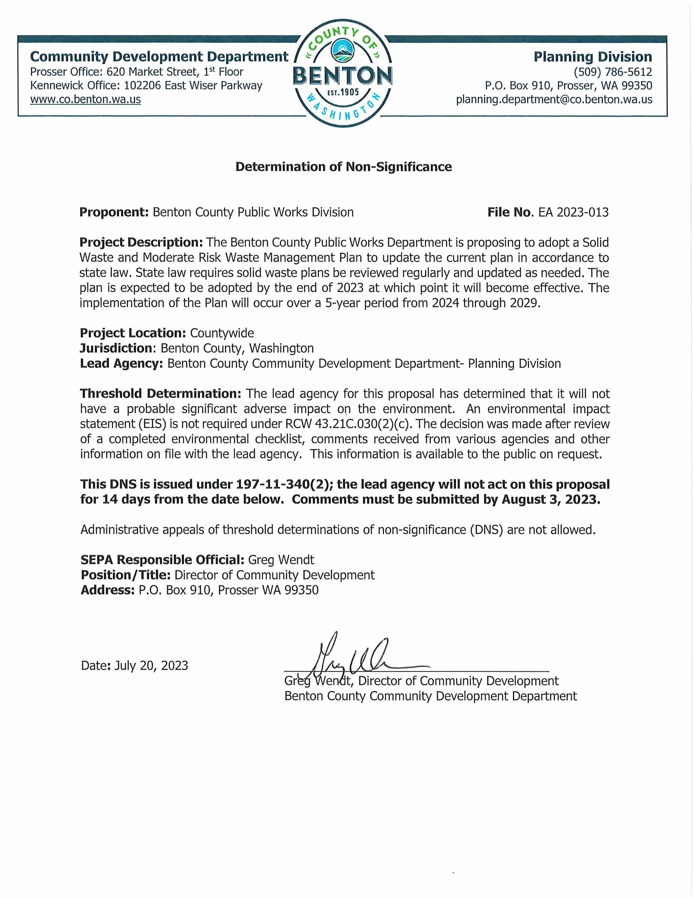

This page intentionally left blank.
Appendix H:
Comments and Responses on the Draft Plan

This page intentionally left blank.

Section A: Revisions required for Plan approval
Comment Number |  | Plan section – page # |  | Comment | Benton County Response  Include section & page #s if applicable
N/A |  | N/A |  | No required changes are needed. | N/A
Section B: Recommended revisions
Comment Number |  | Plan section – page # |  | Comment | Benton County Response  Include section & page #s if applicable
Plan clarity, content, and navigation
1 |  | Cover and throughout |  | Name of Plan  To bring some statewide consistency to plan titles and to make it clear that the Plan addresses the State’s Hazardous Waste Planning requirements, we recommend the title be changed to Benton County Comprehensive Solid and Hazardous Waste Management Plan for Years 2024-2029. | Concur with comment. Changes made to Plan.
2 |  | 1.9.3, 1-7 |  | City of Richland Solid Waste Management Plan  Recommend a link to the City Plan be included. It is available online on the City’s website. | Concur with comment. Changes made to Plan.
3 |  | 1.12.1, 1-10 |  | LightRecycle Washington Program  Add language to indicate the LightRecycle program is set to sunset in 2025 unless action is taken to extend the law and that after July 1, 2026, the program may be terminated or extended. | Concur with comment. Changes made to Plan.
4 |  | 1.12.13, 1-13  & 1-14 |  | Organics Management Law  For the CPO specifically, there are also requirements for jurisdictions to adopt a CPO with a population less than 25,000 if they require the hauler to collect organics or they themselves provide organics curbside collection. The CPO focus sheet has the language that should be added into this section or you could match what you have in 6.2.1.  The facility siting requirement takes effect on July 1, 2024. | Concur with comment. Changes made to Plan.
Section B: Recommended revisions
Comment Number |  |  | Plan section – page # | Comment | Benton County Response  Include section & page #s if applicable
5 |  |  | 2.2.3, 2-4 | Composition Study  To create Figure 2.1 we recommend using the state’s most current data included in the 2020-2021 waste composition. To illustrate the changes in the composition of the waste stream, the 2020-21 study includes a table (page 44) showing how the composition of the waste stream has changed since 2015 and 2016. These changes could be noted in this section as well. | Acknowledge comment. The 2020-2021 State Waste Composition was conducted during the Covid pandemic. Language in Plan notes the reasoning behind the use of the 2015 Composition Study. No change made to Plan.
6 |  |  | 3.3.1, 3-4  (Table 3-1) | Unincorporated Population 2021  The 2021 unincorporated population in Table 3.1 should be changed from 30,752 to 36,760 to reflect the population data in Table 2.1. 30,752 was the unincorporated population of the County in 2010. | Concur with comment. Changes made to Plan.
7 |  |  | 5.1.1, 5-1 | Statewide Recycling Rate  In Bullet 1, note that Washington State had set a goal to reach a recycling rate of 50% by 2007. This goal is no longer included in the most recent State Plan, 2021. As you mention, Ecology now emphasizes overall waste generation instead. In addition, we recommend referencing the State’s Plan goal of maximizing the “effectiveness of recycling and organic processing systems” (pg. 13,State Plan). | Acknowledge comment. These are goals from RCW 70A.205 not State Plan. No change made to Plan.
8 |  |  | 5.1.1, 5-2 | Urban and Rural Recycling  Bullet points 2 & 3 are duplicated in the paragraphs below. | Acknowledge comment. The bullet points reference relate to different requirements for establishing vs. developing programs. No change made to Plan.
Section B: Recommended revisions
Comment Number | Plan section  – page # |  |  | Comment | Benton County Response  Include section & page #s if applicable
9 | 5.1.2, 5-2 |  |  | CROP  To make it easier to ensure each requirement is met, we suggest adding the section where it is met alongside each bullet point. It does appear to meet the requirements. However, the cost is not really being discussed in the implementation chapter because it shows $0 for WRR9 and WRR16. Either update the costs or make a comment as to why there is no cost to implement the CROP. In addition, I suggest changing WRR16 from "maintain and update.." to “implement the actions listed as part of the CROP.” | Acknowledge comment.  Comment reference on-going recommendations in accordance with Table 11.1 footnote. No change to Plan.
10 | 5.2.4, 5-7  Table 5-2 |  |  | Paint  Benton County now has a contract with Paint Care. Paint should, at a minimum, be listed in the limited collection section versus the potentially recyclable section as it is now routinely recycled statewide and at no cost to the county. | Concur with comment. Changes made to Plan.
11 | 5.2.12, 5-  10 |  |  | China Sword  There is some duplication within the first 5 paragraphs. We suggest combining and deleting information that is duplicated. | Acknowledge comment. No change made to Plan.
12 | 5.2.12, 5-  11, Table  5-3 |  |  | Market Data  We would recommend adding a link to Ecology’s market data which is updated every 2 months and is posted available in BOX. | Concur with comment.  Ecology link added to document.
13 | 5.4.8, 5-  18 |  |  | Waste Diversion Goal  A waste diversion goal of 40% is listed, however, there is no date upon which Benton County expects to achieve that goal and is this goal a sustained goal of 40% or do they wish to increase it throughout the planning period? | Concur with comment. Changes made to Plan and Recommendation WRR8.
14 | 5.4.9, 5-  18 |  |  | 2018 Recycling Rate  The 2021 data is now available and we suggest using the updated data for this plan so that it is as current as possible. The 2021 diversion rate is listed as 34.7% which is a decrease since the 2018 data. | Acknowledge comment.  Leaving 2018 data as is. See Section 5.4.9 for explanation.
Section B: Recommended revisions
Comment Number | Plan section  – page # |  |  | Comment | Benton County Response  Include section & page #s if applicable
15 | 5.4.12, 5-  18 |  |  | Glass Recycling  There is a new depot located in the Tri-Cities that is collecting glass which is not referenced in the Plan. We recommend noting that jurisdictions and companies are working together to address the difficulties of recycling glass on the East side of the Cascades. And, note that Benton County would be interested in adding glass to its programs when it becomes feasible financially. | Concur with comment. Changes made to Plan.
16 | 6.5.2, 6-4 |  |  | Residential Collection  As part of the new Organics Management Law, Benton County will have some residential collection requirements in 2027. There is no mention of this new requirement. | Concur with comment.  Changes made to Plan.
17 | 6.3.1, 6-2 |  |  | Yard Debris Collection  Clarify if Richland collection is limited to residential or if it includes multi-family, commercial etc. Also, with Kennewick collecting leaves but sending them to disposal, we recommend noting if they plan to make any changes to that program to help reach the goals that are listed by the state in the above sections. | Clarified with City of Richland. Yard Debris Collection does not include multi-family or commercial.
18 | 7.3.1, 7-2 |  |  | Agricultural Waste  Because you have WAC 173-350-100 in quotations I would update to reflect the exact wording which is: "wastes from farms resulting from the raising or growing of plants and animals including, but not limited to, crop residue, livestock manure, animal bedding, and carcasses of dead animals." | Concur with comment. Changes made to Plan.
19 | 7.13.3, 7-  11 |  |  | Litter Funding  Update the last sentence in paragraph 1 to state that “Beginning in 2008, half of the funds were redirected away from the litter grants however funding was fully restored in 2019. | Concur with comment. Changes made to Plan.
Section B: Recommended revisions
Comment Number | Plan section  – page # |  |  | Comment | Benton County Response  Include section & page #s if applicable
20 | 7.16.2, 7-  13 |  |  | Drug Take Back  Update this section to reflect the new program. "Chapter 69.48 RCW - The Drug Take- Back Program created a unified, statewide, medication return program for the collection and disposal of covered drugs in 2020. Administered by the Washington State Department of Health and funded by pharmaceutical producers, Washington State’s Drug Take-Back Program became the first statewide extended producer responsibility (EPR) program for residential medications in the nation." (Pierce County Plan language). This update may change your SW2 recommendation, so we recommend evaluating this recommendation. | Concur with comment. Changes made to Plan. Deleted Recommendation SW2.
21 | 8.2.2.1,  8-3 |  |  | WA State SWMP  The most recent plan was published in 2021 not 2015. This section also quotes MRW percentages and goals from the previous plan. | Concur with comment. Changes made to Plan.
22 | 8.2.2.5,  8-5 |  |  | Paint Care  Benton County is now signed on with Paint Care. Reference this in this section. | Concur with comment. Changes made to Plan.
23 | 8.2.3, 8-6  & 8.6.3,  8-104 |  |  | MRW Facility  Update the opening date for the facility. | Concur with comment. Changes made to Plan.
24 | 8.3.2, 8-7 |  |  | Hazardous Waste Generators  We do have a list of all generators in Benton County. The last sentence states it is unknown how many there are. You could attach this as an exhibit, add a link to this list, or just update your reference. The list can be found here - | Concur with comment. Changes made to Plan.  Deleted last sentence.
25 | 8.4.1.3,  8-7  8.6.1, 8-8 |  |  | HHW Education  These two paragraphs contradict each other. If funding has been the issue and limited education has been provided but now the education is planning to be increased and is part of the recommendations, then you may need to add language explaining why or how that situation is different and will allow for this increase. Alternatively, you could delete the 8.4.1.3 paragraph as the 8.6.1 has much more thorough information. | Concur with comment. Changes made to Plan.  Deleted Section 8.4.1.3.
Section B: Recommended revisions
Comment Number | Plan section  – page # |  |  | Comment | Benton County Response  Include section & page #s if applicable
26 | Appendix C |  |  | SWAC  Resolution 2022-176 has expired terms. All but 2 are now expired. Add the new resolution to show current members throughout this planning period. | Concur with comment.  New Resolution has been inserted in Appendix C.
27 - WSDA | 4.4.1, 4-5  & Ch. 6 |  |  | WSDA – Japanese Beetle Import - WSDA recommendation letter  In September 2022, a quarantine for Japanese beetle was put in place in the southeastern corner of Yakima County and the southwestern corner of Benton County (see WAC 16-470-700 to 720). Under this quarantine, yard debris is considered a regulated article (WAC 16-470-710) and is prohibited from moving outside of the quarantined area unless it meets one of the following treatment methods (WAC 16- 470-717(2)):  Steam heated to a temperature of 140 degrees Fahrenheit for one hour, to kill all life stages of Japanese beetle;  When consisting solely of woody materials containing no soil, yard debris may be chipped to a screen size of one inch in two dimensions or smaller during the Japanese beetle adult flight season (May 15th through October 15th). Woody material containing no soil can be moved outside of the Japanese beetle adult flight season without chipping;  Another treatment determined to be effective at eradicating Japanese beetle and approved in writing by the director.  Since a portion of Benton County is under quarantine for Japanese beetle, it is recommended that information about the quarantine and its restrictions are included in the Plan. If needed, WSDA can provide more detailed information about this quarantine.  Under section 4.4 of the Plan, it’s stated, “Periodically, Yakima County residents may use the Prosser Transfer Station Facility, particularly during Prosser Cleanup Days.” Prosser is located outside of the Japanese beetle quarantine area, therefore, yard debris coming from quarantined portions of Yakima County is prohibited (unless it meets the criteria stated above). Additionally, yard debris from the quarantined portion of Benton County is prohibited from being transported into non-quarantined areas of the County.  ECY - Yakima County recently updated their SW Management Plan and you can find information on this topic on page 5-5. We recommend adding this into the Chapter 6 Organics section, as well. | Concur with comment.  Language added to Section 4.4.1 and 6.2.2.
Section B: Recommended revisions
Comment Number | Plan section  – page # |  |  | Comment | Benton County Response  Include section & page #s if applicable
28 - WSDA | 6.6.2, 6-2 |  |  | Apple Maggot Quarantine - WSDA recommendation letter  Regarding the apple maggot quarantine, under section 6.2.2 WSDA Regulations, the Plan discusses Benton County’s status as non-quarantined for apple maggot. It is recommended that language is added clarifying that since Benton County is considered non-quarantined, it cannot accept organics or municipal solid waste from an apple maggot quarantine area unless a special permit has been issued by WSDA. | Concur with comment.  Language added to Section 6.2.2.
 | Additional comment submitted by Ecology |  |  | Emerging Issues Section – “As we implement this Plan, issues may arise that could directly impact our local solid and hazardous waste management programs. These include the introduction of new state, federal, and international government regulations and policies, advancements in technology, and changes in product use and design. Consequently, we may need to adjust the recommendations in this Plan or add new action items to our implementation strategy to effectively address them before our Plan is updated again in 20xx. When these issues arise, the Plan may need to be amended or revised to address them using the process defined in (reference Chapter, etc. in Plan) and will be referenced in our next Plan update in 20xx.” | Concur with comment.  Language added to Section 11.5.
Section C: Minor edits
Comment Number |  |  | Plan section – page # | Comment | Benton County Response  Include section & page #s if applicable
29 |  |  | 5.2.3.3 | City of Kennewick - Font  The font in the first half of this section does not match the rest of the document. | Concur with comment.  Font corrected.
30 |  |  | Ch. 7 | RCW’s Recodified  Many of the RCW’s referenced throughout chapter 7 need to be updated to their new recodified numbers. | Concur with comment.  RCW reference updated.
31 |  |  | 7.13.5, 7-11 | Funding  Update sentence two from "if funding continues to be reduced" to "if funding is reduced." | Concur with comment.  Sentence updated.
Section C: Minor edits
Comment Number |  |  | Plan section – page # | Comment | Benton County Response  Include section & page #s if applicable
32 |  |  | 11.1, 11-1 | Chapter 7 Recommendations  The recommendations are listed as SW in the chapter but as MW on the table. | Concur with comment.  Corrected in Chapter 7 Recommendations.
33 |  |  | 11.1, 11-4 | Chapter 9 Recommendations  ER1) does not match the exact wording found within the chapter. | Concur with comment.  Table 11.2 corrected.
34 |  |  | Appendix E & G | SEPA  Combine the SEPA checklist with the Determination versus having these in separate non-consecutive appendices. | Leaving as separate appendices.
35 |  |  | Appendix F, F-1 | UTC  Update the county name on the UTC cost assessment from Thurston to Benton. | Concur with comment.  Correction made.
36 |  |  | Appendix F, F-7 | Ecology Grant Reference  Update the reference to the CPG grant to the LSWFA grant. | Concur with comment.  Correction made.
SEPA Comment |  |  | Comments submitted during SEPA by Kennewick Irrigation District | 1. Please note that permanent structures are not allowed within irrigation easements.  2. Please protect all existing irrigation facilities.  3. No permanent structures or grading allowed within the Kennewick Irrigation District canal right-of-way.  4. The Moderate-Risk Waste facility discussed on section 8.0 of the Benton County Solid Waste Management Plan is located adjacent to an open channel irrigation canal and is within a City of Kennewick wellhead protection zone.  a. KID requires adequate measures are in place to prevent any hazardous wastes from entering the open canal and protecting the aquifer. | Acknowledge comment.  No change made to Plan.
SEPA Comment |  |  | Comments submitted during SEPA by City of Kennewick | Acronyms and abbreviations formatting - CROP is in italics - Plan is in italics.  5-6 City of Kennewick formatting - The first paragraph for Kennewick has an indent.  8-10 8.6.3 Household Collection Change time period – MRW Facility did not open in Spring 2023. | Concur with comments.  Changes made to Plan.

